ZERO CARBON ACTION ASSOCIATION LIMITED
TENDER FOR THE PROVISION OF SERVICES
STANDARD TERMS AND CONDITIONS
Reference No. ZCAA-A001/10/25

FOREWORD

Tenderers who respond to any such invitation to which these terms and conditions are applicable are required to confirm compliance with these terms and conditions, and those issued under any addenda, in addition to the other terms and conditions of that invitation.

The Chinese translation of this document is for reference only. In the event of any conflict or inconsistency between the English text and the Chinese translation of this document, the English text shall prevail.

TABLE OF CONTENTS INTERPRETATION
PART 1 – TERMS OF TENDER

1. Invitation to Tender
2. Supplementary Information/Tender Addenda
3. Tender Preparation and Submission
4. Tenders to Remain Open
5. Prices
6. Checklist of Compliance
7. Company/Business Organisation Status
8. Cancellation of Tender
9. Counter-Proposals
10. Authenticity of Documents Submitted
11. Personal Data Provided
12. Warranty against Collusion
13 Warning against Bribery
14. Environmental Protection
15. Tenderer’s Commitment
16. New Information
17. Contractors’ Performance Monitoring
18. Cost of Tender
19. Request for Information
20. Tenderer’s Enquiries
21. Communication with the Association
22. Negotiations
23. Association Discretion
24. Financial Vetting
25. Award of Contract
26. Acceptance
27. Contract Deposit
28. Complaints about Tendering Process or Contract Award
29. Documents of Unsuccessful Tenderers
30. Consent to Disclosure
Appendix

PART 2 – GENERAL CONDITIONS OF CONTRACT

1. Total Services and Variation
2. Contractor’s Acknowledgement, Obligations and Contract
Performance
3. Warranties and Representations
4. Costs and Expenses
5. Order and Provision of Services
6. Inspection
7. Non-exclusive Contract
8. Association Property
9. Association Premises/Contractor’s Premises
10. Payment of the Contract Price
11. Contract Deposit
12. Variations
13 Liability and Indemnities
14. Termination
15. Intellectual Property Rights
16. Conflict of Interest
17. Confidentiality
18. Probity
19. Insurance
20. Process Agent
21. Relationship of the Parties
22. Assignment and Sub-contracting
23. Disclosure of Information
24. Publicity
25. Vicarious Liability
26. Force Majeure
27. Retention of Records
28. Notices
29. Entire Agreement
30. Governing Law
31. Severability
32. Waiver
33. Recovery of Sums Due
- Assistance in Legal Proceedings
- Contracts (Rights of Third Parties) Ordinance
36. Order of Precedence

INTERPRETATION

In the documents issued by the Association in connection with this Invitation to Tender (including these Standard Terms and Conditions (Reference No. ZCAA-A001/10/25) and the Contract that is made pursuant to this Invitation to Tender), unless otherwise defined or the context otherwise requires:

  - the following expressions shall bear the same meanings as set out below:

“Appendix” | means an appendix attached to the Tender Form;
“Association” |  |  | means Zero Carbon Action Association Limited;
“Association Representative” | means:  - the Head of the Association;  - any person of the Association specified by the Head of the Association for the purposes of the Contract; and  - any other person authorised by the person referred to in (b) for the purpose of the Contract;
“Companies Registry” | means the Companies Registry of the government;
“Contract” | means the agreement made between the Association and the Contractor pursuant to the Invitation to Tender, and reference to the terms thereof shall include:  - the terms set out in the Tender Document, completed, modified or expanded as necessary or appropriate to include the terms accepted by the Association and the Contractor; and  - all other documents attached to the Tender Form as a Schedule or other attachment by whatever name called, completed and stamped with a chop of the Association;
“Contract Deposit” | has the meaning given to it in Clause 11 of the General Conditions of Contract;
“Contract Period” | means, subject to early termination or extension provided for in the Contract:  - the period specified in the Special Conditions of Contract as the contract period; or  - if no such period is specified in the Special Conditions of Contract, the period from the date on which the Contract is constituted in accordance with Paragraph 26.1 of the Terms of Tender to the date on which the Contractor  has fully discharged all its obligations under the Contract (both dates inclusive);
“Contract Price” |  | means the amount calculated in accordance with the Price Schedule, which is payable by the Association to the Contractor under the Contract for the full and proper performance by the Contractor of its obligations under the Contract;
“Contractor” |  | means the Tenderer whose Tender is accepted by the Association;
“Estimated Contract Price” |  | means the amount specified at the Price Schedule under the heading “Estimated Contract Price”

“Force Majeure Event” | means:  - any supervening outbreak of war affecting Hong Kong and/or any other parts of the PRC, hostilities (whether war be declared or not), invasion, acts of foreign enemies, rebellion, revolution, military or usurped power, overthrow (whether by external or internal means) of the government and/or the government of the PRC, civil war, riot, civil disturbances, fire if not caused or contributed to by the Contractor, its related persons (as defined in Paragraphs 23.6 and 23.7 of the Terms of Tender) or any employee or agent or ex-employee or ex-agent thereof, civil commotion and acts of God;  - any supervening catastrophic event which is similar to the foregoing if not caused or contributed to by the Contractor, its related persons (as defined in Paragraphs 23.6 and  23.7 of the Terms of Tender) or any employee or agent or ex-employee or ex-agent thereof; or  (c) any supervening epidemic outbreak in Hong Kong;  and which, in any case of (a), (b) and (c) above,  prevents the performance of the duties and obligations of any party hereunder;
“General Conditions of Contract” |  | means the General Conditions of Contract set out in Part 2 of these Standard Terms and Conditions (Reference No. ZCAA-A001/10/25);
“general holiday” or “public holiday” |  | means every Sunday and any other day which is a general holiday by virtue of the General Holidays Ordinance (Chapter 149 of the Laws of Hong Kong);

“Good Industry Practice” |  | means the standards, practices, methods and procedures conforming to law and the degree of skill and care, diligence, prudence and foresight which would reasonably and ordinarily be expected from a skilled and experienced person or body engaged in a similar type of undertaking under the same or similar circumstances;
“Hong Kong” |  | means the Hong Kong Special Administrative Region of the People’s Republic of China;
“Inland Revenue Department” |  | means the Inland Revenue Department of the government;
“Inspecting Officer” |  | means the personnel appointed by the Association Representative for the purpose of inspecting the  Services performed in pursuance of the Contract;
“Intellectual Property Rights” | means patents, trade marks, service marks, trade names, design rights, copyright, domain names, database rights, rights in know-how, new inventions, designs, processes, and other intellectual property rights of whatever nature and wheresoever arising, whether now known or created in the future, in each case whether registered or unregistered, and include applications for the grant of any such rights;
“Interpretation” | means this Interpretation section;
“Invitation to Tender” | means this invitation to tender for the provision of the Services to the Association on the terms and conditions set out in the Tender Document;
“Materials” | means any and all works and materials (including their drafts and uncompleted versions) developed, written or prepared by the Contractor, its employees, agents or sub-contractors in relation to the Services (whether individually or collectively or jointly with the Association) including without limitation, any reports, summaries, models, questionnaires, analyses, papers, documents, records, plans, drawings, formula, tables, charts, data or information collected, compiled, produced or created by the Contractor in relation to the Services recorded or stored by whatever means;

“Notes for Tenderers” | means the notes for tenderers (if any) attached to the Tender Form;
“PRC” | means the People’s Republic of China;
“Price Schedule” | means the price schedule attached to the Tender Form containing details of the Contract Price and the payment timetable;
“Schedule” | means a schedule attached to the Tender Form;
“Services” | means the services to be provided by the Contractor to the Association as specified in the Service  Specifications;
“Service Specifications” |  | means the specifications referred to the Tender Form;
“Special Conditions of Contract” |  | means the special conditions of contract attached to the Tender Form;
“Tender” |  | means an offer to provide the Services as submitted by a Tenderer in response to the Invitation to Tender;
“Tender Acceptance” |  | has the meaning given to it in Paragraph 26 of the Terms of Tender;
“Tender Closing Time” |  | means the time on the date specified in the “LODGING OF TENDER” section of the Tender Form as the latest date and time before which Tenders must be deposited with the Associaion, and as such date and time as may be extended in accordance with Paragraph 3.7(b) of the Terms of Tender;

“Tender Document” |  | means the documents issued by the Association for the purpose of the Invitation to Tender, and reference to the terms thereof shall include the terms set out in:  - the Tender Form;  - this Interpretation section;  - the Notes for Tenderers (if any);  - the Terms of Tender;  - the Terms of Tender (Supplement) (if any);  - the General Conditions of Contract;  - the Special Conditions of Contract (if any);  - the Service Specifications (if any);  - the Price Schedule;  - the Information Schedule; and  - all other documents attached to the Tender Form whether as a Schedule or other attachment by whatever name called;
“Tender Form” | means the Tender Form issued for the Invitation to Tender;
“Tender Submission Date” | means the date of the Offer to be Bound;
“Tenderer” | means the person whose particulars are set out in the “Offer to be Bound” section of the Tender Form;
“Terms of Tender” | means the Terms of Tender set out in Part 1 of these Standard Terms and Conditions (Reference No. ZCAA-A001/10/25) and the Terms of Tender (Supplement) (if any) attached to the Tender Form;
“Terms of Tender (Supplement)” | means the terms of tender (supplement) (if any) attached to the Tender Form;

“working day” | means Monday to Friday other than a public holiday or a day on which Tropical Cyclone Warning Signal no. 8 or above is hoisted or a Black Rainstorm Warning Signal is in force for any duration between 0900 and 1200 hours in Hong Kong; and

  - the following rules of interpretation shall apply:

    - references to statutes or statutory provisions shall be construed as references to those statutes or statutory provisions as replaced, amended, modified or re-enacted from time to time; and shall include all subordinate legislation made under those statutes;

    - words importing the singular shall include the plural and vice versa; words importing a gender shall include all other genders; references to any person shall include any individual, firm, body corporate or unincorporate (wherever established or incorporated);

    - headings are inserted for ease of reference only and shall not affect the construction of the Tender Document or the Contract;
    - references to a document shall:

      - include all schedules, appendices, annexures and other materials attached to such document; and

      - mean the same as from time to time amended or supplemented in accordance with the terms of the Tender Document or the Contract;

    - references to “Tenderer” or “Contractor” shall include its permitted assigns, successors, or any persons deriving title under them;

    - references to “Association” shall include its assigns, successors-in-title and persons deriving title under them, regardless of whether or not any of these persons are mentioned separately in the relevant provisions;

    - references to a “Paragraph” in the Terms of Tender are to a paragraph in the Terms of Tender; references to a Clause, Sub-clause, Section or Paragraph in or a Schedule, Appendix or any other attachment to a document are to a clause, sub-clause, section or paragraph in or a schedule, appendix or attachment to that document;

    - references to “law” and “regulation” shall include any constitutional provisions, treaties, conventions, ordinances, subsidiary legislation, orders, rules and regulations having the force of law and rules of civil and common law and equity;

    - any word or expression to which a specific meaning has been attached in any part of the Tender Document shall bear such meaning whenever it appears in the same and other parts of the Tender Document;

    - a time of a day shall be construed as a reference to Hong Kong time;

    - references to “normal business hours” mean 0900 to 1800 hours;

    - references to a day mean a calendar day;

    - references to a month or a monthly period mean a calendar month;

    - any negative obligation imposed on any party shall be construed as if it were also an obligation not to permit or suffer the act or thing in question, and any positive obligation imposed on any party shall be construed as if it were also an obligation to procure that the act or thing in question be done;

    - any act, default, neglect or omission of any employee, licensee, agent or sub-contractor of the Contractor shall be deemed to be the act, default, neglect or omission of the Contractor;

    - words importing the whole shall be treated as including a reference to any part of the whole;

    - the expressions “include” and “including” shall be construed without limitation to the words following;

    - words and expressions extend to their grammatical variations and cognate expressions where those words and expressions are defined in the Tender Document or by reference to any other definition;

    - references to “writing” include typewriting, printing, lithography, photography, facsimile and the printed out version of a communication by electronic mail and other modes of representing and reproducing words in a legible form; and

    - where a general obligation in the Tender Document or the Contract is followed by more specific obligations, the general obligation shall not be construed restrictively by reference to the specific obligations or deemed to be fully performed by reason only that the specific obligations have been performed.

  - Nothing in the Contract shall be taken to restrict, derogate from or otherwise interfere with any power or duty, or the exercise or performance of any power or duty conferred or imposed by or under any law upon the Association or any person in the service of the Association.

  - All rights and powers of the Association under the Contract may be exercised by the Association Representative. If any provision of the Contract provides for a determination of any matter by the Association or the Association Representative, the determination made by the Association or the Association Representative (as the case may be) shall, in the absence of manifest error, be final and conclusive.

  - Unless otherwise provided for in the Tender Document, all quotations and payments shall be made in Hong Kong Dollars.

PART 1 TERMS OF TENDER

- Invitation to Tender

  - Unless otherwise specified in the Tender Form, Tenders are invited for the provision of all of the Services subject to and in accordance with the Tender Document.

  - The Standard Terms and Conditions (Reference No. ZCAA-A001/10/25) comprising the Interpretation section, the Terms of Tender and the General Conditions of Contract are attached with the Tender Document.

  - A Tenderer should read the Tender Document carefully prior to submitting a Tender and ensure that it understands all requirements of the Tender Document.

  - A Tenderer should obtain such independent advice from its own advisers as it considers appropriate.

  - A Tenderer should check the numbers of pages of the Tender Document. If it finds any missing or indistinct pages, it should inform the Association Representative immediately so that the same can be rectified.

  - A Tenderer will be regarded to be thoroughly conversant with all aspects of the Tender Document (including the Contract) and in general to have obtained all necessary information of any circumstances which may influence or affect its Tender or its performance of the Contract. The Association does not assume any liability in respect of any errors or mistakes made by a Tenderer or any neglect or failure of the Tenderer to obtain any information or clarification relating to the provision of the Services to the Association in accordance with the Contract.

  - No error, mistake, neglect or failure by a Tenderer shall affect any provision of the Tender Document (including the Contract) or relieve the Tenderer from any of its obligations or liabilities under the Tender Document (including the Contract). For the avoidance of doubt, a successful Tenderer shall not be entitled to any additional payment, compensation or allowance by reason of any such error, mistake, neglect or failure. If a Tenderer is awarded the Contract, it shall not be excused from any liability under the Contract as a consequence of any misinterpretation by it of any matter or fact relating to the Tender Document or the Contract.

  - Information, statistics and forecasts set out in the Tender Document are provided for a Tenderer’s reference only. The Association does not warrant or represent that the information, statistics and forecasts are complete, true or accurate. The Association does not bind itself to adhere to such information, statistics and forecasts.

  - Without prejudice to Paragraph 1.8, the estimated requirement of the Services specified in the Price Schedule or Service Specifications (if any) is/are estimate(s) of the Services that may be required by the Association. They are given for a Tenderer’s reference only and are not figures to which the Association binds itself to adhere. The Association’s actual requirements may vary depending on the actual need of the Association Representative and the successful Tenderer must accept any increase or decrease of the stated estimates.

  - By submitting a Tender, a Tenderer will be regarded to have agreed to all terms and conditions set out in the Tender Document.

Supplementary Information/Tender Addenda

All supplementary information or tender addenda to the Invitation to Tender will be provided in writing by the Association and forwarded to all prospective Tenderers who have registered with the Association when obtaining a copy of the Tender Document.

Tender Preparation and Submission

  - Save in accordance with the terms of the Tender Document, a Tenderer must not alter any provision of the Tender Document.

  - A Tender must be completed in either English or Chinese and in accordance with other requirements of the Tender Document. The Association will not consider a Tender that is completed in any other language.

  - A Tenderer shall submit, in the following manner, its completed Tender together with all information and documents required under the Tender Document or relevant to its Tender in accordance with the terms of the Tender Document. A Tender not so submitted (for example, a Tender submitted by e-mail or facsimile) will not be considered.

Tender Submission:

The Tender (including the Tender Form) shall be completed in ink or typescript and submitted in duplicate in accordance with the Lodging of Tender section of the Tender Form.

  - The Association may not consider a Tender if:

    - false, inaccurate or incorrect information is given in the Tender;

    - complete information (including descriptive literature, catalogues and any other document required under any provision of the Tender Document) is not given with the Tender; and

    - any particulars or data requested for in the Tender Document is not furnished in full in the Tender.

  - When completing the Tender Document (including the Offer to be Bound section of the Tender Form), a Tenderer shall ensure that the name of the Tenderer is the same as the name shown in:

    - if the Tenderer is a company incorporated in Hong Kong:

      - the Certificate of Incorporation of the Tenderer; or

      - if there is a change of name of the Tenderer since the date of its Certificate of Incorporation, the latest Certificate of Change of Name of the Tenderer;

    - if the Tenderer is a sole proprietorship or a partnership, the latest business registration certificate of the Tenderer; or

    - if the Tenderer is formed, established or incorporated outside Hong Kong, a document equivalent to Paragraph 3.5 (a)(i), (a)(ii) or (b) above (as the case may be) issued by a governmental or competent authority of the place where the Tenderer is formed, established or incorporated.

  - Execution and Submission of Tenders

    - Part 4 “Offer to be Bound” of the Tender Form shall be duly signed by:

      - if the Tenderer is a sole proprietorship, the Tenderer;

      - if the Tenderer is a partnership, a partner of the Tenderer; or

      - if the Tenderer is a body corporate, one or more persons who are duly authorised by the Tenderer to sign and submit the Tender for and on behalf of the Tenderer.

    - a Tender will not be further considered if Part 4 “Offer to be Bound” of the Tender Form is not completed and signed in the manner described in Paragraph 3.6(a) above or submitted with the Tender before the Tender Closing Time.

  - Tender Closing Time

    - A Tender must be deposited in the tender box as specified in the Tender Form before the Tender Closing Time. A Tender deposited in the tender box specified at or after the Tender Closing Time will not be considered;

    - In case Tropical Cyclone Warning Signal No. 8 or above is hoisted or a Black Rainstorm Warning Signal is in force for any duration between 0900 and 1200 hours on the date and time specified in the “LODGING OF TENDER” section of the Tender Form, the latest date and time before which Tenders are to be deposited at the tender box referred to in Paragraph 3.7(a) will be extended to 1200 hours on the following working day.

  - All documents to be submitted by a Tenderer shall either be originals or certified true copies of the documents. If a Tenderer fails to comply with this requirement, its Tender may not be further considered.

Tenders to Remain Open

  - A Tender once submitted by a Tenderer will be binding on the Tenderer.

  - It is an essential requirement of this Invitation to Tender that a Tender shall remain valid and open for acceptance for the longest of the following periods:

    - a period of not less than ninety (90) days after the Tender Closing Time;

    - a period specified in the Terms of Tender (Supplement) for which Tenders are to remain valid and open for acceptance, if any; and

    - a period offered in the Tender for which it is to remain valid and open for acceptance,

(“Tender Validity Period”).

  - If a Tenderer does not state in its Tender the period for which the Tender is to remain valid and open for acceptance, the Tender Validity Period of that Tender shall be the longer of the periods in Paragraphs 4.2.

  - If a Tenderer offers in its Tender a period that is shorter than any of the periods referred to in Paragraphs 4.2, or if it rejects the Tender Validity Period prescribed in Paragraph 4.2, its Tender will not be further considered.

Prices

  - Unless otherwise provided for in the Tender Document, a Tenderer shall quote all the prices requested for in the Tender Document in Hong Kong Dollars. Such prices shall be net prices allowing for all trade and cash discounts. The prices shall cover all expenses incidental to the due and proper performance of the Contract by the Contractor.

  - Prices quoted by a Tenderer shall only be shown in the Price Schedule.

  - A Tenderer must quote fixed prices. A Tender with any price variation clause, including one based on foreign exchange market fluctuation, will not be considered further.

  - A Tenderer should make sure that all prices quoted in its Tender are accurate before it submits the Tender. The Tenderer shall be bound by the Tender prices quoted in its Tender if the Tender is accepted by the Association. Under no circumstances will the Association be obliged to accept any request for price adjustment on any ground (including any mistake made in prices quoted).

  - Without prejudice to the generality of the Terms of Tender, the Association may require a Tenderer who in the opinion of the Association has submitted an unreasonably low price to justify and demonstrate that such a Tenderer is capable of carrying out and completing the Contract. The Association may reject the Tender if the Tenderer fails to so justify and demonstrate to the Association’s satisfaction.

Checklist of Compliance

A Tenderer should ensure that its Tender complies with all the essential requirements stipulated in the Tender Document. The Tenderer should complete the Checklist of Compliance, if any, and submit it with its Tender.

Company/Business Organisation Status

  - A Tenderer shall provide the following details relating to itself in the Schedules:

    - name and address of the company/business organisation;

    - length of business experience;

    - shareholders/partners/proprietor of the company/business organisation and their percentage of ownership;

    - names and correspondence addresses of the following:

      - managing director/partners;

      - other directors; and

      - sole proprietor;

    - a copy of a valid Business Registration Certificate and copies of other documents evidencing its business status;

    - if the Tenderer is a company or body corporate, its Memorandum (if any) and Articles of Association, a copy of the agreement made between its shareholders (if any), Certificate of Incorporation, Certificate of Change of Name (if any), and other corporate documents;

    - if the Tenderer, being an incorporated entity, is a company incorporated in Hong Kong or has a principal place of business in Hong Kong, a copy of the latest annual return filed with the Companies Registry;

    - place and date of its incorporation or formation;

    - company profile information of the Tenderer including the number and location of full time/contract employees, core business strategies and strength, and industry expertise;

    - a copy of the relevant document (e.g. board resolutions of the Tenderer if it is a company) showing that the authorised person(s) who sign(s) the Offer to be Bound has/have the authority to sign it for and on behalf of the Tenderer; and

    - names and addresses of banks which are prepared to provide references or other relevant financial data which indicate the financial viability of the Tenderer.

  - If a Tenderer is incorporated, formed or established outside Hong Kong, a legal opinion in form and substance satisfactory to the Association and issued by a lawyer duly qualified to practise the laws of the place of incorporation, formation or establishment (as the case may be) of the Tenderer and acceptable to the Association shall be provided upon request by the Association on the following issues and any other issues as may be required by the Association:

    - the Tenderer is duly incorporated, formed or established and validly existing under the laws of the place of the Tenderer’s incorporation, formation or establishment and that the Tenderer has full power, capacity and authority to carry on the business as it is now conducting and to provide the Services to the Association on the terms and conditions of the proposed Contract;

    - the Tenderer has the full power, authority and legal capacity to:

      - execute and submit its Tender and to incur the liabilities and perform the obligations under the Tender Document; and

      - enter into and execute the Contract and to incur the liabilities and perform the obligations thereunder;

    - the proposed Contract with the Association will, upon its formation pursuant to Paragraph 26.1, constitute the legal, valid and binding obligations of the Tenderer in the place of its incorporation, formation or establishment and is enforceable against the Tenderer in accordance with its terms;

    - the execution, delivery and performance of its Tender and the proposed mode of execution, delivery and performance of the Contract (if awarded to the Tenderer) have been duly authorised by all necessary corporate action of the Tenderer, and does not violate any provision of any applicable law, regulation or decree of the Tenderer’s place of incorporation, formation or

establishment, or the Memorandum and Articles of Association or similar constitutional documents of the Tenderer;

    - no authorisations, consents, approvals are required from any governmental authorities or agencies or other official bodies in the place of incorporation, formation or establishment in connection with the execution and delivery of the Tenderer’s Tender, or the performance by the Tenderer of its obligations under the Tender Document and the Contract;

    - the Tenderer’s Tender and the Contract (if awarded to the Tenderer) need not be registered or filed in the place of incorporation, formation or establishment in order to secure their validity and/or priority;

    - there is no restriction under the laws of the place of the Tenderer’s incorporation, formation or establishment affecting the Tenderer’s obligations under the Tender Document and the Contract;

    - the choice of the laws of Hong Kong to govern the Tender Document and the Contract is a valid choice of laws and would be recognised and given effect to by the courts of the place of incorporation, formation or establishment of the Tenderer; and

    - it is not necessary under the laws of the place of incorporation, formation or establishment of the Tenderer that the Association be licensed, qualified or otherwise registered in such place of incorporation, formation or establishment in order to enable it to enforce its rights under the Tender Document and the Contract.

  - The Association may require a Tenderer to provide, at its own expense, additional legal opinion satisfactory to the Association in all respects issued by a lawyer duly qualified to practise the laws of the place of incorporation, formation or establishment of the Tenderer and acceptable to the Association on any other matters arising from its Tender.

  - If a Tenderer proposes to engage any sub-contractor to perform the Contract, subject to the other provisions in the Tender Document relating to such engagement, the Tenderer shall submit with its Tender, information and documents relating to each of such proposed sub- contractor on the matters referred to in Paragraph 7.1, and if the proposed sub-contractor is incorporated outside Hong Kong, the legal opinion referred to in Paragraphs 7.2 and 7.3 above.

Cancellation of Tender

Without prejudice to the Association’s right to cancel the tender at its absolute discretion or for public interest reasons, where there are changes of requirement after the Tender Closing Time for operational or whatever reasons, the Association is not bound to accept any conforming tender and reserves the right to cancel the tender.

Counter-Proposals

  - A Tenderer must not submit any proposal that has the effect of varying or modifying any essential requirements specified in the Tender Document.

  - If a Tenderer fails to comply with Paragraph 9.1, its Tender will be disqualified and will not be further considered by the Association.

  - Subject to Paragraph 9.1, if a Tenderer still wishes to submit a counter- proposal (“Counter-Proposal”), the Counter-Proposal must be submitted in the following manner:

    - the Counter-Proposal shall be attached to the Offer to be Bound;

    - the original provision which the Counter-Proposal relates to should be fully recited before the proposed alteration or deletion;

    - the proposed alteration to the original provision should be underlined and should bear the corresponding clause number of the original provision unless it is an addition;

    - if it is an addition, the additional provision should be underlined;

    - words to be deleted should be crossed out by a single line only; and

    - an explanation should be given below the alteration or deletion and put in square brackets “[ ]”.

  - Any Counter-Proposal that is not submitted in accordance with Paragraph 9.3 will not be considered by the Association and will not be regarded to form part of the Tender submitted by a Tenderer. In such event, the Tenderer shall be deemed to have agreed to the original term to which the Counter-Proposal relates and the Association will continue to consider the Tenderer’s Tender on this basis.

  - Notwithstanding and without prejudice to the aforesaid, the Association may negotiate with the Tenderer any Counter-Proposal but is not obliged to do so. The Association may at its absolute discretion reject any Counter-Proposal. If negotiation is conducted but fails, the Association may reject or exclude the Counter-Proposal and assess the Tender as it is without the Counter-Proposal.

Authenticity of Documents Submitted

All documents submitted by a Tenderer to the Association in relation to its Tender shall be original documents or certified true copies of the original documents. If a Tenderer fails to comply with this requirement or fails to provide such verification as the Association may require to prove the authenticity of a document submitted to the Association, the Association may not further consider the Tender.

Personal Data Provided

  - All personal data provided in a Tender will be used by the Association for the purposes of the Invitation to Tender and all other purposes arising from or incidental to it (including for the purposes of tender evaluation, the award of the Contract and resolution of any dispute arising from the Invitation to Tender).

  - By submitting a Tender, a Tenderer is regarded to have agreed to, and to have obtained from each individual whose personal data is provided in the Tender, his consent for the disclosure, use and further disclosure by the Association of the personal data for the purposes set out in Paragraph 11.1.

  - An individual to whom personal data belongs and a person authorised by him in writing has the right of access and correction with respect to the individual’s personal data as provided for in sections 18 and 22 and Principle 6 of Schedule 1 to the Personal Data (Privacy) Ordinance (Chapter 486 of the Laws of Hong Kong). The right of access includes the right to obtain a copy of the individual’s personal data provided in the Tender.

  - Enquiries concerning the personal data collected by means of the Invitation to Tender, including the making of access and corrections, should be addressed to the Association Representative.

Warranty against Collusion

  - By submitting a Tender, a Tenderer is regarded to have represented and warranted to the Association that in relation to the Invitation to Tender:

    - save with the prior written consent of the Association, it has not communicated and will not communicate to any person other than the Association the amount of any price submitted in its Tender;

    - it has not fixed and will not fix the amount of any price submitted in its Tender by arrangement with any person;

    - it has not made and will not make any arrangement with any person as to whether it or that other person will or will not submit a Tender; and

    - it has not otherwise colluded and will not otherwise collude with any person in any manner whatsoever in the tendering process.

  - In the event that a Tenderer is in breach of any of the representations and/or warranties in Paragraph 12.1, the Association shall be entitled to, without compensation to any person or liability on the part of the Association:

    - reject the Tenderer’s Tender;

    - if the Association has accepted the Tender, withdraw its acceptance of the Tender; and

    - if the Association has entered into the Contract with the Tenderer, terminate the Contract.

  - By submitting a Tender, a Tenderer is regarded to have undertaken to indemnify and keep indemnified the Association against all losses, damages, costs or expenses arising out of or in relation to any breach of any of the representations and/or warranties in Paragraph 12.1.

  - A breach by a Tenderer of any of the representations and/or warranties in Paragraph 12.1 may prejudice its future standing as an Association contractor or service provider.

  - Paragraph 12.1 shall have no application to a Tenderer’s communications in strict confidence with its own insurers or brokers to obtain an insurance quotation for computation of the prices quoted in its Tender, or with its professional advisers, consultants or sub-contractors to solicit their assistance in preparation of its Tender.

  - The rights of the Association under Paragraphs 12.2 to 12.4 are in addition to and without prejudice to any other rights or remedies available to it against the Tenderer.

Warning against Bribery

  - The offer of an advantage to any Association Representatives with a view to influencing the award of the Contract is an offence under the Prevention of Bribery Ordinance (Chapter 201 of the Laws of Hong Kong). Any such offence committed by a Tenderer or any of its officers (including directors), employees or agents will render its Tender null and void.

  - The successful Tenderer shall inform its officers, employees (whether permanent or temporary), agents and sub-contractors who are connected with the provision of the Services that the soliciting or accepting of advantages, as defined in the Prevention of Bribery Ordinance (Chapter 201 of the Laws of Hong Kong) is not permitted. The successful Tenderer shall also caution its officers (including directors), employees and agents and sub-contractors against soliciting or accepting any hospitality, entertainment or inducement which may impair their impartiality in relation to the selection of its sub-contractors, if any, or the supervision of the work of the sub-contractors once selected.

Environmental Protection

  - Tenderers are requested to minimise the impact of their activities on the environment

  - The following environment-friendly measures are recommended to be adopted in the preparation of documents relating to a Tender and the future performance of the Contract:

    - all documents should be printed on both sides and on recycled paper. Paper that exceeds 80 gsm should not be used for the text;

    - use of plastic laminates, glossy covers or double covers should be avoided as far as possible. If art board paper has to be used as document covers, recyclable non-glossy paper should be used; and

    - single line spacing should be used and excessive space in the margins and in between paragraphs should be avoided.

Tenderer’s Commitment

  - All Tenders, information and responses from a Tenderer must be submitted in writing. Each of them is the representation of the Tenderer and will, if accepted by the Association, be incorporated into and made part of the Contract in such manner as the Association considers appropriate.

  - The Association reserves the right not to consider a Tender that directly or indirectly attempts to preclude or limit the effect of the requirement stated in Paragraph 15.1 above.

New Information

A Tenderer should inform the Association in writing immediately of any factor which might affect its ability to meet any requirements of the Tender Document. The Association reserves the right not to consider a Tenderer’s Tender further if the Tenderer’s continued ability to meet such requirements is in doubt.

Contractors' Performance Monitoring

If a Tenderer is awarded the Contract, its subsequent performance will be monitored and may be taken into account when its future offers for other tenders / quotations exercises are evaluated.

Cost of Tender

A Tenderer shall submit its Tender at its own cost and expense. The Association shall not be liable for any costs and expenses whatsoever incurred by a Tenderer in connection with the preparation or submission of its Tender, including all costs and expenses relating to (a) communication or negotiations with or providing presentation or demonstration to the Association, (b) site visits or surveys made by the Tenderer, and (c) presenting the Tenderer’s reference sites and equipment to the Association Representative during the site visits, whether before or after the Tender Closing Time.

Request for Information

  - In the event that the Association determines that:

    - clarification in relation to any Tender is necessary; or

    - a document or a piece of information, other than the document or information set out in Paragraph 19.2, is missing from any Tender,

it may, but is not obliged to, request the Tenderer concerned to make the necessary clarification, or submit the required document or information. Each Tenderer shall thereafter within five (5) working days or such other period as specified in the request submit such clarification, information or document in the form required by the Association. A Tender will not be considered further if complete information or document is not provided as required by the deadline as specified in the request, or in the case of clarification, such clarification is not provided by such deadline or is not acceptable to the Association. As an alternative to seeking clarification or further information or document, the Association may not consider the Tender further or may proceed to evaluate the Tender on an “as is” basis.

  - The document and information not covered by Paragraph 19.1 are:

    - price information or quotes required in the Tender Document;

    - a signed Offer to be Bound; and

    - any other document or information in respect of which it is specified in the Tender Document that a failure to provide to the Association in a Tender at the time of submission of the Tender or by the Tender Closing Time will result in the Tender not being considered.

  - Tenderers should also note that the Association will not consider any clarification or information submitted by a Tenderer after the Tender Closing Time irrespective of whether or not the clarification or information is submitted at the invitation of the Association if the Association considers that such clarification or information would alter the Tenderer’s Tender in substance or give the Tenderer an advantage over the other Tenderers.

Tenderer’s Enquiries

  - Any enquiries from the Tenderer concerning the Tender Document up to the date of lodging its Tender with the Association shall be in writing and shall be submitted to the Association specified in the Notes for Tenderers.

  - After lodging a Tender with the Association, the Tenderer shall not attempt to initiate any further contact, whether direct or indirect, with the Association on its Tender or the Tender Document. The Association shall have the sole right to initiate any such further contact and all such contacts and any replies of the Tenderer thereto shall be in writing or formally documented in writing.

  - Unless otherwise expressly stated by the Association in writing, a statement made by the Association (whether oral or written) in response to any enquiry made by a prospective Tenderer shall be for information only. No such statement shall constitute a representation or warranty by the Association of any nature whatsoever (whether express or implied), and no invitation is made by the Association to any Tenderer or prospective Tenderer to rely on such statement. No such statement shall form part of the Tender Document or alter, negate or constitute a waiver of any provision of the Tender Document.

Communication with the Association

  - All communications given or made by the Association or a Tenderer in relation to the Invitation to Tender shall be in writing and sent or delivered to the other party in the manner provided in Clause 28 of the General Conditions of Contract, save that the Association may, by prior notice to a Tenderer, require the Tenderer to send or deliver a written communication by post or facsimile only. A Tenderer shall complete the Appendix and should note that the Association will not accept the use of a postal box as the Tenderer’s correspondence address for any purpose whether before or after the award of the Contract.

  - All communications in relation to the Invitation to Tender shall be conducted directly between the Association and the Tenderer irrespective of the number of sub-contractors involved.

Negotiations

  - The Association reserves the right to negotiate with any Tenderer the terms of the Tenderer’s Tender and conditions of the Contract.

  - Negotiations will normally be conducted only with the Tenderer whose Tender complies with all the essential requirements and is in the sole opinion of the Association the most advantageous to the Association. Where there is no Tender (despite having complied with all the essential requirements) is so considered by the Association or where the most advantageous Tender cannot be determined until after any

Counter-Proposals have been resolved or withdrawn, the Association reserves the right to hold negotiations also with the other Tenderers.

Association Discretion

  - Notwithstanding anything to the contrary in this Tender Document, the Association reserves the right to disqualify a Tenderer on grounds including any one of the following:

    - a petition is presented or a proceeding is commenced which has not been withdrawn as at the Tender Closing Time or an order is made or a resolution is passed for the winding up or bankruptcy of the Tenderer;

    - the Tenderer has made or submitted a false, inaccurate or incomplete statement or representation or a forged document in the Tender or in any subsequent submission by the Tenderer or communication between the Association and the Tenderer since submission of that Tender;

    - in the event of a claim alleging or the Association having grounds to believe that any thing(s), service(s) or material(s) to be supplied or recommended by the Tenderer in its Tender infringe or will infringe any Intellectual Property Rights of any person;

    - the Tenderer has made significant or persistent breaches or deficiencies in performance of any substantive requirement or obligation under other contracts;

    - the Tenderer has been convicted by the final judgement in respect of serious crimes or other serious offences;

    - in the event of the professional misconduct or acts or omissions that adversely reflect on the commercial integrity of the Tenderer;

    - any failure of the Tenderer to pay taxes to the government; or

    - the Tenderer has made any restrictions or limitations which seek to limit or avoid the responsibility of the Tenderer in contract, tort or otherwise for failing to exercise the skill and care required by the Contract, or reasonably expected of the Tenderer/Contractor under the Contract in the Tender or in any subsequent submission by the Tenderer or communication between the Association and

the Tenderer since submission of the Tender.

The grounds specified in Paragraphs 23.1(a) to 23.1(h) are separate and independent, and shall not be limited by reference to or inference from the other of them.

  - For the purposes of Paragraph 23.1, each Tenderer shall provide at the time of submission of its Tender (and thereafter up to the time of award in relation to any event occurring between the time of submission and the time of award) all information at least in relation to itself that is reasonably relevant to facilitate the Association’s determination as to whether to exercise its right of disqualification, including but not limited to the following:

    - details of any petition or proceeding mentioned in Paragraph 23.1(a);

    - details of conviction of the Tenderer in Hong Kong or any overseas jurisdictions in respect of (i) serious offences; and (ii) other offences involving bribery, false accounting, corruption, dishonesty or employment handed down any time during a period of five (5) years preceding the Tender Closing Time and thereafter up to the time of award;

    - details of all infringement claims as mentioned in Paragraph 23.1(c); and

    - details of all breaches or performance deficiencies of the Tenderer or a related person as mentioned in Paragraph 23.1(d).

If none of the events as mentioned in Paragraphs 23.2(a) to 23.2(d) above has ever occurred within the applicable period as mentioned above, the Tenderer shall provide a statement to that effect by completing the relevant part of the Information Schedule at the time of submission of its Tender. If found missing, the Association reserves the right to seek clarification pursuant to Paragraph 23.3 below.

  - In addition to the information mentioned in Paragraph 23.2, the Association reserves the right to request from a Tenderer and take into account all information about:

    - the Tenderer itself;

    - any of the directors or management staff of the Tenderer who conduct similar business as the Tenderer or whose businesses any of which is similar to the business of the Tenderer; and

    - any of the related persons of the Tenderer and of any directors and management staff of the related persons who conduct similar business as the Tenderer or whose businesses any of which is similar to the business of the Tenderer,

and such information is reasonably relevant to facilitate the Association’s determination as to whether to exercise its right of disqualification under Paragraph 23.1.

Such information relating to any of the aforesaid persons may include, without limitation, details of any conviction in respect of offences referred to in Paragraph 23.2(b) or details of any breaches or performance deficiencies referred to in Paragraph 23.1(d), details of any serious crimes or serious offences referred to in Paragraph 23.1(e), of any professional misconduct, acts or omissions referred to in Paragraph 23.1(f) and of any failure to pay taxes to the government referred to in Paragraph 23.1(g) above.

  - If the Tenderer fails to comply with the request made by the Association pursuant to Paragraph 23.3 above within such time as required by the Association or has otherwise submitted false, inaccurate or incomplete information, the Association may disqualify the Tenderer pursuant to Paragraph 23.1(b) above.

  - In providing the information required under Paragraphs 23.2 and 23.3 above, the Tenderer may show cause to satisfy the Association that the petition, proceedings, conviction record, infringement claim, breach or performance deficiency, or professional misconduct, as the case may be, does not cast doubt on the fitness, propriety or capability of the Tenderer to perform the Contract to be awarded in this Invitation to Tender.

  - If the Tenderer is a company, the expression “related person” of the Tenderer includes any one of the following:

    - a shareholder (corporate or individual) which directly or indirectly beneficially owns fifty (50) percent or more of the issued share capital of the Tenderer (“majority shareholder”);

    - a holding company or a subsidiary of the Tenderer;

    - a holding company or a subsidiary of a majority shareholder of the Tenderer;

    - a company in which a majority shareholder (being an individual) of the Tenderer directly or indirectly beneficially owns fifty (50) percent or more of its issued share capital or controls the composition of its board of directors.

The expressions “holding company” and “subsidiary” have the meanings given to them in the Companies Ordinance (Chapter 622 of the Laws of Hong Kong).

  - If the Tenderer is a sole proprietor or partnership, the expression “related person” includes any one of the following:

    - any partner of the Tenderer (if it is a partnership);

    - the spouse, parent, child, brother or sister of the Tenderer, and, in deducing such a relationship, an adopted child shall be deemed to be a child both of the natural parents and the adopting parent, and a step child to be a child of both the natural parent and of any step parent;

    - a company in which the Tenderer or any partner of the Tenderer beneficially directly or indirectly owns fifty (50) percent or more of its issued share capital or controls the composition of its board of directors.

  - References to related persons, directors and management staff of the Tenderer or of a related person include persons who were in such capacity at such time of the incident referred to in Paragraphs 23.1(d), 23.1(e), 23.1(f), 23.1(g) or Paragraph 23.2(b).

Financial Vetting

  - If the Estimated Contract Price of a Tender exceeds HK$15 million, the Tenderer has to demonstrate its financial capability before it can be considered for the award of the Contract. For this purpose, the Tenderer is required to submit the following documents for financial vetting:

    - Originals (or copies certified by its auditors) of the audited accounts of the Tenderer, and the audited consolidated accounts of the group if the Tenderer is a subsidiary of another company for the three (3) financial years prior to the Tender Submission Date. The audited accounts must comply with the following requirements:

      - The audited accounts must be prepared on the same basis for each year in accordance with accounting principles generally accepted in Hong Kong and the disclosure requirements of the Companies Ordinance (Chapter 622 of the Laws of Hong Kong).

      - The latest audited accounts must be for the period ending no more than eighteen (18) months before the Tender Submission Date.

      - The audited accounts must contain the directors’ report, auditors’ report, statement of financial position (also referred to as balance sheet), statement of profit or loss and other comprehensive income (also referred to as income statement), statement of changes in equity, statement of cash flows and notes to the accounts.

      - All such accounts must have been audited by certified public accountants (practising) or for a non-Hong Kong company, by auditors recognised by its local law.

      - If any such accounts are in a language other than Chinese or English, translations, certified as accurate by the respective consulate or a notary public registered in Hong Kong, must be provided.

      - If the Tenderer is a joint venture or partnership, audited accounts for each member of the joint venture or partnership must be submitted if the members are incorporated bodies.

Remarks: Unaudited accounts are acceptable only if the Tenderer is an unincorporated business where audited accounts are not mandatorily required, or the Tenderer is a newly established business where the first accounts are not yet available. For unincorporated businesses, tax records such as profits tax assessment issued by the Inland Revenue Department for the past three (3) financial years (if available) should be provided. The unaudited accounts and tax records must be certified by the sole proprietor, partners or directors of the Tenderer, certified public accountants or other accountants acceptable to the Association.

    - Management accounts with a period ending not more than three
(3) months before the Tender Submission Date if this has not been covered by the latest audited accounts. The accounts shall be prepared on the same basis in accordance with accounting principles generally accepted in Hong Kong. They must be certified by (i) the sole proprietor, partners or directors of the

Tenderer, or (ii) certified public accountants or other accountants acceptable to the Association;

    - Projected statement of profit or loss and other comprehensive income and statements of cash flows of the Contract for each contract year and the pre-operating period (if applicable) and, if possible, those of the company during the Contract Period, setting out the revenue, details of operating expenses, capital expenditure including the initial investments and the sources of finance, and other particulars showing how the Tenderer will deal with the Contract. The projected accounts and statements must comply with the following requirements:

      - They should be certified by the company’s chief executive. For a joint venture or partnership, separate certification from each member of the joint venture or partnership is required.

      - The assumptions used in preparing the projections should be reasonable and must be clearly stated. All the supporting schedules and detailed calculations should also be provided.

      - The assumptions by the Association included in the Tender Document must be reflected in the Tenderer’s projections.

    - Original letters from bankers, where applicable, confirming lines of credit facilities available to the Tenderer and the current undrawn/unutilised balances of such credit facilities on or after a specified date (shortly before the Tender Submission Date or a date fixed by the Association) and stipulating the expiry date of the facilities;

    - Copies (certified by the sole proprietor, partners, directors or company secretary of the Tenderer) of letters of undertaking, minutes of board meetings or returns of allotment of shares to support injection of capital, where applicable; and

    - Written confirmation from a guarantor that it is willing to provide financial support or guarantee to the Tenderer, where applicable.

  - Tenderers shall upon the request in writing by the Association provide the documents mentioned in Paragraph 24.1 and any other financial and corporate information as required by the Association for assessment of the financial capability of the Tenderer to undertake the Contract within the time stipulated in the written request by the Association.

  - If the successful Tenderer has passed the financial assessment, it shall submit to the Association a Contract Deposit either in cash or in the form of a banker’s guarantee in Hong Kong Dollars in an amount equivalent to two percent (2%) of the Estimated Contract Price in accordance with Paragraph 27.3 below.

  - If the successful Tenderer fails in the financial assessment, or it is a newly established company, or it is unable to submit adequate information for conducting a meaningful financial assessment, the Tenderer shall submit to the Association a Contract Deposit either in cash or in the form of a banker’s guarantee in Hong Kong Dollars in an amount equivalent to five percent (5%) or the percentage specified in the Terms of Tender (Supplement), if any, whichever is the higher, of the Estimated Contract Price in accordance with Paragraph 27.3 below.

Award of Contract

  - Subject to the other provisions of the Tender Document, the Association will normally award the Contract to the Tenderer which the Association has determined to be capable of fulfilling the terms of the Contract and whose Tender:

    - conforms with all the essential requirements stipulated in the Tender Document and has the lowest tender price among all the Tenders where the Invitation to Tender is not subject to a marking scheme on the technical and price aspects; or

    - conforms with all the essential requirements stipulated in the Tender Document and has the highest combined technical and price score where the Invitation to Tender is subject to a marking scheme on the technical and price aspects.

  - Each Tenderer acknowledges that the Association may elect at its sole option to accept all or any part of the Tenderer’s Tender.

  - The Association is not bound to accept the Tender with the lowest price offer or the Tender with the highest combined technical and price score or any Tender and reserves the right to accept all or any part of any Tender at any time within the Tender Validity Period.

Acceptance

  - A Tender shall not be regarded to have been accepted by the Association unless the Association issues to the successful Tenderer an acceptance in writing (“Tender Acceptance”) and send it by either post or facsimile

transmission to the successful Tenderer’s address or facsimile number (as the case may be) specified in the Appendix. A binding Contract between the Association and the successful Tenderer is only constituted:

    - if the Tender Acceptance is sent by post, at the time of posting; or

    - if the Tender Acceptance is transmitted by facsimile, at the time when a transmission report is generated by the Association’s facsimile machine, confirming that the Tender Acceptance has been transmitted to the aforementioned facsimile number.

  - A duplicate hard copy of the Contract, including the “Memorandum of Acceptance” duly completed by the Association, will subsequently be delivered to the successful Tenderer evidencing the earlier acceptance by post or facsimile transmission, as the case may be.

  - Tenderers who do not receive any notification within the Tender Validity Period should assume that their Tenders have not been accepted.

Contract Deposit

  - Based on the rate/unit price quoted by a Tenderer in the Price Schedule, an Estimated Contract Price that may be payable by the Association under the Contract during the Contract Period pursuant to the Tenderer’s Tender will be determined by the Association.

  - If the Estimated Contract Price payable by the Association to the successful Tenderer exceeds HK$10 million but is less than or equals to HK$15 million, as security for the due and faithful performance of the Contract by the successful Tenderer, the successful Tenderer shall deposit with the Association, within twenty-one (21) days from the date of the Tender Acceptance, an amount equivalent to two percent (2%) of the Estimated Contract Price (“Contract Deposit”).

  - If the Estimated Contract Price payable by the Association to the successful Tenderer exceeds HK$15 million, as security for the due and faithful performance of the Contract by the successful Tenderer, the successful Tenderer shall deposit with the Association, within twenty-one (21) days from the date of the Tender Acceptance, an amount equivalent to:

    - two percent (2%) (if it passes the financial vetting); or

    - five percent (5%) or the percentage specified in the Terms of Tender (Supplement), if any, whichever is the higher, (if it fails the financial vetting or in cases where the financial information available is inadequate for a meaningful assessment of the Tenderer’s financial capability to fulfill the Contract requirements to be conducted),

as the case may be of the Estimated Contract Price.

  - The successful Tenderer shall pay the Contract Deposit either in cash or in the form of a banker’s guarantee. Each Tenderer should state clearly the method of providing the Contract Deposit. If the successful Tenderer fails to do so, it will be regarded to have undertaken to pay the Contract Deposit to the Association in cash.

  - If the successful Tenderer elects to pay the Contract Deposit by way of a banker’s guarantee, the banker’s guarantee must comply with the following:

    - it must be issued by a bank that holds a valid banking licence granted under the Banking Ordinance (Chapter 155 of the Laws of Hong Kong) and acceptable to the Association; and

    - the banker’s guarantee shall come into effect on the date of commencement of the Contract Period unless another date is specified in the Tender Acceptance as the date on which the banker’s guarantee is to take effect. In the event that another date is so specified, the banker’s guarantee shall take effect no later than such date.

  - The Contract Deposit, whether paid by way of cash or banker’s guarantee shall be returned to the Contractor or released in accordance with the Contract.

Complaints about Tendering Process or Contract Award

  - The tendering process is subject to internal monitoring to ensure that the relevant contract is awarded properly and fairly. Any Tenderer who feels that its Tender has not been fairly evaluated may write to the Association Representative who will personally examine the complaint and refer it to the approving authority/relevant tender boards for consideration if the complaint relates to the tendering system or procedures followed. The Tenderer should lodge the complaint within three (3) months after the award of Contract.

Documents of Unsuccessful Tenderers

  - The Association may destroy all documents submitted by unsuccessful Tenderers three (3) months after the Contract has been constituted under Paragraph 26.1.

Consent to Disclosure

  - The Association may disclose, whenever it considers appropriate, to the public or upon request by any member of the public (which may have been a Tenderer) without any further reference to or consent from the successful Tenderer or any other Tenderer, particulars of the Services to be provided by the successful Tenderer, the date of the award, the name and address of the successful Tenderer and the Estimated Contract Price.

  - Nothing in Paragraph 30.1 shall prejudice the Association’s power to disclose whenever it considers appropriate information of any nature whatsoever (whether or not specified in Paragraph 30.1) if the disclosure is made under any one of the following circumstances:

    - the disclosure of any information to any public officer or public body, as defined in the Interpretation and General Clauses Ordinance (Chapter 1 of the Laws of Hong Kong) or any other person employed, used or engaged by the Association (including agents, advisers, contractors and consultants);

    - the disclosure of any information already known to the recipient;

    - the disclosure of any information which is public knowledge;

    - the disclosure of any information in circumstances where such disclosure is required pursuant to any law of Hong Kong, or an order of a court of Hong Kong or a court or tribunal with competent jurisdiction; or

    - without prejudice to the power of the Association under Paragraph 30.1, to the extent the information relates to a Tenderer, with the prior written consent of that Tenderer.

APPENDIX I

Evaluation of Tender

Without prejudice to other rights and powers of the Association Representative not to consider a tender under other applicable provisions in the Tender Documents, the evaluation of tenders will be conducted as follow:

Stage 1 Completeness Check
A completeness check will be conducted by checking whether the tender has been submitted in accordance with the proposals as follow:
(i) Form of Tender/Contract Schedule/Price Schedule
(ii) Information Schedule
(iii) Proposed Operation Plan
(iv) Offer to be Bound
(v) Company/Business Organization Status
(vi) Schedule of Compliance
Failing which the tender will not be considered further. In addition to above documents, each Tenderer is required to provide all proposals, information and supporting documents requested in the Tender Documents or relevant to its tender.
Stage 2 Evaluation- Marking Scheme
- Technical Assessment
The technical information of conforming tenders will be assessed in strict accordance with the criteria set out in the marking scheme. Tenderers shall score passing mark of at least 8 for item 1 (Quality of Operation Plan) and an overall passing mark of 30 or their tenders will not be considered further. The weighted technical score of each tender which scores all passing marks will be determined by the formula (“Weighted Technical Score”):
40 X | Overall mark of the tender being considered
40 X | Highest overall mark among all tenders which have scored all passing marks in Stage 2 Evaluation

- Price Assessment
Upon completion of the technical assessment, the tender assessment panel will take the Estimated Contract Price as reference to determine the weighted price score of each conforming tender which scores all passing marks as follows (“Weight Price Score”):

60 X | Lowest Tender Price among all tenders which have scored all passing marks in Stage 2 Evaluation
60 X | Tender Price of the tender being considered

- Calculation of the Combined Scores
The Tenderer whose tender passes the completeness check and has the highest Combined Score will normally be awarded the Contract. If more than one tender achieve the same highest Combined Score, the Association shall make recommendation for acceptance and award of Contract to the tender which is least costly to the Association.
The Combined Score of each conforming tender which scores all passing marks will be determined by the formula (“Combined Score”):
Weighted Technical Score  determined in (a) above | + | Weight Price Score  determined in (b) above

Basis of Acceptance

- A Tenderer should note that tenderers are invited for the provision of the Services as more particularly specified in the Special Conditions of Contract and Service Specification.
- The Association Representative is not bound to accept the tender with the highest Combined Score or any tender. The Association Representative reserves the right to accept all or any part of any tender at any time within the Tender Validity Period.
- Without prejudice to and in addition to the provisions of these terms and conditions, the Association Representative will normally award the Contract to the Tenderer who meets the following criteria:
(a) it is a conforming tender and is not disqualified under any applicable provision of the
Tender Documents;
(b) its tender fulfills all the essential requirements stipulated in the Tender Documents; and
(c) it has scored the highest Combined Score.
APPENDIX II
Marking Scheme

- Key Notes for Tenderers

- The technical score will carry a weighting of 40% as against a weighting of 60% for price score.
- Tenderers shall score passing marks of at least 8 for item 1 (Quality of Operation Plan) and an overall passing mark of 30 before applying the 40% weighting in the Marking Scheme or their tenders will not be considered further.
- Upon completion of the technical assessment, the price information will be evaluated. Tender with the highest Combined Score will normally be recommended for acceptance.

- Assessment Criteria

Assessment Criteria |  | Maximum Marks | Unit Marks (M) | Weighting (W)  (See Note 1) |  |  |  |  |  | Marks Scored  (M x W) | Remarks/ Basis of Assessment
 |  | Maximum Marks | Unit Marks (M) | 5 | 4 | 3 | 2 | 1 | 0 | Marks Scored  (M x W) | Remarks/ Basis of Assessment
1 | Quality of Operation Plan  (Passing Mark: 8) | 40 | 8 |  |  |  |  |  |  |  | See Note 2
2 | Company’s/ major executive or managerial personnel’s experience in waste collection services in the 6-year period immediately preceding the Original Tender Closing Date | 6 | 2 |  |  |  |  |  |  |  | See Note 3
3 | Company’s/ major executive or managerial personnel’s experience in construction waste collection services in the 8-year period immediately preceding the Original Tender Closing Date | 15 | 3 |  |  |  |  |  |  |  | See Note 4
4 | Number of vehicle possessed which is/are appropriate for construction waste collection service | 8 | 2 |  |  |  |  |  |  |  | See Note 5
(Overall Passing Mark: 30) |  |  |  |  |  |  |  |  |  |  | See Note 6

- Explanatory Notes for Marking Scheme
Weighting
Note 1 | Tenderer’s proposal / qualification in respect of the features mentioned in the assessment criteria will be rated as:
For items 1 and 3
Weighting of 5, 4, 3, 2, 1 or 0 will be awarded.
For items 4
Weighting of 4, 3, 2, 1 or 0 will be awarded.
For items 2
Weighting of 3, 2, 1 or 0 will be awarded.

Operation Plan
Note 2 | Weighting
 | 5 – Proposed plan is practicable and provides detailed information on all items as well as good suggestion(s) on over half of the items as required in the “Appendix to Explanatory Notes for Marking Scheme”.
 | 4 – Proposed plan is practicable and provides detailed information on over half of the items as well as good suggestion(s) on more than one of the items as required in the “Appendix to Explanatory Notes for Marking Scheme”.
 | 3 – Proposed plan is practicable and provides detailed information on over half of the items as well as good suggestion(s) on one of the items as required in the “Appendix to Explanatory Notes for Marking Scheme”.
 | 2 – Proposed plan is practicable and provides detailed information on over half of the items as required in the “Appendix to Explanatory Notes for Marking Scheme”.
 | 1 – Proposed plan is practicable and provides brief information on all items as required in the “Appendix to Explanatory Notes for Marking Scheme”.
 | 0 – Proposed plan is impracticable or fails to provide information on any items as required in the “Appendix to Explanatory Notes for Marking Scheme”.

Past Experience (Waste)
Note 3 | Weighting
 | 3 – Five (5) or more aggregate years of experience in waste collection services in the 6-year period immediately preceding the Original Tender Closing Date.
 | 2 – Three (3) to less than five (5) aggregate years of experience in waste collection services in the 6-year period immediately preceding the Original Tender Closing Date.
 | 1 – One (1) to less than three (3) aggregate years of experience in waste collection services in the 6-year period immediately preceding the Original Tender Closing Date.
 | 0 – Less than one (1) aggregate years of experience in waste collection services in the 6-year period immediately preceding the Original Tender Closing Date or no valid documentary proof submitted.
Remarks | - Tenderers shall submit valid documentary proof to demonstrate their claims of experience.
 | (ii) The aggregate year of experience will be counted in calendar days and converted to years by dividing by 365.
 | (iii) For the purpose of counting the year(s) of experience, the overlapping period under different contracts will not be counted.

Past Experience (Construction Waste)
Note 4 | Weighting
 | 5 – Ten (10) or more aggregate years of experience in construction waste collection services in the 8-year period immediately preceding the Original Tender Closing Date.
 | 4 – Eight (8) to less than ten (10) aggregate years of experience in construction waste collection services in the 8-year period immediately preceding the Original Tender Closing Date.
 | 3 – Six (6) to less than eight (8) aggregate years of experience in construction waste collection services in the 8-year period immediately preceding the Original Tender Closing Date.
 | 2 – Four (4) to less than six (6) aggregate years of experience in construction waste collection services in the 8-year period immediately preceding the Original Tender Closing Date.
 | 1 – Two (2) to less than four (4) aggregate years of experience in construction waste collection services in the 8-year period immediately preceding the Original Tender Closing Date.
 | 0 – Less than two (2) aggregate years of experience in construction waste collection services in the 8-year period immediately preceding the Original Tender Closing Date or no valid documentary proof submitted.
Remarks | - Remarks (i) to (iii) under Note 3 will apply to this Note.

Number of Vehicle
Note 5 | Weighting
 | 4 – Possess six (6) or more vehicles which are appropriate for construction waste collection service.
 | 3 – Possess five (5) vehicles which are appropriate for construction waste collection service.
 | 2 – Possess four (4) vehicles which are appropriate for construction waste collection service.
 | 1 – Possess three (3) vehicles which are appropriate for construction waste collection service.
 | 0 – Possess two (2) or fewer vehicle which is appropriate for construction waste collection service.

 | Overall Passing Mark
 | Note 6 |  | Tenderers shall score an overall passing mark of at least 30 before applying the 40% weighting in the Marking Scheme or their tenders will not be considered further.
- Appendix to Explanatory Notes for Marking Scheme
Note: Information provided for the Operation Plan should be for the Contract to be awarded under the tender.

 | Items under Assessment
Operation Plan  (Item 1 for Marking Scheme) | - If all required equipment could be checked and accepted within 14 days after the contract awarded, extra marks will be given.  - Provide detailed operation schedules, including but not limited to (a) how to facilitate collection service with mobile application; (b) how to take care with the environment and society when executing the contract; (c) how to enhance the efficiency of the service; (d) how to apply innovative idea; (e) how to achieve key performance indicator of the contract; (f) how to manage daily incoming service booking requests including how to assign the requests to individual collection vehicle drivers and how to accept as many booking requests as possible, etc.  - Give details of provision and use of construction waste collection vehicles and any other equipment used in the Services. The information must cover but not limited to the make and model, design of these vehicles. Tenderers should state whether they are already in possession of the vehicles, equipment and materials or they would hire or procure new ones before starting to provide the Services.

PART 2
GENERAL CONDITIONS OF CONTRACT

- Total Services and Variation

  - The Services to be performed under the Contract shall be as laid down in the Inspecting Officer Service Specifications, Special Conditions of Contract and Schedule (if any) and shall be carried out, as and when required, to the satisfaction of the. All orders placed under the Contract shall be issued in writing and the Association will not be responsible for Services performed on oral instructions issued by any person whomsoever.

  - The Contractor shall not extend the Services beyond the requirements specified in the Service Specifications, Special Conditions of Contract and Schedule (if any) except as directed in writing by the Association Representative; but the Association Representative may, subject to the proviso hereinafter contained, at any time during the Contract Period by notice in writing direct the Contractor to alter, amend, omit, add to, or otherwise vary any of the Services and/or the Contract Period, and the Contractor shall carry out such variations, and be bound by the same conditions, so far as are applicable, as though the said variations were stated in the Service Specifications, Special Conditions of Contract and Schedule (if any).

  - Where a variation has been made to the Contract the amount to be added to or deducted from the Contract Price in accordance with that variation shall be determined in accordance with the rates specified in the Price Schedule so far as the same may be applicable and where rates are not contained in the Price Schedule, or are not applicable, such amount shall be such sum as is reasonable in the circumstances.

Contractor's Acknowledgement, Obligations and Contract Performance

  - The Contractor acknowledges and agrees that it has been supplied with sufficient information to enable it to provide to the Association the Services, which shall comply fully with the requirements set out in the Service Specifications and other provisions of the Contract. The Contractor shall not be entitled to any additional payment nor be excused from any liability under the Contract as a consequence of any misinterpretation by the Contractor of any matter or fact relating to the Service Specifications or any other provisions of the Contract.

  - The Contractor further acknowledges that the Association relies on the skill and judgment of the Contractor in the provision of the Services and the performance of its obligations under the Contract.

  - The Contractor shall perform its obligations under the Contract:

    - with appropriately experienced, qualified and trained personnel and with all due care, skill and diligence; and

    - in accordance with Good Industry Practice.

  - The Contractor shall comply with all applicable laws and regulations. In particular, the Contractor shall:

    - comply with the Employment Ordinance (Chapter 57 of the Laws of Hong Kong) and the Immigration Ordinance (Chapter 115 of the Laws of Hong Kong). The Contractor shall not employ any persons who are forbidden by the laws of Hong Kong or are not entitled for whatever reasons to undertake any employment in Hong Kong;

    - make its own arrangements to provide Mandatory Provident Fund Schemes to its employees in accordance with the provisions of the Mandatory Provident Fund Schemes Ordinance (Chapter 485 of the Laws of Hong Kong); and

    - comply with the requirements of the Occupational Safety and Health Ordinance (Chapter 509 of the Laws of Hong Kong) and any other legal provisions pertaining to the health and safety of the personnel, government staff and others who may be affected by its performance of Services.

  - The Contractor shall secure, obtain and maintain throughout the Contract Period all and any governmental authorisations, approvals, permits or licences which may be required or necessary in connection with the performance of the Contract and to bear all costs, charges and expenses that may be incurred in obtaining and maintaining the permits and licences.

  - The Contractor shall pay all taxes, duties, fees, charges, assessments of any nature levied by relevant governmental authorities and to pay the fines and penalties imposed for any offence or infringement by the Contractor under any laws or regulations in connection with the performance of the Contract.

  - The Contractor shall be responsible for the accuracy of all drawings, documents and information supplied by the Contractor to the Association in connection with the Services. Without prejudice to any other provisions of the Contract, the Contractor shall indemnify the Association against all losses and damages arising from, and costs and expenses incurred in connection with, any discrepancies, errors or omissions therein.

  - If at the request of the Contractor assistance of any Association staff is provided after normal business hours, the Contractor will be responsible for the overtime remuneration, subsistence allowances and travelling expenses of such Association staff directly engaged in such assistance.

Warranties and Representations

  - The Contractor warrants, represents and undertakes that:

    - the Contractor and its sub-contractors, their employees and agents shall have the necessary training, skill, experience, qualifications and expertise to provide the Services on the terms and conditions set out in the Contract;

    - the Contractor shall carry out the Services with all due diligence and in a timely, safe, proper, skilful and workmanlike manner;

    - the Services shall conform in all respects to the Service Specifications and conditions under the Contract;

    - it shall not employ any illegal workers to carry out its obligations under the Contract;

    - the Contractor has full power, capacity and authority to enter into the Contract and to perform its obligations under the Contract;

    - the Contract constitutes valid, legally binding obligations of the Contractor enforceable in accordance with its terms;

    - all authorisations, approvals, consents, licences, exemptions and other requirements of any governmental, administrative or other authority or body in any relevant jurisdiction which are required to authorise the Contractor to execute, deliver and perform the Contractor’s obligations under the Contract (including where its procedures so require, the consent of its parent company) have been duly and unconditionally obtained and are in full force and effect and the use of the Services by the Association will not contravene any applicable laws;

    - all information supplied, and statements and representations made by or on behalf of the Contractor in or in relation to its Tender and the Contract are true, accurate and complete;

    - no claim is being made and no litigation, arbitration or administrative proceeding is presently in progress, or to the best of the Contractor’s knowledge and belief, pending or threatened against it or any of its assets which will or might have a material adverse effect on its ability to perform its obligations under the Contract;

    - it is not subject to any contractual obligation, compliance with which is likely to have a material adverse effect on its ability to perform its obligations under the Contract;

    - no proceedings or other steps have been taken and not discharged (nor to the best of its knowledge, are threatened) for the winding up or bankruptcy of the Contractor or for its dissolution or for the appointment of a receiver, administrative receiver, liquidator, manager, administrator or similar office in relation to any of the Contractor’s assets or revenue;

    - it owns, has obtained and is able to obtain, valid licences for all Intellectual Property Rights that are necessary for the performance of its obligations under the Contract; and

    - it has not done or omitted to do anything which could have a material adverse effect on its assets, financial condition or position as an ongoing business concern or on its ability to fulfil its obligations under the Contract.

  - The warranties, representations and undertakings, expressed or implied, contained in Clause 3.1 and other provisions of the Contract (collectively, “Warranties” and each, a “Warranty”) shall be true without limitation in time, save that in case of any Warranty expressed to be effective during the Contract Period, it shall be true on each day of the Contract Period as if it is repeated on each such day.

  - Each of the Warranties shall be separate and independent and without prejudice to any other Warranty, and shall not be limited by reference to or inference from any other Warranty or any other provision of the Contract.

  - Unless otherwise expressly excluded from or provided to the contrary in the Contract, the rights, duties and liabilities imposed on a service provider and the rights conferred on the party contracting with the service provider under the Supply of Services (Implied Terms) Ordinance (Chapter 457 of the Laws of Hong Kong) apply to bind the Contractor and the Association respectively.

Costs and Expenses

Save as otherwise expressly provided for in the Contract, the Contractor shall comply with all provisions of the Contract and its obligations under the Contract at its own costs and expenses.

Order and Provision of Services

  - Whenever required by the Association by a written order signed by the Association Representative (“Order”) specifying:

    - the Services to be provided to the Association;

    - the date and time for provision of the Services referred to in (a); and

    - the conditions, if any, applicable to the provision of the Services referred to in (a),

the Contractor shall provide to the Association the Services so specified in the Order in accordance with the Order and the provisions of the Contract.

  - If no date and time for provision of the Services is specified in an Order, the Contractor shall provide the Services specified in the Order within fourteen (14) working days from the date of the Order.

  - Time shall be of the essence as regards each provision of the Services specified in an Order.

  - Notwithstanding any provision of the Contract, due provision of any Services to the Association shall not be regarded to have taken place unless and until such Services are accepted by the Association.

Inspection

  - The Services performed shall be subject to inspection and certification by the Inspecting Officer and/or the Association Representative. Upon breach of any term or condition of the Contract by the Contractor, including but not limited to failure to comply with the performance requirements in accordance with the Service Specifications, the Association shall be entitled to reject unsatisfactory performance of the Services and withhold payment of the Contract Price until the deficiencies or defects have been rectified by the Contractor.

  - In the event that the Contractor, its sub-contractors or any of the Services performed shall fail to comply with any of the requirements of the Contract, or in the event that there is a breach of or non-compliance with any warranty, undertaking or obligation on the part of the Contractor to observe and perform which is capable of remedy, the Association may by notice in writing to the Contractor at any time require the Contractor to make good the defect, deficiency or remedy the breach at its sole costs and expenses within such time as may be stipulated by the Association in the notice.

Non-exclusive Contract

Nothing in the Contract shall preclude the Association from procuring any Services from any other person.

Association Property

When Association property is issued to the Contractor under the Contract, the Contractor shall be responsible for the due return of all such property. Should any such property be lost or damaged from any cause whatsoever while in the possession or control of the Contractor or his servants, workmen or agents, the Contractor shall pay for the same at total original cost plus twenty percent (20%). A count of the articles or material in the possession of the Contractor may be made at any time by the Association Representative and the Contractor shall render such assistance as is necessary for this purpose.

Association Premises/Contractor’s Premises

  - The Contractor, shall ensure that all persons engaged by him in carrying out the Contract keep to such parts of Association premises as are necessary for the due discharge of the Contractor’s obligations under the Contract.

  - Where the Services are carried out on the Contractor’s premises, such premises shall be open to inspection by the Association Representative or Inspecting Officer at all reasonable times.

  - The safety of any craft, vessel and vehicle used by the Contractor and brought alongside or onto Association premises, piers or wharves, as the case may be, shall be the responsibility of the Contractor, who shall indemnify the Association in respect of any loss or damage to such Association premises, piers or wharves.

Payment of the Contract Price

  - In consideration of the Contractor’s due and proper performance of all its obligations in accordance with the Contract, the Association shall pay the Contractor the Contract Price in accordance with the payment timetable set out in the Price Schedule.

  - Notwithstanding any provision in the Contract, unless otherwise agreed in writing by the Association, in respect of any Services provided to the Association, the Association shall not have any obligation to pay the Contractor any Contract Price for such Services unless and until the Services have been accepted by the Association. The Association shall pay the Contractor the Contract Price within sixty (60) days after the date of acceptance of the Services.

  - The Contract Price is inclusive of all charges for provision of Services. Subject to Clause 1 and save as otherwise expressly provided for in the Contract, the Contractor shall not be entitled to any adjustment in the Contract Price for any reason (including foreign exchange fluctuations).

  - In the event that the Contractor has made a standing offer to provide the Services to the Association if and when demanded during the Contract Period, the Contractor and the Association hereby acknowledge and agree that the consideration for the standing offer shall be One Hong Kong Dollar, payable by the Association to the Contractor, if demanded, and that the Contractor irrevocably undertakes to keep the standing offer open throughout the Contract Period.

  - The Contractor shall invoice the Association for any payment of the Contract Price. In respect of each provision of the Services, the Contractor shall deliver to the Association an invoice setting out the particulars of the Services provided (including the unit rate), the Order number (if any), the amount of Contract Price payable for the Services and such other

information as the Association Representative may require from time to time.

  - Notwithstanding any provision of the Contract, the Association is entitled to withhold payment of all or any part of the Contract Price and any other sum payable by the Association to the Contractor under the Contract if:

    - the Contractor fails to observe or perform any provision of the Contract;

    - the Association disputes on any reasonable ground its obligation to pay the amount in question;

    - the Association has reasonable grounds to believe that the Contractor is or will be liable to the Association under any provision of the Contract for the loss or damage suffered by the Association; or

    - withholding of payment is required by any applicable law.

  - No payment made by the Association under the Contract shall prejudice or carry any implication whatsoever on any rights or cause of action which has accrued or may accrue, or any remedy available, to the Association in respect of any breach of the Contract by the Contractor.

Contract Deposit

  - If the Estimated Contract Price exceeds HK$10 million, as security for the due and faithful performance of the Contract by the Contractor, the Contractor shall deposit with the Association within twenty-one (21) days from the date of Tender Acceptance, an amount specified in Paragraph 27.2 or 27.3 of the Terms of Tender (“Contract Deposit”).

  - If the Contractor fails to comply with Clause 11.1, the Association may terminate the Contract immediately.

  - Without prejudice to Clause 11.2, if the Contractor fails to comply with Clause 11.1, the Association may withhold from any sum due or payable by the Association to the Contractor from time to time, such amount which in aggregate does not exceed the amount of Contract Deposit payable to the Association under Clause 11.1. The Association may apply the amount so withheld to satisfy the Contractor’s obligation under Clause 11.1 in full or in part, and to the extent that the amount is so applied, the latter amount shall be treated as Contract Deposit paid in cash pursuant to Clause 11.1.

  - If:

    - the Contractor fails to comply with any provision of the Contract, the Association may deduct from the Contract Deposit paid in cash, or call on the banker’s guarantee, to recover the amount of costs, losses, damages or expenses suffered or incurred by the Association arising from or relating to such failure; or

    - any amount is due or payable by the Contractor to the Association under the Contract, the Association may deduct from the Contract Deposit paid in cash, or call on the banker’s guarantee, to recover the amount due or payable, in each case irrespective of whether or not a demand for payment has been made against the Contractor.

  - The Contract Deposit (whether paid in cash or in the form of the banker’s guarantee) may be deducted or called on by the Association without the Association first having recourse to any other security or rights or taking any other steps or proceedings against the Contractor or any other person, and may be enforced for any balance due after resorting to any one or more of other means of obtaining payment or discharge of the monies, obligations and liabilities owing by the Contractor to the Association.

  - If any deduction is made by the Association from the Contract Deposit or a call is made on the banker’s guarantee any time prior to the expiry or termination of the Contract, the Contractor shall, within twenty-one (21) days after the date of the written demand by the Association, deposit a further sum or provide a further banker’s guarantee, in a sum equal to the amount so deducted or so called, which further sum shall be added to the residue and form part of the Contract Deposit. If the Contractor is required to provide a further banker’s guarantee under this Clause, the further banker’s guarantee must comply with the requirements in Paragraphs 27.5(a) and (b) of the Terms of Tender and shall come into operation on the date of its execution.

  - If based on the Orders issued by the Association under Clause 5.1, the Association determines that the total Contract Price payable by it for such Orders is likely to exceed the Estimated Contract Price, the Association may, by written notice to the Contractor, require the Contractor to submit to the Association such additional amount as further Contract Deposit such that the Contract Deposit shall at all times during the Contract Period be an amount equivalent to two percent (2%) (or five percent (5%) or the percentage specified in the Terms of Tender (Supplement), if any, whichever is the higher, if the Contractor failed in the financial assessment under Paragraph 24 of the Terms of Tender in the tender evaluation stage) of the Estimated Contract Price specified by the Association in the notice.

  - If a notice is issued by the Association under Clause 11.7, the Contractor shall within twenty-one (21) days deliver to the Association the additional amount of further Contract Deposit required in the notice in the form of either cash or a further banker’s guarantee. The further banker’s guarantee must comply with the requirements in Paragraphs 27.5(a) and (b) of the Terms of Tender and shall come into operation on the date of its execution. A further Contract Deposit paid by the Contractor to the Association shall form part of the Contract Deposit.

  - If the Contractor fails to comply with Clause 11.6, 11.7 or 11.8, the Association may terminate the Contract immediately.

  - Upon the expiry or termination of the Contract:

    - if the Contract Deposit is paid in cash, the Association shall, after deducting the sums due from the Contractor to the Association, return the balance of the Contract Deposit in cash and without interest to the Contractor three (3) months after completion of all the obligations under the Contract by the Contractor to the Association’s satisfaction, or the expiry or termination of the Contract, whichever is the later;

    - if the Contract Deposit is paid by way of a banker’s guarantee, the banker’s guarantee shall be discharged and released in accordance with its terms.

Variations

Subject to the provisions of the Contract, no waiver, cancellation, alteration or amendment of or to the provisions of the Contract shall be valid unless made by an instrument in writing and duly signed by the Contractor and the Association.

Liability and Indemnities

  - Neither the Association nor any of its employees or agents shall be under any liability whatsoever for or in respect of:

    - any loss of or damage to any of the Contractor's property or that of its employees or agents however caused (whether by any Negligence of the Association or any of its employees or agents or otherwise); or

    - any injury to or death of the Contractor (in the case where the Contractor is a natural person) or any of its employees or agents, save and except any such injury or death caused by the Negligence of the Association or any of its employees or agents.

  - Without prejudice to any other provision of the Contract, the Contractor shall indemnify each of the Association and its employees and agents (each an “Indemnified Person”) against:

    - any and all claims (whether or not successful, compromised, settled, withdrawn or discontinued, in whole or in part), actions, investigations, demands, proceedings or judgments, joint or several, threatened, brought or established against an Indemnified Person (“Claims”); and

    - any and all liabilities, losses, damages, costs, charges or expenses (including (i) all legal fees and other awards, costs, payments, charges and expenses and (ii) any loss or damage sustained by or any injury to or death of any person in consequence of any Negligence of the Contractor or any of its employees, sub- contractors or agents) which an Indemnified Person may pay or incur as a result of or in relation to any Claims,

which in any case arise directly or indirectly in connection with, out of or in relation to:
      - the performance or breach of any provisions of the Contract by the Contractor, its employees, agents or sub-contractors;

      - the negligence, recklessness, tortious acts or wilful omission of the Contractor, its employees, agents or sub-contractors;

      - any default, unauthorised act or wilful misconduct of the Contractor, its employees, agents or sub-contractor(s);

      - any claim that the use or possession of the Materials infringes the Intellectual Property Rights of any person; or

      - the non-compliance by the Contractor, its employees, agents or sub-contractor(s) with any applicable law, or regulation, order or requirement of any government agency or authority.

  - The indemnity under Clause 13.2 shall not apply to any injury or death caused by the Negligence of an Indemnified Person.

  - In the event of any person suffering any injury or death in the course of or arising out of the Contract and whether there be a claim for compensation or not, the Contractor shall verbally inform the Association Representative as early as practicable and deliver to the Association a written report within seven (7) working days after the occurrence of the injury or death, or on an earlier date specified by the Association Representative.

  - For the purposes of this Clause, “Negligence” shall have the same meaning as that assigned to it in section 2(1) of the Control of Exemption Clauses Ordinance (Chapter 71 of the Laws of Hong Kong).

  - The indemnities, payment and compensation given in pursuance of the Contract by the Contractor shall not be affected or reduced by reason of any failure or omission of the Association in enforcing any of the terms and conditions of the Contract.

Termination

  - If:

    - the Contractor fails to provide to the Association any Services specified in an Order within the time as specified in the Order or in accordance with Clause 5.2;

    - any Services are rejected pursuant to the Contract;

    - the Contractor fails to provide to the Association rectified Services by the date specified by the Association Representative pursuant to Clause 6.2;

    - the Contractor commits a fundamental breach of any term of the Contract;

    - the Contractor is in breach of any other provision of the Contract which in the opinion of the Association is not capable of remedy;

    - the Contractor commits a breach of any other provision of the Contract which is capable of remedy and fails to remedy the same within seven (7) days of service of notice by the Association (or such longer period as specified in the notice) requiring such remedy;

    - the Contractor is in breach of any of its warranties and undertakings under the Contract;

    - the Contractor has made a material misrepresentation (including submission of false statement or inaccurate information) during the tendering process of the Contract;

    - the Contractor, any officer (including director), employee, agent or sub-contractor of the Contractor commits an offence under the Prevention of Bribery Ordinance (Chapter 201 of the Laws of Hong Kong) or any law of a similar nature in relation to the Contract or any other contract made by the Contractor with the Association; or

    - the Association is given the right to terminate the Contract under any other provision of the Contract,

the Association may by written notice to the Contractor terminate the Contract immediately.

  - The Association may also by written notice to the Contractor terminate the Contract immediately upon the occurrence of any of the following events:

    - a proposal is made for a voluntary arrangement or any other composition, scheme or arrangement with, or assignment for the benefit of, the Contractor’s creditors;

    - if the Contractor is an incorporated body, a shareholders or members meeting is convened for the purpose of considering a resolution that it be wound up or a resolution for its winding-up is passed (other than voluntarily for the purpose of bona fide reconstruction or solvent amalgamation);

    - a petition is presented for the winding-up or bankruptcy of the Contractor, which is not dismissed within fourteen (14) days after the petition is presented;

    - the Contractor is or becomes insolvent, or any order is made for the Contractor’s bankruptcy;

    - an administrator, administrative receiver, receiver or similar officer is appointed over the whole or any part of the Contractor’s business or assets;

    - the Contractor suspends or ceases, or threatens to suspend or cease, to carry on all or a substantial part of its business;

    - the Association reasonably apprehends that any of the events mentioned above is about to occur; or

    - a Force Majeure Event occurs in such manner entitling the Association to terminate the Contract under Clause 26.7.

  - The Association may at any time suspend or terminate the Contract by giving the Contractor thirty (30) working days prior written notice.

  - On termination of the Contract for any reason, the Association is under no further obligation to the Contractor under the Contract without thereby releasing the Contractor from any of its liabilities under the Contract, or affecting any rights and powers conferred upon the Association by the Contract.

  - The expiry or termination of the Contract shall not affect any accrued rights or liabilities of either party nor shall it affect the coming into force or the continuance in force of any provision of the Contract which is expressly or by implication intended to come into or continue in force on or after such expiry or termination.

  - If the Contract is terminated under Clause 14.1 and the Association makes other arrangements for the provision of any Services from any other source, the Association may recover from the Contractor: (a) any amount in excess of the Contract Price incurred by the Association in engaging another contractor to complete the uncompleted Services and all costs and expenses incurred in making the arrangements for the same including conducting tender for the uncompleted Services; and (b) any additional expenditure incurred by the Association in connection with a default by the Contractor referred to in Clause 14.1. If the Contract is so terminated, until the Association has established the final cost of making other arrangements contemplated under this Clause, no further payments shall be payable by the Association to the Contractor for the Services provided by the Contractor prior to termination and in accordance with the Contract for which payment has yet to be made by the Association.

  - On the expiry or termination of the Contract for any reason, the Contractor shall:

    - immediately return to the Association all documents containing confidential information, personal data and such other information, property and materials in the possession or under the control of the Contractor or any of its sub-contractors and agents, which was obtained or produced in the course of providing the Services;

    - assist and co-operate with the Association to ensure an orderly transition of the provision of the Services to such person specified by the Association Representative and/or the completion of any work-in-progress;

    - within twenty-eight (28) days of the date of termination compile and submit to the Association a report of all relevant information, facts, data, findings and conclusions in respect of the Services which have been provided up to the effective date of termination; and

    - promptly provide all information concerning the provision of the Services which may reasonably be requested by the Association for the purposes of adequately understanding the manner in which the Services have been provided or the purpose of allowing the Association or a replacement contractor to conduct due diligence.

  - Save as otherwise expressly provided for in the Contract, no compensation whatsoever (including compensation for any loss or expense arising from any consequential loss or damage, or loss of opportunity, suffered or incurred by the Contractor) shall be payable by the Association to the Contractor as a result of any suspension or early termination of the Contract by the Association.

Intellectual Property Rights

  - The Association shall be the exclusive owner of the Materials. All the Intellectual Property Rights in the Materials shall vest in the Association at the time they are created. Subject to Clause 15.3, the Contractor warrants that such Materials are original works developed by or on behalf of the Contractor.

  - The Contractor shall not use or allow to be used directly or indirectly the Materials except for the performance of its obligations under the Contract or except with the prior written approval of the Association. “Use” includes any acts restricted by copyright (including reproduction) set out in sections 22 to 29 of the Copyright Ordinance (Chapter 528 of the Laws of Hong Kong).

  - If materials from other copyright works or Intellectual Property Rights from other sources (except those originating from the Association) are included in the Materials or any software and materials are supplied or used by the Contractor in the performance of the Contract and the Intellectual Property Rights are vested in a third party, the Contractor shall identify such materials to the Association and keep the Association informed in writing of such third party materials.

  - The Contractor warrants that:

    - it has or shall have a valid and continuing licence under which it is entitled to use or sub-license such third party materials and the third party Intellectual Property Rights for itself and for the Association and its authorised users to use such third party materials;

    - prior to the use and incorporation of such third party materials, the Contractor shall have obtained the grant of all necessary clearances for itself and for the Association and its authorised users authorising the use of such third party materials for the purposes contemplated under the Contract;

    - the provision of the Services by the Contractor and the use or possession by the Association and its authorised users of the Materials including the third party materials for any of the purposes contemplated by the Contract does not and will not infringe any Intellectual Property Rights of any person; and

    - the exercise of any of the rights granted under the Contract by the Association and its authorised users will not infringe any Intellectual Property Rights of any person.

  - The Contractor hereby waives and will procure its officers, employees, agents, sub-contractors and all authors concerned to waive all moral rights (whether past, present or future) in respect of the Materials to which they may now or at any time in the future be entitled under the Copyright Ordinance and under any similar law in force from time to time anywhere in the world. Such waiver shall operate in favour of the Association, its authorised users and licensees and shall take effect upon delivery of the relevant Materials.

  - The Contractor shall at its own costs execute or procure the execution of any further assignments, deeds, licence, documents and instruments and do or procure the doing of any further things as may be necessary to give full effect to this Clause.

  - The provisions of this Clause shall survive the expiry or termination of the Contract and shall continue in full force and effect notwithstanding such expiry or termination.

Conflict of Interest

  - The Contractor shall during the Contract Period and for three (3) months thereafter:

    - ensure that it (including each and every employee of the Contractor) and each of its sub-contractors and each of their respective employees, officers and agents engaged in the discharge of the obligations hereunder, and each of their respective associates and associated persons, shall not undertake any service, task, or job or do anything whatsoever for or on behalf of any third party (other than in the proper performance of the Contract) which conflicts or which may be seen to conflict with the Contractor’s duties or obligations under the Contract without the prior written approval of the Association (which approval shall not be unreasonably refused or delayed); and

    - forthwith notify the Association in writing of all or any facts which may reasonably be considered to give rise to a situation where the financial, professional, commercial, personal or other interests of the Contractor or any of the Contractor’s sub-contractors or any of their respective employees, officers and agents deployed for the performance of the Contractor’s obligations hereunder or their respective associates or associated persons, conflict or compete, or may be seen to conflict or compete, with the Contractor’s duties or obligations under the Contract.

  - The Contractor shall ensure that each of its associate and associated person, each of its sub-contractors and each of their respective employees, officers and agents deployed in the performance of the Contractor’s obligations hereunder and their respective associates and associated persons shall keep themselves informed and inform the Contractor and keep it informed regularly of all facts which may reasonably be considered to give rise to a situation in which the financial, professional, commercial, personal or other interests of such persons, conflict or compete, or may be seen to conflict or compete, with the Contractor’s obligations under this Contract.

  - In the Contract:

    - “associate” in relation to any person means:

      - a relative or partner of that person; or

      - a company one or more of whose directors is in common with one or more of the directors of that person;

    - “associated person” in relation to another person means:

      - any person who has control, directly or indirectly, over the other;

      - any person who is controlled, directly or indirectly, by the other; or

      - any person who is controlled by, or has control over, a person at (i) or (ii) above;

    - “control” in relation to another person means the power of a person to secure:

      - by means of the holding of shares or interests or the possession of voting power in or in relation to that or any other person;

      - by virtue of powers conferred by any constitution, memorandum or articles of association, partnership, agreement or arrangement (whether legally enforceable or not) affecting that or any other person; or

      - by virtue of holding office as a director in that or any other person;

that the affairs of the first-mentioned person are conducted in accordance with the wishes of that other person;

    - “director” means any person occupying the position of a director by whatever name called and includes a de facto or shadow director;

    - “relative” means the spouse, parent, child, brother or sister of the relevant person, and, in deducing such a relationship, an adopted child shall be deemed to be a child both of the natural parents and the adopting parent and a step child to be a child of both the natural parents and the step parent.

Confidentiality

  - The Contractor shall treat as proprietary and confidential all information, documents, materials and data (including any personal particulars records and personal data (as defined in the Personal Data (Privacy) Ordinance (Chapter 486 of the Laws of Hong Kong)), in whatever form or media, which the Association has for the purposes of or in the course of

performing the Contract, supplied, made available or communicated to the Contractor or which may come to the Contractor’s knowledge or be accessible by the Contractor in the course of carrying out the Services and all advices, recommendations, documents, materials and data given by the Contractor to the Association under the Contract (“Confidential Information”). The Contractor’s obligations under this Clause 17 shall not extend to any information which was rightfully in the possession of the Contractor prior to the commencement of the negotiations leading to the Contract or which is already in the public knowledge or becomes so at a future date (otherwise than as a result of a breach of this Clause).

  - Without prejudice to any other provision of the Contract, the Contractor shall indemnify and keep the Association and its authorised users fully and effectively indemnified against any and all actions, damages, costs, claims, demands, expenses (including the fees and disbursements of lawyers, agents and expert witnesses) and any awards and costs which may be agreed to be paid in settlement of any proceedings and liabilities of any nature arising from or incurred by reason of:

    - a breach of confidence (whether under the Contract or general law) by the Contractor or any of its employees, agents or sub-contractors;

    - any actions or claims made in respect of information subject to the Personal Data (Privacy) Ordinance, which action and/or claim would not have arisen but for the act, negligence or omission of the Contractor or any of its employees, agents or sub-contractors in connection with the performance of the Contract; and

    - any act done or omission in the performance of the Contract that contravenes the Unsolicited Electronic Messages Ordinance (Chapter 593 of the Laws of Hong Kong).

  - The Contractor shall use the Confidential Information solely for the purposes of the Contract. The Contractor shall not, at any time whether during the Contract Period or after the expiry or termination (howsoever occasioned) of the Contract, use (or allow to be used) the Confidential Information for any other purposes without the Association’s prior written consent.

  - The Contractor shall not disclose the Confidential Information to any third parties except in confidence to such of the Contractor’s employees, agents or sub-contractors who need to know the same for the purposes of the Contract.

  - The Contractor undertakes to take all necessary measures for the protection of the Confidential Information and to prevent any unauthorised disclosure or leakage of the Confidential Information.

  - The Contractor shall comply with any disclosure restrictions and conditions of use of the Confidential Information as may be stipulated by the Association from time to time.

  - The Contractor shall ensure that each of its employees, agents, sub- contractors, and any other persons involved in the performance of the Contract are aware of and comply with the provisions of this Clause 17 and the Official Secrets Ordinance (Chapter 521 of the Laws of Hong Kong).

  - The Contractor undertakes, if so requested by the Association, to deliver to the Association on such date as specified by the Association, separate confidentiality agreements duly executed by the Contractor and/or each person to whom any Confidential Information is to be disclosed by the Contractor in accordance with the Contract. The Contractor shall not be regarded to have complied with this Clause unless each confidentiality agreement is executed on terms prescribed by the Association.

  - The Contractor further agrees that it will not at any time whether by itself or through any subsidiary or agent use, sell, license, sub-license, create, develop or deal with any Confidential Information otherwise than in accordance with the Contract.

  - If the Contractor becomes aware of any breach of confidence by any of its employees, agents or sub-contractors, it shall promptly notify the Association and give the Association all reasonable assistance in connection with any action or proceedings which the Association may take or institute against any such persons.

  - The Association may request the Contractor in writing at any time that any Confidential Information disclosed pursuant to the terms of this Clause and any copies, analyses, compilations and extracts thereof whether in hard copies, electronic format or other media be returned, destroyed and/or deleted with a written statement to the effect that upon such return, destruction and/or deletion it has not retained in its possession or under its control, either directly or indirectly, any Confidential Information in whatever form. The Contractor shall comply with any such request from the Association within seven (7) days of receipt of such request.

  - The provisions of this Clause 17 shall survive the expiry or termination of the Contract and shall continue in full force and effect notwithstanding such expiry or termination.

Probity

  - The Contractor acknowledges it has been reminded that:

    - dishonesty, theft and corruption on its part or that of its employees, agents or sub-contractors are criminal offences and may lead to prosecution under section 9 of the Prevention of Bribery Ordinance (Chapter 201 of the Laws of Hong Kong), sections 17, 18D and 19 of the Theft Ordinance (Chapter 210 of the Laws of Hong Kong) and section 161 of the Crimes Ordinance (Chapter 200 of the Laws of Hong Kong);

    - the soliciting or accepting of advantages, as defined in the Prevention of Bribery Ordinance is not permitted.

  - The Contractor shall inform its officers, employees (whether permanent or temporary), agents and sub-contractors that the soliciting or accepting of advantages (as defined in the Prevention of Bribery Ordinance) is not permitted. The Contractor shall also caution its officers, employees and agents and sub-contractors against soliciting or accepting any hospitality, entertainment or inducement which may impair their impartiality in relation to the selection of its sub-contractors, if any, or the supervision of the work of the sub-contractors.

  - The Association may terminate the Contract immediately if the Contractor or any of its employees, agents and sub-contractors is convicted of an offence under the Prevention of Bribery Ordinance, the Theft Ordinance or the Crimes Ordinance.

  - The Contractor shall within two (2) weeks after the commencement of the Contract draw up and submit a staff code of conduct to the Association Representative including, among other probity issues, a statement explicitly prohibiting its sub-contractor (if any), or any person employed by it to provide the Services from soliciting or accepting any form of advantages in discharging his duties under the Contract. It shall ensure that its sub- contractor (if any), or any person employed by it to provide the Services is well aware of the prohibited acts explicitly stated in Clause 18.2 and of the staff code of conduct. The code of conduct should form part of the employment contract to ensure acknowledgement and compliance by the employees.

Insurance

  - The Contractor shall effect and maintain throughout the Contract Period a policy or policies of insurance providing an adequate level of cover in respect of all risks which may be incurred by the Contractor in connection with the performance or attempted performance of its obligations under the Contract, including death, personal injury, loss of or damage to property or any other loss. Such insurances shall include cover in respect of any financial loss arising from any advice given or omitted to be given by the Contractor. The insurance company or companies shall be authorised under the Insurance Companies Ordinance (Chapter 41 of the Laws of Hong Kong).

  - Without prejudice to Clause 19.1, the Contractor shall effect and maintain employer’s liability insurance in respect of all its employees and other staff in accordance with all applicable legal requirements.

  - If required by the Association, the Contractor shall deliver to the Association copies of all insurance policies referred to in the Contract together with receipts or other evidence of payment of the latest premium due under the policies.

  - The Contractor shall be responsible for lodging claims with the insurance company and shall notify the insurance company within the time period specified in the policy of the occurrence of any event liable to give rise to a claim.

  - If the Contractor fails to give effect to or maintain any insurance required under the Contract, the Association may make such alternative arrangements as it considers appropriate to protect its interests and may recover from the Contractor the costs of putting such in place and maintaining such arrangements.

  - No provision in any insurance and no amount of insurance covered shall relieve the Contractor of any liability under the Contract. It is the responsibility of the Contractor to determine the amount of insurance cover that will be adequate to enable the Contractor to satisfy any liability under the Contract.

Process Agent

If the Contractor is not a Hong Kong resident, the Contractor irrevocably appoints the person whose name and address are set out in the Appendix as its process agent to receive on its behalf service of process of any legal action or proceedings arising out of or in connection with the Contract in Hong Kong. Service upon the

process agent shall be good service upon the Contractor whether or not it is forwarded to and received by the Contractor. If, for any reason, the process agent ceases to be or ceases to be able to act as process agent, or no longer has an address in Hong Kong, the Contractor hereby agrees to appoint a substitute process agent with an address in Hong Kong acceptable to the Association and to deliver to the Association a copy of the substitute process agent’s acceptance of that appointment within thirty (30) days. In the event that the Contractor fails to appoint a substitute process agent, or fails to notify the Association of the name and address for service of that substitute process agent, it shall be effective service for the Association to serve the process upon the last known address in Hong Kong of the last known process agent for the Contractor notified to the Association notwithstanding that such process agent is no longer found at such address or has ceased to act or has ceased to be able to act.

Relationship of the Parties

The Contractor enters into the Contract with the Association as an independent contractor only and nothing in the Contract shall create a contract of employment, a relationship of agency or partnership, or a joint venture between the Association and the Contractor. Unless otherwise expressly provided for in the Contract, neither party is authorised to act in the name of, or on behalf of, or otherwise bind the other party.

Assignment and Sub-contracting

  - Unless otherwise provided for in the Contract, the Contractor shall not, without the prior written consent of the Association, assign, transfer, sub- contract or otherwise dispose of any of its interests, rights, benefits or obligations under the Contract. The performance of the Contract by the Contractor shall be personal to it.

  - The Contractor shall submit the proposed sub-contract to the Association for approval. The Association reserves the right to grant permission for sub-contracting and determine the terms and conditions of the sub-contract. A certified copy of the sub-contract shall be deposited with the Association within seven (7) days after the effective date of the sub- contract.

  - The Contractor shall remain fully liable and shall not be relieved from any of its obligations hereunder by entering into any sub-contract for the performance of any part of the Contract and the Contractor shall be responsible for the acts, defaults or neglect of any sub-contractor, its employees and agents.

Disclosure of Information

The Contractor hereby irrevocably authorises, consents and agrees that the Association may, whenever it considers appropriate or upon request by any person (written or otherwise) and without any further reference to the Contractor, disclose to any person in such form and manner as the Association considers fit:

- the Services provided or to be provided by the Contractor;

- the Estimated Contract Price and any other fees, cost and expense payable to the Contractor pursuant to the Contract;

- the price proposal submitted prior to the date of the Contract by the Contractor to the Association in relation to the Services; and

- the engagement by the Association of the Contractor under the Contract and the name and address of the Contractor and persons appointed or engaged by the Contractor to assist in the performance of the Contract.

Publicity

  - Whether before, during or after the expiry or termination of the Contract Period, the Contractor shall not use the Association’s name in any document, publication, advertisement or publicity material without the prior written consent of the Association.

  - Subject to Clause 24.1, the Contractor shall submit to the Association Representative for approval all the proposed advertising or other publicity material relating to the Contract, the Services or other services provided or other work done in connection with the Contract wherein the Association’s name is mentioned or language used from which a connection with the Association can reasonably be inferred or implied.

  - Notwithstanding any consent or approval given under Clause 24.1 or 24.2, whenever required by the Association, the Contractor shall remove all advertisement and publicity material relating to the Contract wherein the Association is mentioned or language used from which a connection with the Association can reasonably be inferred or implied and the Contractor must comply with such request.

Vicarious Liability

Any act, default, neglect or omission of any officers, employees, agents or sub- contractors of the Contractor shall be deemed to be the act, default, neglect or omission of the Contractor.

Force Majeure

  - If the Contractor becomes aware of any matter likely to constitute a Force Majeure Event, the Contractor shall forthwith notify the Association in writing of that matter and all relevant particulars.

  - Within three (3) days after the occurrence of a Force Majeure Event, the Contractor shall notify the Association in writing of the full particulars of the Force Majeure Event including its nature, extent and likely duration of its effect on the Contractor’s ability to perform its obligation under the Contract. In the event of an occurrence of a Force Majeure Event, the Association may on its own issue a notice to the Contractor noting the occurrence of the Force Majeure Event and requiring the Contractor to suspend all or any of the obligations under the Contract. A notice issued by the Contractor or the Association pursuant to this Clause is hereinafter referred to as the “Suspension Notice”.

  - Following the issue of a Suspension Notice by the Contractor or the Association, the Contractor shall keep the Association informed at reasonable intervals, and upon the request of the Association, of:

    - the likely duration of the relevant Force Majeure Event and of its effect on the Contractor’s ability to perform its obligations under the Contract;

    - the actions taken or proposed to be taken by the Contractor to mitigate or minimise the effects of that Force Majeure Event; and

    - any other matters relevant to that Force Majeure Event or the Contractor’s performance affected by that Force Majeure Event.

  - To the extent that the performance of obligations by the Contractor under the Contract is prevented by a Force Majeure Event, the Contractor’s performance of such obligations will, subject to Clause 26.5, be suspended to that extent from the date the Contractor or the Association gives a Suspension Notice in respect of that Force Majeure Event until the Contractor ceases to be so prevented (“Cessation Date”). Notwithstanding anything in the Contract to the contrary, as soon as the Association issues a Suspension Notice to the Contractor, the Contractor shall forthwith

suspend the performance of the obligations to the extent specified in the Suspension Notice.

  - During the suspension of any obligations under Clause 26.4:

    - the Contractor shall use its best endeavours (including incurring any reasonable expenses and re-deploying its manpower and resources) to remove or mitigate the effect of each Force Majeure Event on the Contractor’s performance of the obligations under the Contract;

    - the Association may make alternative arrangements for the performance of any suspended obligations, whether by another person or otherwise; and

    - the Contractor shall not be entitled to any cost, fee or charge or such pro rata portion thereof in respect of the suspended obligations for the suspended period.

  - As soon as the relevant Force Majeure Event has ended, the Contractor shall forthwith notify the Association of the Cessation Date, or the Association may on its own, after consultation with the Contractor, by notice in writing to the Contractor, determine the appropriate Cessation Date. The Contractor shall immediately after the Cessation Date resume performance of the suspended obligations in accordance with the terms and conditions of the Contract. In the event of any disagreement between the Association and the Contractor on the appropriate Cessation Date, the Association’s decision shall be final in the absence of manifest error.

  - Should suspension of the performance by the Contractor of its obligations under the Contract persist or be likely to persist as a result of a Force Majeure Event, the Association shall be entitled to terminate the Contract pursuant to Clause 14.2.

  - The Contractor shall ensure that provisions similar to this Clause 26 are incorporated in all its contracts with sub-contractors made pursuant to this Contract.

Retention of Records

The Contractor shall keep and maintain until six (6) years after the expiry of the Contract, or such longer period as may be agreed by the parties, full and accurate records of the Contract including the Services provided under it, all expenditure reimbursed by the Association, and all payments made by the Association. If requested by the Association, the Contractor shall afford the Association or its representative access to the records as may be requested by the Association.

Notices

  - Each notice, demand, invoice, correspondence or other communication given or made under the Contract by a party shall be in writing and delivered or sent to the other party at its postal address, facsimile number or email address set out in the Appendix (or such other postal address, facsimile number or email address as the addressee has by not less than seven (7) working days’ prior written notice specified to the other party).

  - Such notices, demands, invoices, correspondence or other communications shall be addressed as provided in Clause 28.1 and, if so addressed, shall be deemed to have been duly given or made as follows:

    - if sent by personal delivery during normal business hours on a working day, upon delivery at the address of the relevant party;

    - if sent by post, four (4) days (for any place in Hong Kong) and seven (7) days (for any place outside Hong Kong) after the date of posting;

    - if sent by facsimile during normal business hours on a working day, when despatched with confirmed receipt as evidenced by the transmission report generated at the end of the transmission of such facsimile by the facsimile machine used for such transmission;

    - if sent by email, when actually received in a form readable by an individual.

Entire Agreement

  - The Contract constitutes the whole agreement between the parties thereto and supersedes any previous agreements or arrangements between them relating to the subject matter hereof. The Contractor acknowledges that in entering into the Contract, it has not relied on any statements, warranties or representations given or made by the Association.

  - All of the provisions of the Contract shall remain in full force and effect notwithstanding the completion of the Services (except insofar as those obligations which have been fully performed).

Governing Law

The Contract shall be governed by and construed in accordance with the laws of Hong Kong and the parties hereby agree to submit to the exclusive jurisdiction of the courts of Hong Kong in relation to any matters arising out of the Contract.

Severability

If any provision of the Contract is found by any authority or court of competent jurisdiction to be illegal, invalid or unenforceable, such illegality, invalidity or unenforceability shall not affect the other provisions of the Contract, all of which shall remain in full force and effect.

Waiver

  - No failure, delay, forbearance or indulgence by any party to the Contract to exercise any right, power or remedy available to it under the Contract or at law or in equity shall operate as a waiver thereof; nor shall any single or partial exercise of the same preclude any other or further exercise thereof or the exercise of any other right, power or remedy. A right or a remedy of each party under the Contract shall be cumulative and not exclusive of any other rights, power or remedies provided by the Contract, at law or in equity. Without limiting the foregoing, no waiver by any party of any breach by the other party of any provision hereof shall be deemed to be a waiver of any subsequent breach of that or any other provision hereof.

  - Without prejudice to the generality of Clause 32.1, any right of termination of the Contract or any other right, power or remedy of whatsoever nature conferred upon the Association under the Contract shall be exercisable by it in addition to and without prejudice to any other rights and remedies available to it under the Contract or at law (and, without prejudice to the generality of the foregoing, shall not extinguish any right to damages to which the Association may be entitled in respect of the breach of the Contract) and no exercise or failure to exercise a right of termination shall constitute a waiver by the Association of any other right, power or remedy.

Recovery of Sums Due

Where the Contractor has incurred any liability to the Association, whether at law or in equity and whether such liability is liquidated or unliquidated, the Association may set off, whether by way of equitable set off or at common law the amount of such liquidated liability and a reasonable estimate of the amount of any unliquidated liability, against any sum then due or which at any time thereafter may become due from the Association to the Contractor under the Contract or any other contract made between the Association and the Contractor.

Assistance in Legal Proceedings

  - If and whenever requested to do so by the Association Representative, the Contractor shall provide to the Association all relevant information, documents (including documentation and statements from staff) and other assistance in connection with any inquiry, investigation, arbitration, tribunal hearings or court proceedings in which the Association may become involved or any internal disciplinary hearing of the Association that arises out of or in connection with the Contract or the Contractor’s presence at the Association’s premises. If requested by the Association, the Contractor shall arrange for relevant staff to give evidence at such inquiries, investigations, arbitrations, hearings or proceedings.

  - Where the Contractor or any employees, agents or contractors of the Contractor become aware of an incident, accident or other matter which may give rise to a claim or legal proceedings by a third party against the Association or the Contractor or in respect of the Contract, it shall notify the Association Representative immediately in writing giving full details of such incident, accident or matter as the Association Representative may require.

Contracts (Rights of Third Parties) Ordinance

The parties hereby declare that nothing in this Contract confers or purports to confer on any third party any benefit or any right to enforce any term of this Contract pursuant to the Contracts (Rights of Third Parties) Ordinance (Chapter 623 of the Laws of Hong Kong).

Order of Precedence

In the event of, and only to the extent of, any conflict or inconsistency between the Clauses of the Contract, any document referred to in those Clauses and the Schedules, the following order of precedence shall be applied, but only in so far as is necessary to resolve that conflict or inconsistency:

- Special Conditions of Contract;

- Service Specifications;

- Schedules;

- General Conditions of Contract; and

- any other materials which were submitted by the Contractor as part of its Tender and attached to the Contract.

特別合約條款Special Conditions of Contract

- 合約期 Contract Period
合約及服務開始日期為2026年1月1日，終止日期為2029年12月31日，服務期為期48個月。本會可在提前30個工作天通知承辦商的情況下，單方面提早結束合約。如雙方的同意，合約期可以延續。所有按月計算項目的金額維持不變，並按比例支付所使用項目的費用。
- 服務要求
2.1 | 透過建築廢物回收車輛召喚應用程式和智能環保斗（即「智好斗」及「智好斗2.0」）接收並提供建築廢料收集服務：
2.1.1 | 承辦商必須遵從附件三「服務規格」的要求執行合約。若然承辦商不同意或執行合約期間不遵從本條款，本會有權即時中止合約。
2.1.2 | 承辦商需提供恰當的建築廢物回收車輛（如：附升降板的中型密斗貨車、輕型客貨車、16噸電動勾斗車、24噸勾斗車）以確保合約有效執行。承辦商必須提交有效商業登記文件副本證明其註冊性質（獨資或合伙人公司）。此外，承辦商需同時遞交至少3輛廢物回收車的車輛登記文件（包括1輛中型密斗貨車、1輛輕型客貨車、及1輛16噸電動勾斗車）。
2.1.3 | 承辦商及其員工必須確保由本會及環保署提供的任何場地、設備、設施、用具等得到正確使用及恰當保養。若然涉及任何惡意損毀，本會將會向承辦商追討損失，即時中止合約，並保留追討因該惡意損毀而導致項目受影響的一切損失及法律責任。
2.1.4 | 合約期內首3個月使用的所有環保斗必須符合香港品質保證局推行的「環保斗認證計劃」內的要求，並確保在餘下營運期不間斷地保持有效的認證狀態。承辦商並必須於合約期首3個月內完成「環保斗營運商註冊計劃」下的註冊，並確保在餘下營運期不間斷地保持有效的註冊狀態。若然承辦商不同意或執行合約期間不遵從本條款，本會有權即時中止合約。
2.1.5 | 承辦商需妥善保存所有由政府廢物處理設施及私營的建築廢物回收商發出的運送及重量紀錄，並每月（或本會要求時）向本會遞交相關紀錄。
2.1.6 | 承辦商須提供適當設備及培訓予前線員工，並確保員工擁有安全的工作環境，包括但不限於工地安全、何預防在酷熱環境工作時中暑等培訓。承接合約時，必須已包含一切相關的開支。
2.1.7 | 如因服務使用者虛報重量，導致扣除利潤後出現淨虧損，需由承辦商承擔虧損款項。
2.1.8 | 承辦商需安排至少一位員工作承接訂單工作的統籌人，該統籌人需要負責聯絡客人，和按訂單的收集位置、廢物的種類、重量和體積等，安排訂單及分配負責接單的車輛。訂單的分配工作必須適當考慮廢物的大小、廢物量、收集廢物的地方能否讓中型貨車進行收集等因素，以盡量接收更多的廢物及更多的訂單為目標。
2.1.9 | 承辦商必須承接所有訂單，除非訂單不符合要求，即一張訂單的廢物總量超過半斗或服務使用者虛報重量；除非得到環境保護署經回收基金秘書處（即生產力局）的書面同意，承辦商不可自行定立服務限制。
2.1.10 | 在正常情況下，不可以拒絕接受預約個案或不處理已預約的個案。在收到預約收集服務的要求後，承辦商必須盡力於同一個工作日（如接收服務要求當天為非假日或離下班時間多於兩小時）或下一個工作日上午之前（如接收服務要求當天為假日或離下班時間少於兩小時），回覆是否可以安排收集，竭力聯絡服務使用者商討方便雙方的收集時間、日子或地點，並完成處理該要求。承辦商在任何情況下必須盡力在要求收集時間之前的兩個鐘前或更早的時間回覆是否可以安排收集並完成處理該要求。
2.1.11 | 不可向服務使用者收取額外服務費及要求購買任何物品 （包括搬運費、廢物袋等）。
2.1.12 | 承辦商須在可行情況下協助完成每宗收集個案，如遇上疑難個案，應在可行情況下盡力以寬容方式處理，如有疑問可先尋求本會的意見。若有需要，可再尋環保署的意見。
2.1.13 | 因應題述回收基金項目及另一於新界區提供服務的小型裝修工程建築廢物源頭分類及回收試行項目（ISP-2425-38-001）的服務範圍，兩項目的回收車輛及智能環保斗需靈活調配，以提供更大的服務量及兩項目的協同效應。
2.1.14 | 承辦商必須因應預約個案的服務地點的位置及距離、需要處理的建築廢物量的多少及其他相關因素等，靈活調配項目及上述相連項目的資源，包括回收車輛及智能環保斗。
2.1.15 | 承辦商需按本會/環保署要求同時經營至少5個「智好斗」，及於合約期第25至48個月額外經營至少4個「智好斗2.0」（詳情可參照附件八），以提供定時定點或固定點自助式建築廢物回收服務（包括但不限於擺放及收回智能環保斗於預訂的地點及時間，回收、分類及處置所接收的建築廢物）。
2.1.16  2.1.17 | 在有充足訂單的情況下，每位為同一項目地區服務的回收車司機每日均需完成至少6張訂單，如無提供合理理由而無法完成上述要求的訂單數，會按本合約條款 (2.3) 的懲罰機制扣除服務費用。訂單數的定義及條件包括：  （1）外出執行訂單，無論該訂單最後是否成功完成。  （2）同日同一使用者的訂單只計算一次。  （3）客人自行送交到場地的訂單並不包括在內。  承辦商需按附件六《荔寶路回收場的「好好斗」項目運作方案》提供回收車輛召喚和智能環保斗建築廢料收集服務，如無提供合理理由而不符合《運作方案》的任何部分，會按本合約條款 (2.3) 的懲罰機制扣除服務費用。
2.2 | 提供建築廢物分類及回收場地設施管理服務：
2.2.1 | 承辦商必須遵從附件三「服務規格」的要求執行合約。若然承辦商不同意或執行合約期間不遵從本條款，本會有權即時中止合約。
2.2.2 | 承辦商須同時管理多於一個場地，包括但不限於分類及回收場地。
2.2.3 | 承辦商必須提供恰當的工具及人手以確保合約有效執行。
2.2.4 | 承辦商須提供適當設備及培訓予前線員工，並確保員工擁有安全的工作環境，包括但不限於工地安全、何預防在酷熱環境工作時中暑等培訓。承接合約時，必須已包含一切相關的開支。
2.2.5 | 分類後的惰性廢物比例需要有5%的提升。由此產生的利潤在扣除虧損（如有）後的淨利潤會撥歸回收基金所擁有，承辦商不得要求分配利潤。合適的惰性廢物（如：不含瓦的）需不定期送往私營的建築廢物回收商（如：環保園內的嘉華建材）以製作環保建材，以符合回收基金申請時的承諾，並增加計劃的環保效益。
2.2.6 | 當有車輛進出場地時，承辦商及其員工需提供協助，以盡量減低車輛進出設施時對經過的市民所產生的安全風險。
2.2.7 | 為確保設施內的環境衛生，如收回來的廢物夾雜其他非建築廢物如家居廢物，承辦商及其員工需盡快將他們搬離政府設施安排處理。
2.2.8 | 承辦商需要在許可的情況下在同一天將收回來的建築廢物運送到相關處理設施。
2.2.9 | 合約期間因運作而產生的投訴、查詢或發生的任何意外必需於24小時內通知本會、回收基金秘書處（即生產力局）及環境保護署（環保署），並必須在24小時內向本會交代詳情。
2.2.10 | 承辦商及其員工需負責經常清潔場地，確保在設施內的營運範圍整潔，營運範圍包括存儲工具和物品的區域和公用區域（例如車輛通道），每天工作後及按政府人員的要求必須進行清潔和整理。
2.2.11 | 承辦商及其員工不可在設施內生火及吸煙。
2.2.12 | 承辦商需要把環保斗擺放或裝卸在本會提供的鐵板上，防止對地面造成任何損毀，並防止於裝卸環保斗或車輛經過時產生過量的噪音。
2.2.13 | 項目場地只用作合約及附件三「服務規格」內訂明的用途，承辦商及其員工需遵從相關部門或環保署有關部門的口頭或書面建議及要求。
2.2.14 | 承辦商需要在合約期結束後的7個工作天內把由承辦商提供的所有設備及器材移離場地。
2.2.15  2.2.16 | 承辦商及其員工負責在設施內使用範圍因運作而導致弄污或損毁設施內的地方或物品，並在本會、相關政府部門或環保署要求的時間內還原弄污或損毁的地方或物品。  承辦商需按附件六《荔寶路回收場的「好好斗」項目運作方案》提供建築廢物分類場地設施管理服務，如無提供合理理由而不符合《運作方案》的任何部分，會按本合約條款(2.3) 的懲罰機制扣除服務費用。
2.3 | 承辦商服務表現不符合要求的懲罰機制
2.3.1 | 如承辦商的服務表現不符合合約要求，本會將會根據以下機制扣除服務費用：
2.3.1 | 每月發出書面警告次數  首10次  第11至20次  第21次或以上 | 每個警告扣減金額  港幣2,000  港幣3,500  港幣5,000
2.3.2 | 如承辦商違反以下事項，本會代表有權發出書面警告：  (a) 於服務時間內利用車輛作非執行本合約的用途。  (b) 於任何時間內使用項目場地或設施作非執行本合約的用途。  (c) 把廢物棄置於非政府允許及認可的廢物處理設施。  (d) 於訂單預約時間後24小時內無合理原因而沒有執行訂單。  (e) 無合理原因而拒絕接受訂單預約。  (f) 遞交與本合約無關的廢物處理設施運送證明文件。若懷疑有欺詐成份的情況，本會可要求執法部門處理。  (g) 裝載廢物量超過車輛的最高載重。  (h) 沒有提供合適裝備予員工。  (i) 因違反本合約條款(2.1)或(2.2)而被相關政府部門或環保署投訴。  (j) 違反附件四、附件五和附件六上的守則和條款。  (k) 在收到預約收集服務的要求後，承辦商未能盡力在同一個工作日（如接收服務要求當天為非假日或離下班時間多於兩小時）或下一個工作日上午之前（如接收服務要求當天為假日或離下班時間少於兩小時），回覆是否可以安排收集，或聯絡服務使用者商討方便雙方的收集時間、日子或地點，並完成處理該要求。或承辦商未能盡力在要求收集時間之前的兩個鐘前回覆是否可以安排收集並完成處理該要求。
2.3.3 | 扣減金額會在每月繳付承辦商的總和中自動扣除。如扣減金額已超出每月繳付承辦商的總和，本會會在下月繳付承辦商的總和中自動扣除。
2.3.4 | 如承辦商的前線人員收到超過3次投訴（包括本會、環保署及市民的投訴），本會有權要求承辦商更換前線人員，並不會負責任何賠償、招聘等相關的額外開支。
- 合約價錢
本合約會根據投標表格內訂立的價格及付款方式支付合約價錢。
- 環保斗採購（如有）
根據本會與回收基金的協議，承辦商於合約內購買的所有環保斗（如有）必須於合約期完結後交由本會經公開招標賣出，並將所有收益撥入項目戶口內，承辦商不得提出擁有權。
- 遞交標書
投標者必須把「報價表格」(即79頁至84頁) 及 「技術附表」 (即85頁至86頁)分開兩個信封投遞，並確保「技術附表」內不包含任何合約價錢，如投標者違反上述條款，該標書將不獲考慮。
- 查詢
有關標書的任何查詢請以書面方式經以下途徑遞交本會：
電郵： info.zerocarbonaction@gmail.com
地址： Unit J, 15/F, Maxgrand Plaza, 3 Tai Yau Street, San Po Kong, Hong Kong
- 資料披露
由於本項目為回收基金資助項目，承辦商必須同意所有於項目內收集的資料及數據都會交給回收基金秘書處作審批用途。
投標表格Form of Tender
I. 報價表格 Price Schedule
*投標者必須把「報價表格」(即79頁至84頁) 及 「技術附表」(即85頁至86頁)分開兩個信封投遞，並確保「技術附表」內不包含任何合約價錢，如投標者違反上述條款，該標書將不獲考慮。

A部分：購買及設備其他一次性開支
項目 | 規格要求 | 單價(港幣) | 數量 | 總價(港幣)
完成「環保斗認證計劃」(如適用) | - 為每隻斗 (包括智能環保斗) 進行認證/續期  - 安裝/維修符合認證要求的設備 (詳情請參照附件七平面圖)  - 認證費用 (預計每36個月一次)  *如有需要，可安排視察環保斗  *承辦商必須出示有效單據實報實銷 |  | 9隻
香港品質保證局「環保斗營運商註冊計劃」(如適用) | - 註冊費用 (一般為每36個月一次)  承辦商必須出示有效單據實報實銷 |  | 2次
中型密斗貨車設備 | - 電子稱重手唧車  - 租用GPS (48個月)  *承辦商必須出示有效單據實報實銷 |  | 1組
輕型貨車設備 | - 手提磅  - 租用GPS (48個月)  *承辦商必須出示有效單據實報實銷 |  | 1組
 |  |  | A總價:

備註A:
- 根據本會與回收基金的協議，承辦商於合約內購買的所有環保斗（如有）必須於合約期完結後交由本會經公開招標賣出，承辦商不得提出擁有權。
- A部分所有項目實報實銷，本會於簽訂合約後支付A部分50%訂金，餘款會由本會檢驗符合所有規格要求後於30天內支付。
- 於合約結束日期前3個月的服務月費及一切開支需等待回收基金秘書處完成批核報告及本會獲得撥款後才向承辦商支付。因此備註B5及備註C4所述的結算日數在此情況下並不適用。
- 有關「環保斗認證計劃」及「環保斗營運商註冊計劃」可參閱以下網址:
簡介 - https://bit.ly/3G254Pp
「環保斗認證計劃」手冊 - https://bit.ly/3LYDxlH
「環保斗營運商註冊計劃」手冊 - https://bit.ly/3KgR9Yc
- 有關流動應用程式及平台支援格式及規格詳細資料可致電本會3182 6913或電郵info.zerocarbonaction@gmail.com 查詢。

B部分：運輸服務費用
項目 | 規格要求 | 月費/費用 (港幣) | 數量 | 總價 (港幣)
租用中型密斗貨車 (首24個月) | - 9噸  - 包括附升降板、油費及其他必要開支 (如牌照、維修保養等等)  - 於合約期首24個月，逢星期一、三、五的所有服務日子運作 (或本會所指示的日子運作，一般不會超過合約期內總服務日子的一半)  - 預計每月總收集至少110噸建築廢物 及 處理400張以上訂單 |  | 1*24月
租用中型密斗貨車 (第25至48個月) | - 9噸  - 包括附升降板、油費及其他必要開支 (如牌照、維修保養等等)  - 於合約期第25至48個月的所有服務日子運作  - 預計每月總收集至少165噸建築廢物 及 處理600張以上訂單  - 需同時負責清理「智好斗2.0」的建築廢料 |  | 1*24月
中型密斗貨車司機 (首24個月) | - 包括所有必要開支  - 於合約期首24個月，逢星期一、三、五的所有服務日子工作 (或本會所指示的日子工作，一般不會超過合約期內總服務日子的一半) |  | 1*24月
中型密斗貨車司機 (第25至48個月) | - 包括所有必要開支  - 於合約期第25至48個月的所有服務日子工作 |  | 1*24月
租用電動勾斗車 | - 16噸，電能驅動  - 包含充電費用及其他必要開支 (如牌照、維修保養等等)  - 於合約期內一半的服務日子運作  - 根據「智好斗」的服務時間表運作  - 運作至少5個「智好斗」  - 如「智好斗」已滿，需在第二個工作天把已滿的「智好斗」收走，並在下一個服務日子前把已清空的「智好斗」放回 |  | 1*48月
16噸電動勾斗車司機 | - 包括所有必要開支  - 於合約期內一半的服務日子工作  - 根據「智好斗」的服務時間表工作 |  | 1*48月
租用輕型貨車 | - 包括油費及其他必要開支 (如牌照、維修保養等等)  - 於合約期內所有的服務日子運作  - 預計合約期首24個月每月總收集至少110噸建築廢物 及 處理400張以上訂單；第25至48個月每月總收集至少165噸建築廢物 及 處理600張以上訂單 |  | 1*48月
輕型貨車司機 | - 包括所有必要開支  - 於合約期內所有的服務日子工作 |  | 1*48月
把建築廢物送往指定的建築廢物處置設施處理 (首24個月) | - 承辦商需使用24噸勾斗車把已載滿建築廢物的環保斗送往相應的廢物處置設施處理  - 費用按每次計算，每月最多15次，承辦商必須出示有效紀錄實報實銷  - 預計每月處理至少110噸建築廢物 |  | 15*24月
把建築廢物送往指定的建築廢物處置設施處理 (第25至48個月) | - 承辦商需使用24噸勾斗車把已載滿建築廢物的環保斗送往相應的廢物處置設施處理  - 費用按每次計算，每月最多20次，承辦商必須出示有效紀錄實報實銷  - 預計每月處理至少165噸建築廢物 |  | 20*24月
隧道收費補貼 | - 來往九龍及香港島 (包括紅磡海底隧道、東區海底隧道、西區海底隧道、香港仔隧道等) 的補貼  *承辦商需出示有效紀錄實報實銷。如隧道費超出補貼上限，承辦商需自行承擔多出的隧道費 |  | 48月
總月費: |  |  | B總價:

備註B:
- 詳情請參考「服務規格」。
- 投標者必須提交「運作方案」。
- 上述月費請包含一切服務的必要開支，本會不接受承辦商要求上述報價以外的一切費用，如因承辦商報價出錯而造成損失，承辦商需自行承擔。
- 有關環保署流動應用程式及平台支援格式及規格詳細資料可致電本會3182 6913或電郵info.zerocarbonaction@gmail.com 查詢。
- 政府廢物處理設施處理費用根據由設施發出的有效紀錄實報實銷。服務月費會於本會收妥每一個月的政府廢物處理設施紀錄後一併結算，並於結算完成後60天內付款。
- 於合約結束日期前3個月的服務月費及一切開支需等待回收基金秘書處完成批核報告及本會獲得撥款後才向承辦商支付。因此備註B5及備註C4所述的結算日數在此情況下並不適用。
- 如承辦商的服務表現不符合合約要求，本會將會根據「特別合約條款」(2.3) 的機制扣除服務費用，承辦商不得異議，因此本會不保證承辦商能獲得合約全數費用。

C部分：分類及回收場管理服務費用
項目 | 規格要求 | 月費(港幣) | 數量 | 總價(港幣)
物流及訂單安排服務 | - 承辦商需提供至少一位員工作安排物流及承接訂單工作  - 需要負責聯絡客人，和按訂單的收集位置、廢物的種類、重量和體積等，安排訂單及分配負責接單的車輛  - 訂單的分配工作必須適當考慮廢物的大小、廢物量、收集廢物的地方能否讓中型密斗貨車進行收集等因素，以盡量接收更多的廢物及更多的訂單為目標  - 安排16噸電動勾斗車按「智好斗」的服務時間到指定地點擺放及收走「智好斗」  - 安排中型密斗貨車清理「智好斗2.0」的建築廢料  - 安排24噸勾斗車把已載滿建築廢物的環保斗送往相應的廢物處置設施處理 |  | 48月
場地設施及雜項 | - 分類工具、手機及其他營運所需的必要設備，需提供至少一部電子稱重手唧車供場地使用 (本會會提供員工休息室、供電設施、鐵板、流動廁所、冷氣、水機、防火設備、滅蟲服務、場地急救用品，投標者無須考慮上述開支)  - 承辦商需出示單據每半年實報實銷一次 |  | 8次
人手 (首24個月) | - 需提供至少2名分類員  - 負責於場地進行分類工作  - 需同時處理由回收車及智能環保斗收集而來的建築廢物  - 預計合約期首24個月每月處理至少110噸建築廢物 |  | 24月
人手 (第25至48個月) | - 需提供至少3名分類員  - 負責於場地進行分類工作  - 需同時處理由回收車及智能環保斗收集而來的建築廢物  - 預計合約期第25至48個月每月處理至少165噸建築廢物 |  | 24月
總月費: |  |  | C總價:

備註C:
- 詳情請參考「服務規格」。
- 投標者必須提交「運作方案」。
- 上述月費請包含一切服務的必要開支，本會不接受承辦商要求上述報價以外的一切費用，如因承辦商報價出錯而造成損失，承辦商需自行承擔。
- 政府廢物處理設施處理費用根據由設施發出的有效紀錄實報實銷。服務月費會於本會收妥每一個月的政府廢物處理設施紀錄後一併結算，並於結算完成後60天內付款。
- 於合約結束日期前3個月的服務月費及一切開支需等待回收基金秘書處完成批核報告及本會獲得撥款後才向承辦商支付。因此備註B5及備註C4所述的結算日數在此情況下並不適用。
- 如承辦商的服務表現不符合合約要求，本會將會根據「特別合約條款」(2.3) 的機制扣除服務費用，承辦商不得異議，因此本會不保證承辦商能獲得合約全數費用。

D部分：預計合約總價 Estimated Contract Price
A總價 + B總價 + C總價 = | HK$  （＊政府廢物處理設施處理費用根據由設施發出的有效紀錄實報實銷。）

備註D:
- 如承辦商的服務表現不符合合約要求，本會將會根據「特別合約條款」(2.3) 的機制扣除服務費用，承辦商不得異議，因此本會不保證承辦商能獲得合約全數費用。

投標者是否願意讓本會將其公司名稱作為項目參與者刊登或發佈於項目宣傳品內（例如: 網頁）？
*是 / 否 *[請刪去不適用者]
由於本項目為回收基金資助項目，所有於項目內收集的投標者資料及數據都會交給回收基金秘書處作審批用途。此外，投標者是否願意把項目內收集的資料及數據公開予回收業界或公眾？
*是 / 否 *[請刪去不適用者]

公司或機構資料Company/Business Organization Status

投標者需提交以下資料：

- 投標者名稱及地址:
- 公司或主要執行人在廢物收集服務方面的業務經驗： 年
- 公司或主要執行人在建築廢物收集服務方面的業務經驗： 年

- 請提交商業登記證、公司註冊證、組織章程（如有）或其他證明公司註冊情況的文件副本。
廢物收集業務證明副本（如合約、廢物運載紀錄等等）。

執行附表Schedule of Compliance

*(a) 我/我們同意由我/我們於本招標文件中提供的服務完全符合招標文件所列的各項要求。
*(b) 我/我們同意由我/我們於本招標文件中提供的服務於以下方面未能符合招標文件所列的要求:
*請刪去不適用者。
應約履行Offer to be Bound

- 我／我們同意遵從招標文件內的條款及細則。
- 我／我們證實以下資料正確無錯：
(a) 商業登記證 (編號： ) 有效日期至
(b) 公司註冊證書或公司更改名稱證明書（如有） (編號： )
- 我／我們保證商業登記證及勞工保險於合約執行期間保持有效。
授權人姓名及簽名：

投標者名稱及公司印：

聯絡電話： 傳真號碼：

日期：

備註：
- 投標者必須遞交「應約履行」。如截標日前無法遞交「應約履行」，該標書將不會被考慮。
- 遞交「應約履行」前，投標者需確保投標者名稱與註冊證明文件（商業登記證或公司註冊證書或公司更改名稱證明書（如有））一致。
II. 技術附表 Technical Information
*投標者必須把「報價表格」(即79頁至84頁) 及 「技術附表」 (即85頁至86頁)分開兩個信封投遞，並確保「技術附表」內不包含任何合約價錢，如投標者違反上述條款，該標書將不獲考慮。

運作方案 Operation Plan
- 投標者是否能於2026年1月1日完成訂製及準備所有設備，例如中型密斗貨車、輕型貨車、16噸電動勾斗車、車磅、GPS及其他必要設備？
- 投標者是否能配合流動應用程式進行收集？

- 投標者如何能於執行合約期間採用環境及社區友善措施？

- 投標者如何能提高服務執行效益？例如如何提升收集量及訂單數量。

- 投標者如何能採用具創意及創新的方法執行合約？ 例如如何利用科技紀錄員工出勤紀錄。

- 投標者如何能達到合約關鍵指標？

- 投標者是否能準備足夠器材執行合約？

- 投標者是否能提供載貨間長度不少於2.4米的型號的輕型貨車？

方案內容包括但不限於上述列舉內容，如位置不足，投標者可自行添加紙張。

資料附表Information Schedule

- 投標者需提交至少3輛廢物回收車的資料，包括1輛中型密斗貨車、1輛輕型客貨車、及1輛16噸電動勾斗車，填妥以下表格並提交下述文件副本及相片：
(a) 由運輸署發出的車輛登記文件；
(b) 清楚拍攝車身四面的照片；
(c) 列明車輛最高承載量的文件；
(d) 有效的第三者保險文件。

車輛登記號碼 | 車輛廠名及型號 | 最高許可承載量
公司或機構資料Company/Business Organization Status

投標者需提交以下資料：

(a) 投標者名稱及地址:
(b) 公司或主要執行人在廢物收集服務方面的業務經驗： 年
(c) 公司或主要執行人在建築廢物收集服務方面的業務經驗： 年

(d) 請提交商業登記證、公司註冊證、組織章程（如有）或其他證明公司註冊情況的文件副本。
廢物收集業務證明副本（如合約、廢物運載紀錄等等）。

執行附表Schedule of Compliance

*(a) 我/我們同意由我/我們於本招標文件中提供的服務完全符合招標文件所列的各項要求。
*(b) 我/我們同意由我/我們於本招標文件中提供的服務於以下方面未能符合招標文件所列的要求:
*請刪去不適用者。

應約履行Offer to be Bound

1. 我／我們同意遵從招標文件內的條款及細則。
2.我／我們證實以下資料正確無錯：
(a) 商業登記證 (編號： ) 有效日期至
(b) 公司註冊證書或公司更改名稱證明書（如有） (編號： )
3.我／我們保證商業登記證及勞工保險於合約執行期間保持有效。
授權人姓名及簽名：

投標者名稱及公司印：

聯絡電話： 傳真號碼：

日期：

備註：
- 投標者必須遞交「應約履行」。如截標日前無法遞交「應約履行」，該標書將不會被考慮。
- 遞交「應約履行」前，投標者需確保投標者名稱與註冊證明文件（商業登記證或公司註冊證書或公司更改名稱證明書（如有））一致。

附件三 APPENDIX III
服務規格Service Specifications

- 一般運作程序

- 承辦商透過手機應用程式接收預約訂單，並於指定時間前往九龍（包括深水埗區、油尖旺區、九龍城區、黃大仙區、觀塘區）、香港島（包括中西區、灣仔區、東區、南區）及將軍澳、另一於新界區提供服務的計劃（ISP-2425-38-001）覆蓋的地區（包括包括屯門區、元朗區、大埔區、北區、沙田區、荃灣區、葵青區及西貢區（將軍澳除外））（偏遠地區除外）及由本會與回收基金秘書處及環保署協商確定並由本會書面指示後覆蓋的地區內利用中型密斗車、輕型貨車及智能環保斗（即「智好斗」及「智好斗2.0」）接收建築廢物，承辦商亦需要在本合約的分類及回收場進行定點回收，並將所接收的建築廢物適當篩選、分類及處置。由於服務對象限於小型裝修工程，雖然每次建築廢物量多於半斗或用戶虛報承辦商可拒收，但應該盡量以彈性及寬容的手法處理該等個案及將問題清晰告知客戶，並紀錄於手機應用程式中。運作時不可違反的事項見特別合約條款2.3.2項。

- 到達收集點後，如廢物量符合規定，承辦商便可要求裝修工人協助把建築廢物透過升降尾板把廢料搬到回收車內，並分別為惰性及非惰性廢物稱重，然後把重量輸入到手機應用程式內，程式會自動計算訂單價錢，承辦商按照價錢收費。承辦商需要有效分辨建築廢物來自哪一用戶。如使用輕型貨車，上述升降尾板的部分不適用 。承辦商須在可行的情況下在現場拍照記錄收集的廢物，並將圖片上載於「好好斗」程式上。

- 收集完成後，車輛返回分類場地把回收的建築廢物進一步分類並即時為收集的訂單評分，除非得到負責場地的政府人員同意，否則工人需在關上蓋掩的斗內工作，盡量避免建築廢物散落斗外地面。分類完成後把惰性廢物及非惰性廢物分別運往政府公眾填料接收設施及堆填區，合符要求的惰性廢物盡量送到私營回收設施（如環保園的嘉華建築材料），非惰性廢物內的可回收物品，如五金、廢紙，則送往私營回收商循環再用。承辦商必須把運送紀錄保存妥當及交給本會查閱。

- 服務日子星期一至六，公眾假期（即紅日）除外，服務時間由早上9時至下午6時。在有充足訂單的情況下，每位為同一項目地區服務的司機每日均需完成至少6張訂單，如無合理理由而無法完成上述要求的訂單數，會按特別合約條款 (2.3) 的懲罰機制扣除服務費用。如擺放建築廢料的斗已滿需要送去傾倒，承辦商需自行安排把廢料分別運送至公眾填料庫及堆填區（公眾假期除外）。服務時間有機會因應實際運作情況再作調整。

- 承辦商必須同時經營5個「智好斗」，及於合約期第25至48個月額外經營至少4個「智好斗2.0」（詳情可參照附件八），於指定的時段（早上9時及下午6時）在本會指定的地點（範圍包括整個「好好斗」建築廢物收集的服務地區）擺放及運走智能環保斗，並將收集到的建築廢物按合約條款 (2.2) 送回分類場進一步分類，及將已清空的智能環保斗按本會要求放回指定的地點，詳情見附件六。日後運作有機會因應實際情況再作調整。

- 承辦商需按本會要求提供合適車輛收集建築廢物、運載智能環保斗、及將廢料運送至公眾填料庫及堆填區。日後運作有機會因應實際情況再作調整。

- 項目預期首24個月每月接收的建築廢料及訂單目標數量為110噸 及 400張（如超過110噸 及 400張仍需繼續接收）；第25至48個月每月接收的建築廢料及訂單目標數量為165噸 及 600張（如超過165噸 及 600張仍需繼續接收）。預計當中多於70%為惰性建築廢物，經過分類後佔比有5%的提升，即分類後最少有75%為惰性建築廢物。

2. 工作流程及指引

- 每個工作天的16:00為截單時間， 16:00前下的訂單須於當天開始處理並盡力回覆。16:00或之後或非工作天下的訂單須於下一個工作天12:00前開始處理並盡力回覆。

- 承辦商人員必須盡早安排有提早預約的訂單，如沒有合理理由，必須於下單後的24小時內作出回覆，如為非工作日則為非工作日後的1個工作天（例：客戶於星期六12:30下單，如24小時內即為星期日的12:30前，但因為星期日是非工作日，所以會延遲到下一個工作天（即星期一），承辦商人員必須於星期一12:30前作出回覆）。越早預約的訂單應該有越大的優先權，承辦商人員應優先安排較早預約的訂單。

- 如因時間上未能安排，必須竭力聯絡客戶商討更改為雙方可同意的收集時間，在無法協商雙方同意收集時間的情況下才可直接以「預約已滿」為由拒絕。

- 每一張訂單在確認前必須先事先聯絡客戶，以確定客戶所提供的資料准確無誤，及查詢更多所需詳情。而在前往每一張訂單的預約地點之前（約半小時至一小時前），必須事先聯絡客戶通知，及提醒客戶是否已將所有需要棄置的建築廢料放置於路邊並有人看管，及預留足夠的停車位置給回收車停泊。

- 若承辦商人員在致電3次或以上聯絡不上客戶（每次相隔至少10分鐘），承辦商人員必須使用「好好斗」流動應用程式內置的通訊工具，例如文字、聲音或視像訊息要求客戶回覆，該客人的訂單會被暫時擱置留待下一個工作天再作處理（已確認的訂單除外）。工作人員必須將訂單和通話紀錄截圖，並上載於通訊軟件群組（如：WhatsApp）上；若承辦商人員於第二個工作天致電3次或以上及透過「好好斗」流動應用程式內置的通訊工具仍然聯絡不上客戶（每次需相隔至少10分鐘），該客戶的訂單可直接拒絕。承辦商人員必須將訂單和通話紀錄截圖，並上載於通訊軟件群組（如：WhatsApp）上。

- 若承辦商人員已聯絡客戶，但訂單因實際運作情況未能接受（訂單仍是「申請處理中」的狀態），例如客戶未能回覆確認日期/時間；或因實際運作情況未能確認收集日期/時間等，承辦商人員必須將這些訂單上報於通訊軟件群組（如：WhatsApp）上，並提供未能確認的原因。

- 若客人重覆下單（只要裝修地址一樣，即使日期和時間不同也會被視為重覆），承辦商人員必須竭力以電話及好好斗流動應用程式內的聯絡工具聯絡客戶，在無法與客戶聯絡的情況下才會以最新一張為準及其餘以「客人重覆輸入的訂單」為由拒絕。

- 已接受的訂單需自行定製一份行程編排表作紀錄，以避免之後安排混亂，並每天於通訊軟件群組（如：WhatsApp）上上載安排好的行程編排表。

- 由客戶直接送往回收場的訂單會因應回收場的實際情況接受/拒絕。如訂單被拒絕，應該盡量以彈性及寬容的手法處理該等個案及將問題清晰告知客戶，工作人員需將訂單截圖並上載於通訊軟件群組（如：WhatsApp）上，並提供拒絕原因。

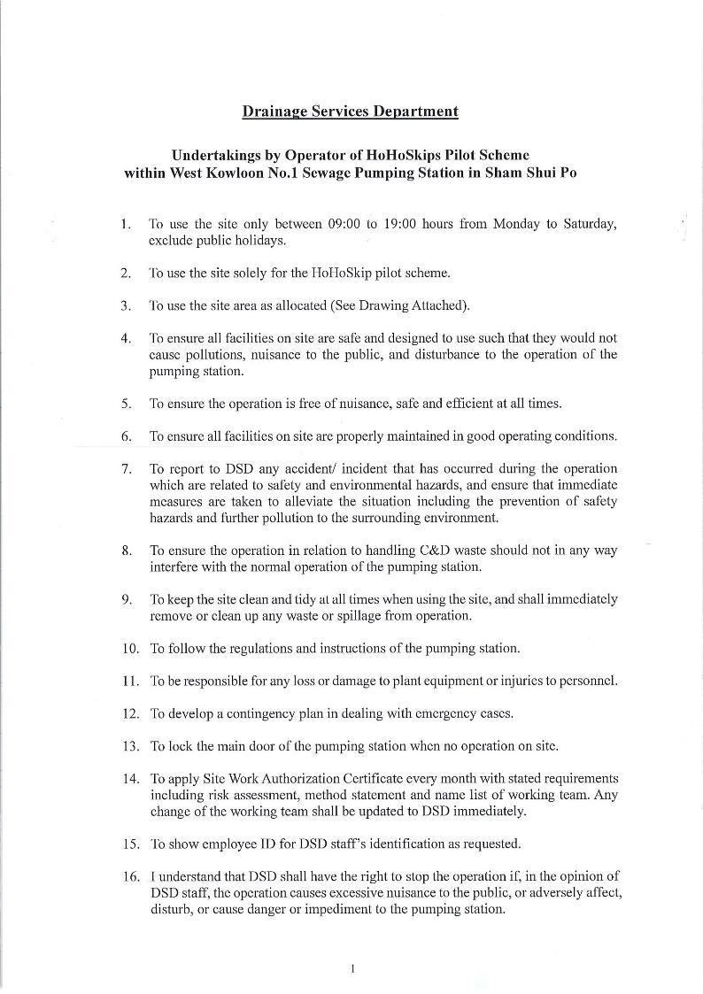
附件四 APPENDIX IV

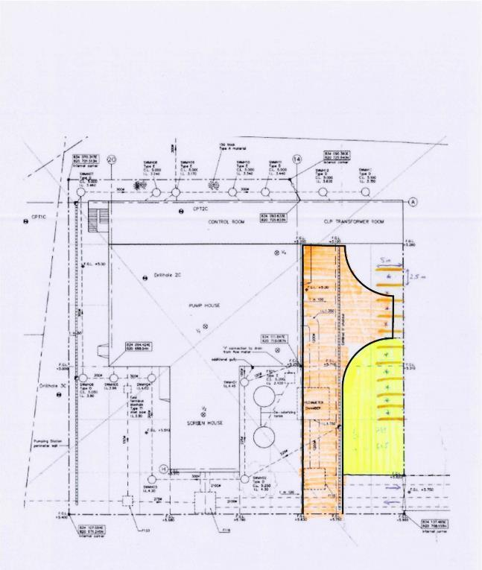

附件五 APPENDIX V
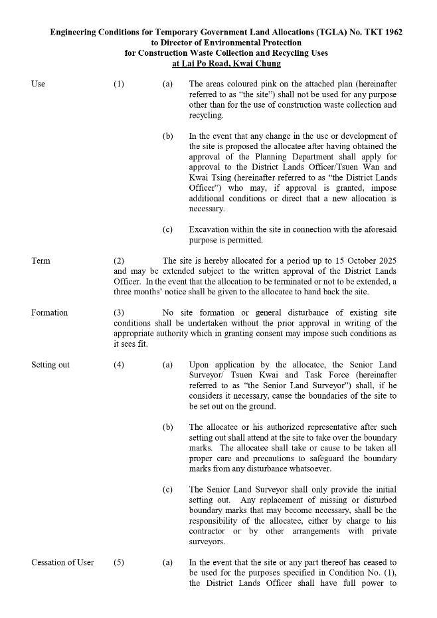

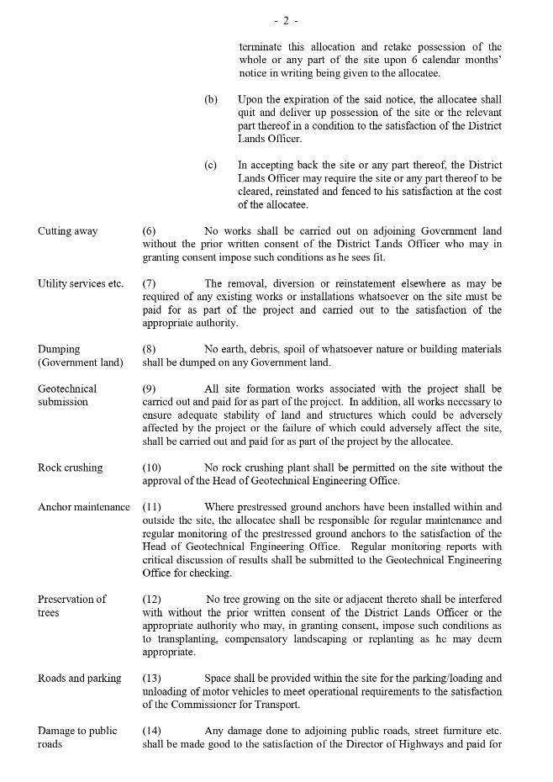
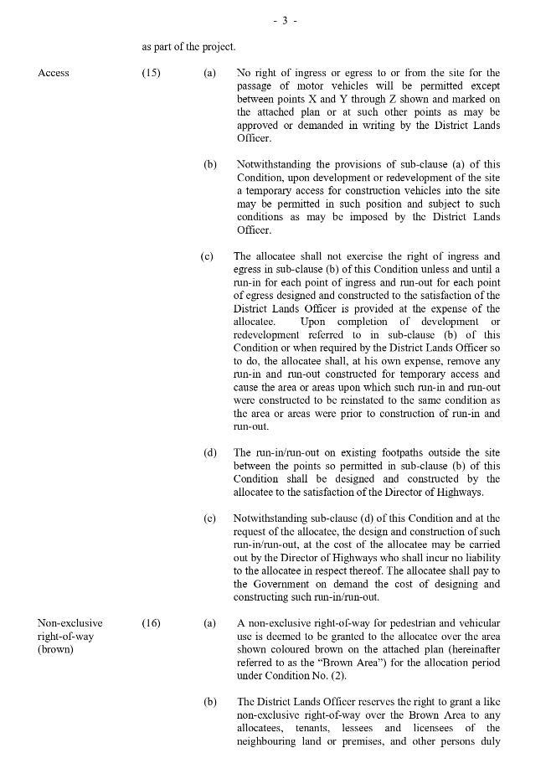
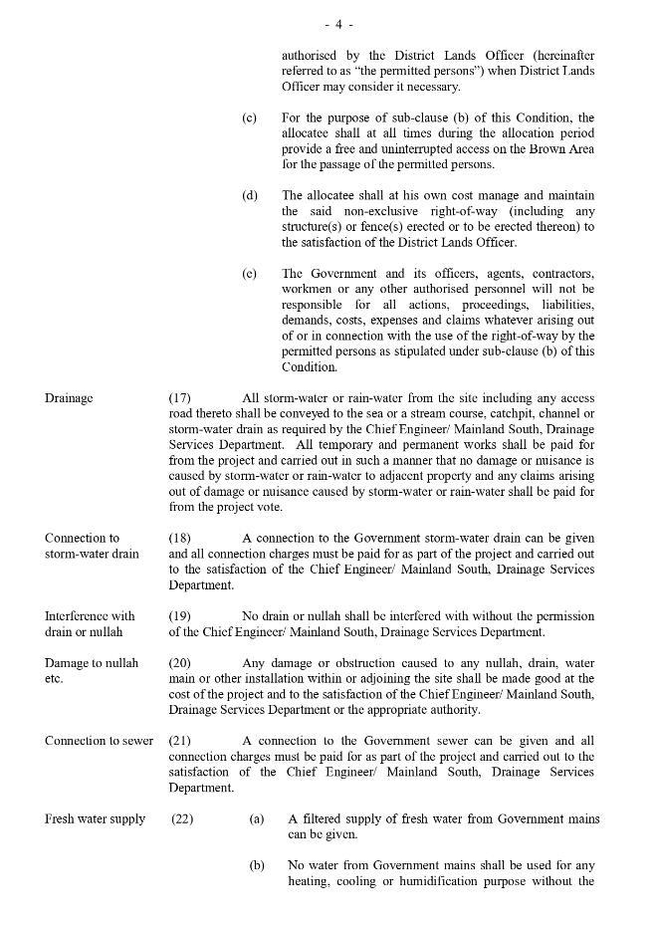
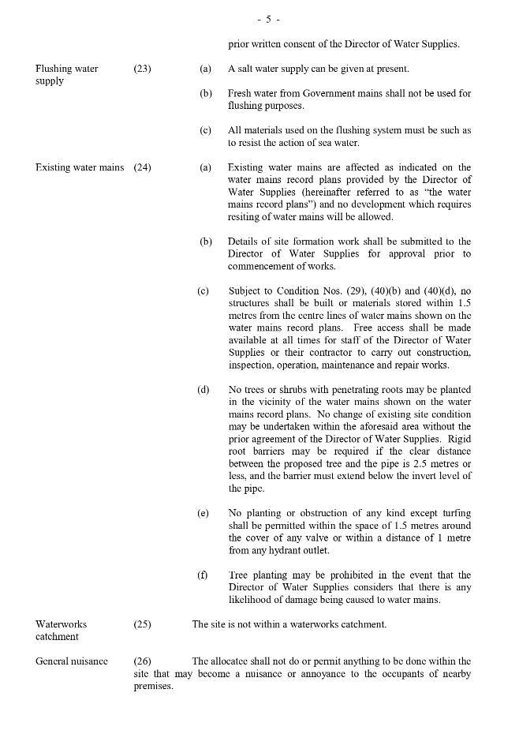
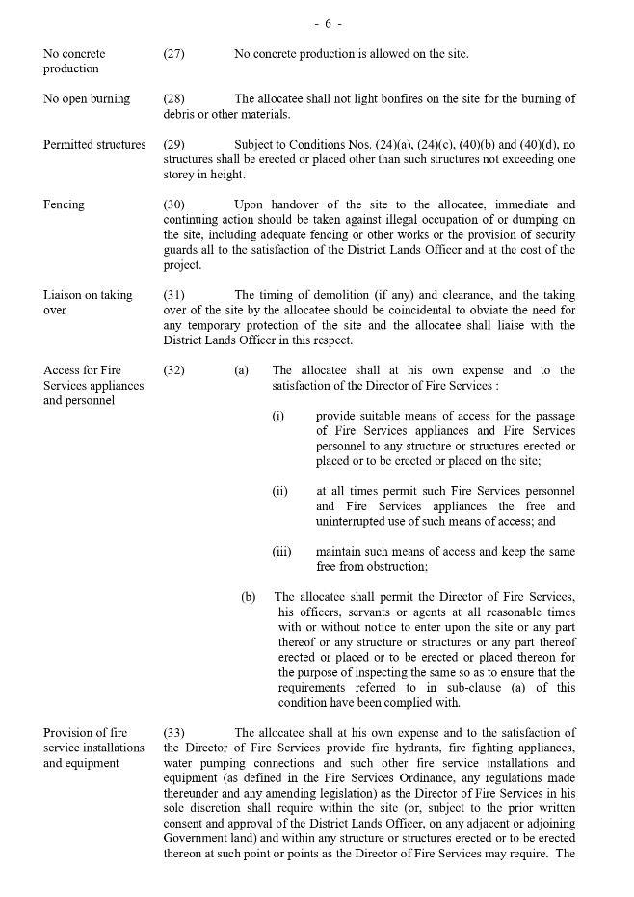
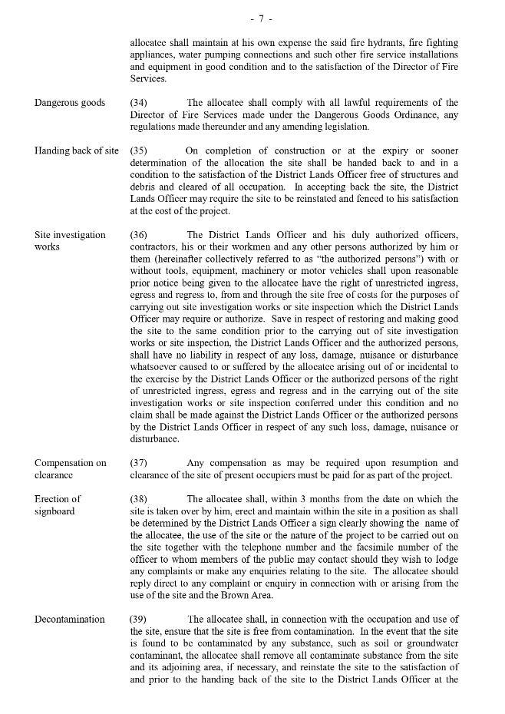
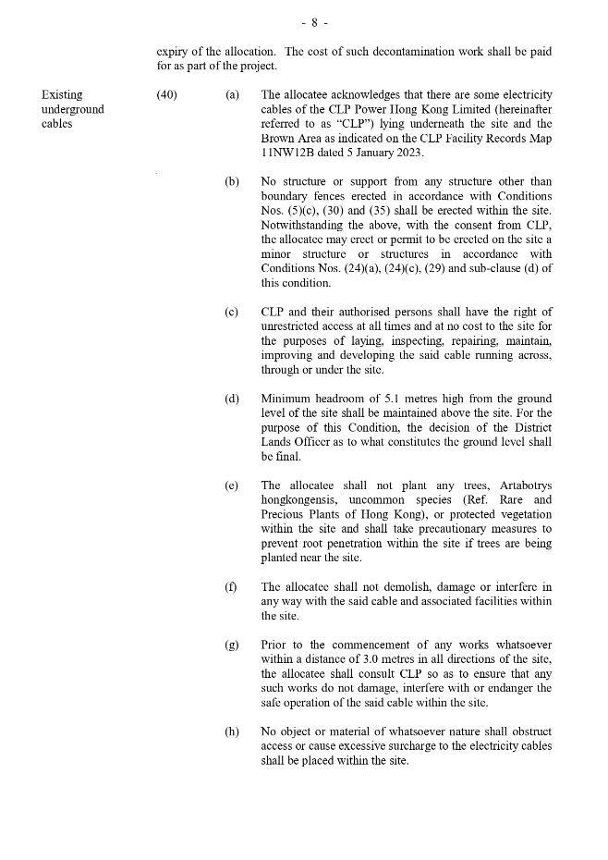
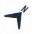
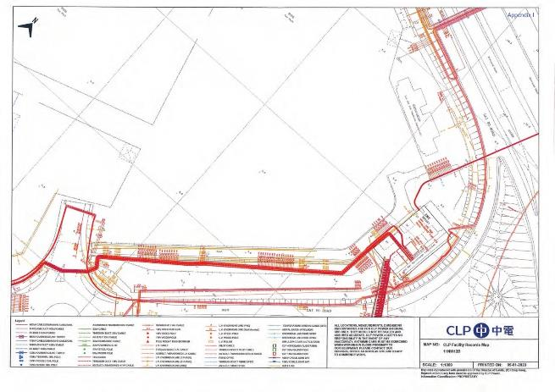
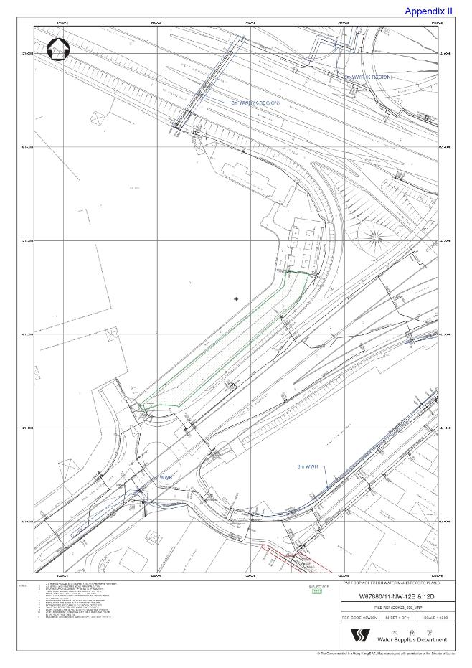
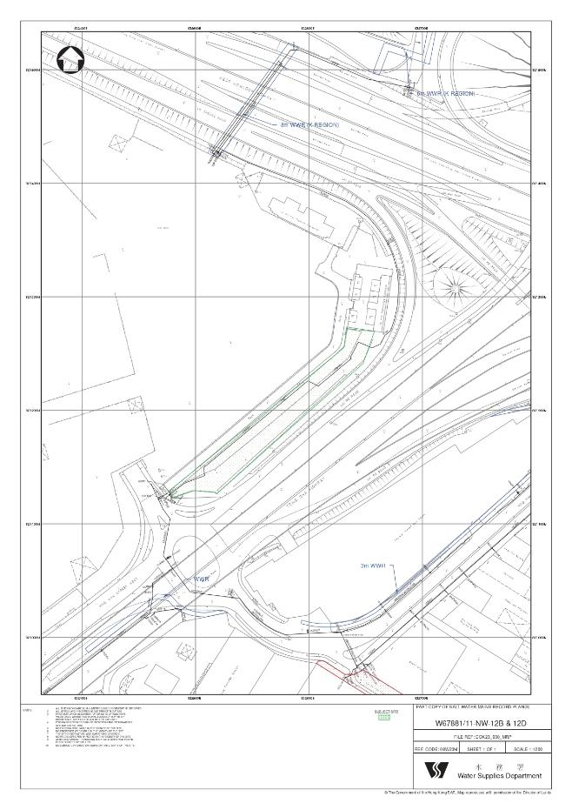
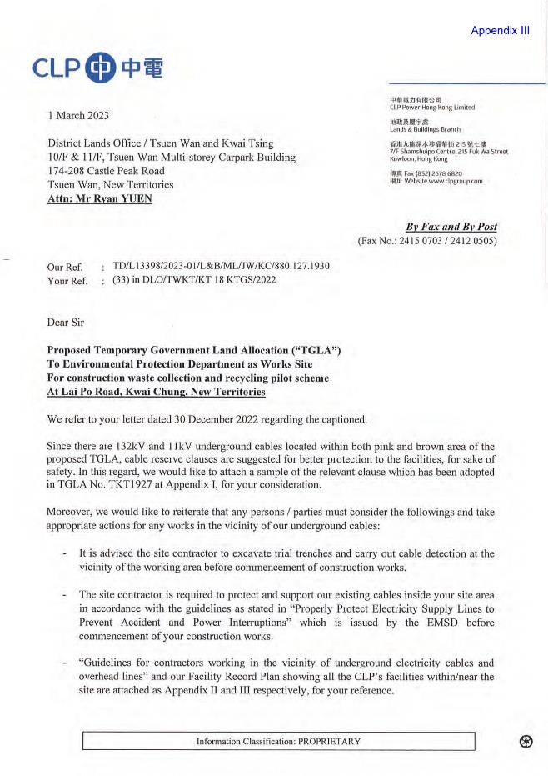
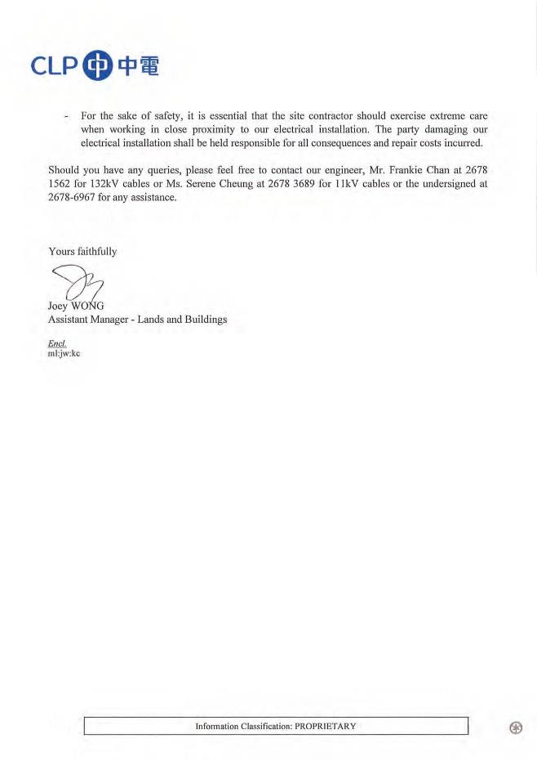
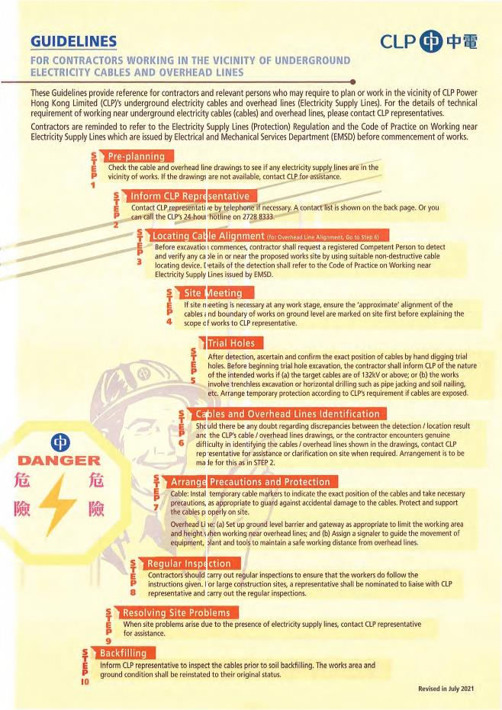
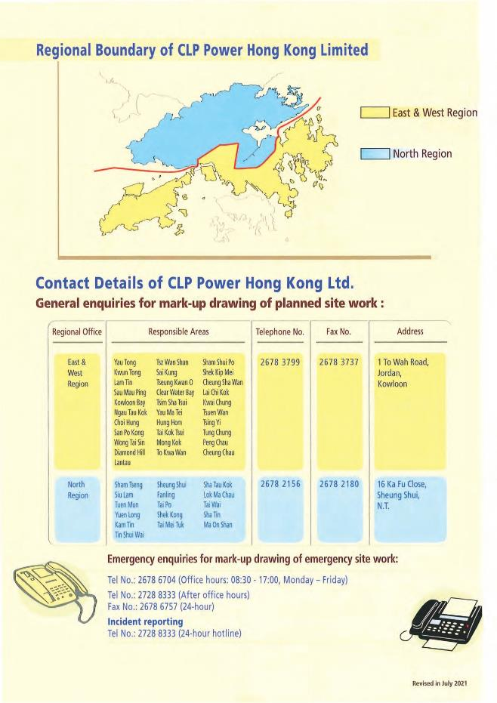
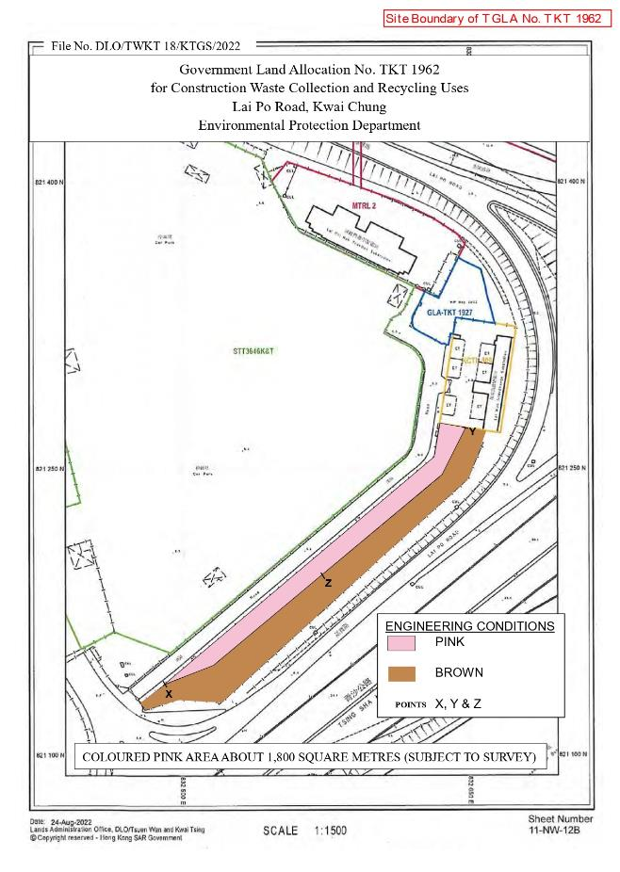
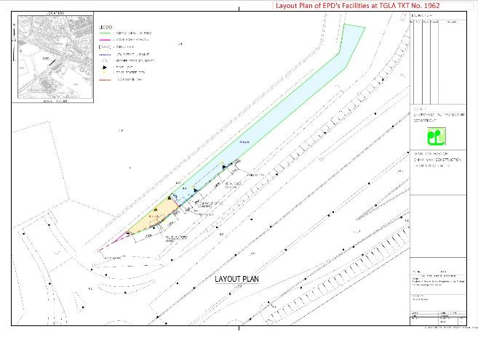

附件六 APPENDIX VI

荔寶路回收場的「好好斗」項目運作方案

- 如環境保護署（環保署）同意暫借位於葵涌荔寶路荔枝角交匯變電站旁的用地（即TGLA No. TKT 1962，下稱「荔寶路回收場」）給零碳行動協進會使用，供其僅作「好好斗」項目運作之用，「好好斗」市區項目分類員主要會在荔寶路回收場進行分類工作。

- 暫借荔寶路回收場後，零碳行動協進會及其回收營運承辦商承諾在環保署的要求下，隨時把荔寶路回收場的任何部分及任何大小歸還給環保署使用。

- 現時的使用者守則並沒有硬性的廢物袋及回收物件最大及最重的限制，零碳行動協進會及其回收營運商承諾會盡力彈性及寬容處理每宗個案，並遵照環保署最終的指示處理。

- 透過「好好斗」市區項目收集到的建築廢物，將會送往荔寶路回收場處理，然後按附錄一的流程圖進行分類工作，不含瓦的惰性建築廢料會送往私營的建築廢物回收商，例如嘉華建材位於環保園的設施，以符合回收基金申請時的承諾，並增加計劃的環保效益。

- 透過服務市區項目的輕型客貨車收集到的建築廢物，由於其數量相對比較少，而且體積不大，所以仍會被送往西九龍一號污水泵房處理，然後按附錄一的流程圖進行分類工作，不含瓦的惰性建築廢料會送往私營的建築廢物回收商，例如嘉華建材位於環保園的設施，以符合回收基金申請時的承諾，並增加計劃的環保效益。

- 西九龍一號污水泵房的分類工作主要會由輕型客貨車司機一併負責，並放置三個用於篩選廢物的環保斗，一個用於儲存一般惰性建築廢物，另一個用於儲存非惰性建築廢物，最後一個用於儲存適合製造環保磚的惰性建築廢物。輕型客貨車司機必須將收集到的建築廢物直接送往西九龍一號污水泵房，然後根據廢物的特性分類為惰性或非惰性，不含瓦的惰性建築廢物會分類以送往私營的建築廢物回收商，例如嘉華建材位於環保園的設施。回收人員必須盡可能將惰性內的含瓦物料抽出，以增加符合送往私營的建築廢物回收商的惰性建築廢物數量，目的是進一步增加計劃的環保效益。當載滿其中一個環保斗後，勾斗車會到西九龍一號污水泵房將滿載的環保斗送去相應的政府及私營廢物處理設施處理。

- 如市民希望自行將建築廢料交給零碳行動協進會處理，需前往荔寶路回收場，西九龍一號污水泵房不會對公眾開放。

- 西九龍一號污水泵房主要會用作存放上述三個環保斗和放置輕型客貨車，以及篩選輕型貨車收集得來的建築廢物。

- 回收人員（包括司機和分類員）仍可選擇在西九龍一號污水泵房上班和下班，午飯時段亦可選擇在西九龍一號污水泵房用膳和休息，但大前提是零碳行動協進會必須確保運作不影響在荔寶路回收場提供的服務，員工正常到達及離開工作地點的時間必須保持為兩處所的營運時間，即上午九時及下午六時，中午飯暫停服務的時間會維持為一個小時。

- 員工離開荔寶路回收場時須將閘口C及閘口D關上並鎖上（見附錄三）。閘口A及閘口B應維持開放給公眾使用「智好斗」的自助回收服務，並根據環保署指示的時間關上並鎖上，閘口A及閘口B的開放時間會因應情況再作調整。

- 「智好斗」會配合在荔寶路回收場及自助回收服務時間表的安排，包括擺放在荔寶路回收場（見附錄三）及其他政府用地（見附錄四）提供自助回收服務，以及按照環保署的自助服務時間表及其服務地點，例如但不限於公眾垃圾收集站及路旁位置（見附錄四），一般於早上十時前擺放在時間表所列的公眾地方及提供服務，並一般於下午四時半後搬離這些公眾地方，存放於荔寶路回收場及清理其回收的建築廢物，留待下一個工作天重複相關的流程。日後「智好斗」擺放及搬離時間和運作或會因應情況和「智好斗」的數量再作調整，零碳行動協進會及其回收營運承辦商會根據環保署的指示配合所需的改動。

- 提供自助服務的「智好斗」，所收集到的建築廢物將會按附錄一的流程圖在荔寶路回收場進行分類及處置，不含瓦的惰性建築廢料必須送往私營的建築廢物回收商，例如嘉華建材位於環保園的設施，以符合回收基金申請時的承諾，並增加計劃的環保效益。

- 「智好斗」需使用16噸電動勾斗車運送。

- 電動勾斗車在閒置時會擺放在荔寶路回收場。該等電動勾斗車只會用於「好好斗」項目，並在有需要時可使用附錄二的充電樁充電。

- 零碳行動協進會將會為荔寶路回收場安裝一些必要設備，如消防設備、急救用品、流動廁所、水機等，和安排一些必要服務如滅蟲服務等。

- 緊急集合點將設置在員工休息室外的空地上（見附錄三綠色方格），如有任何突發情況需要緊急疏散，員工會在標示的位置集合並向綠色箭嘴方向撤離。

- 在荔寶路回收場的進出口位置將會增設告示板，上面清楚地標明使用場地機構的名稱，土地用途或在該地點進行的項目的性質，以及就項目作出任何投訴或提出任何查詢的電話號碼和特發情況的緊急聯絡電話號碼。

- 零碳行動協進會將會申請電錶轉名，負責繳交荔寶路回收場的電費。

- 零碳行動協進會承諾會考慮在荔寶路回收場添置機動設施（例如氣動輔助搬運裝置），以便利建築廢物的搬運工作，提高建築廢物的分類及篩選效率。

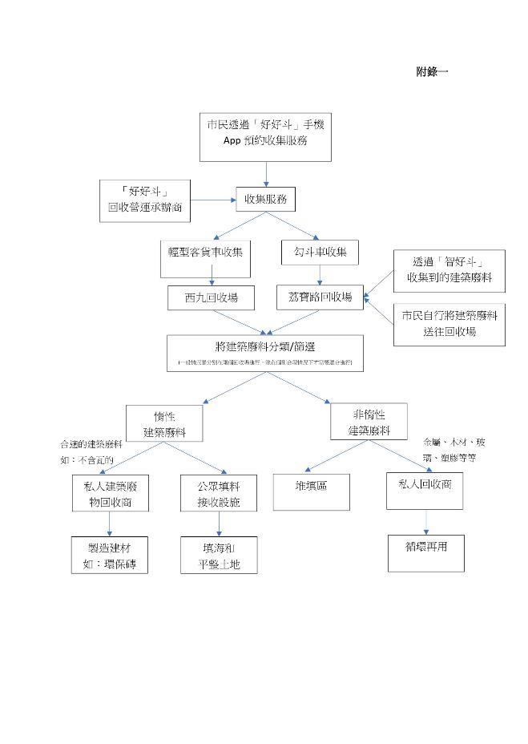
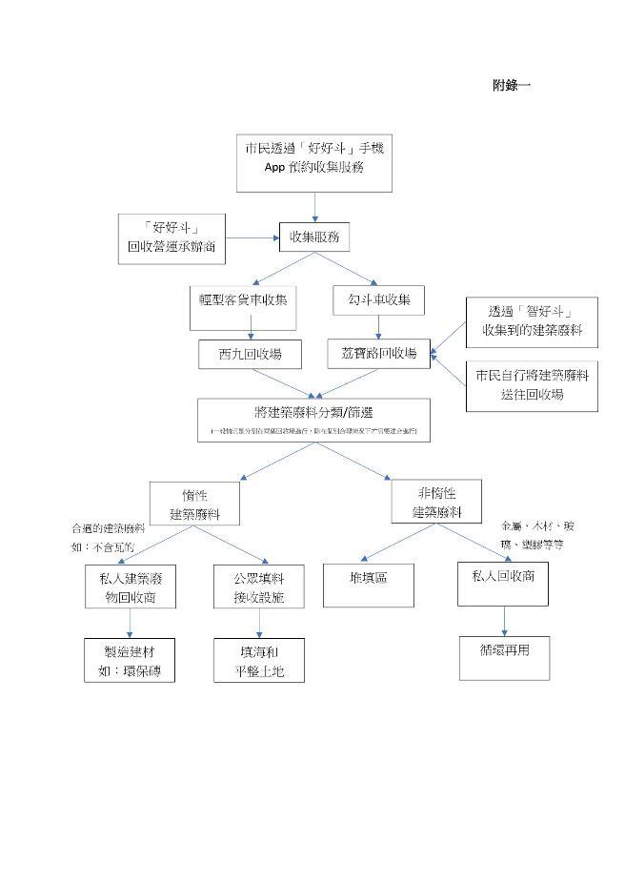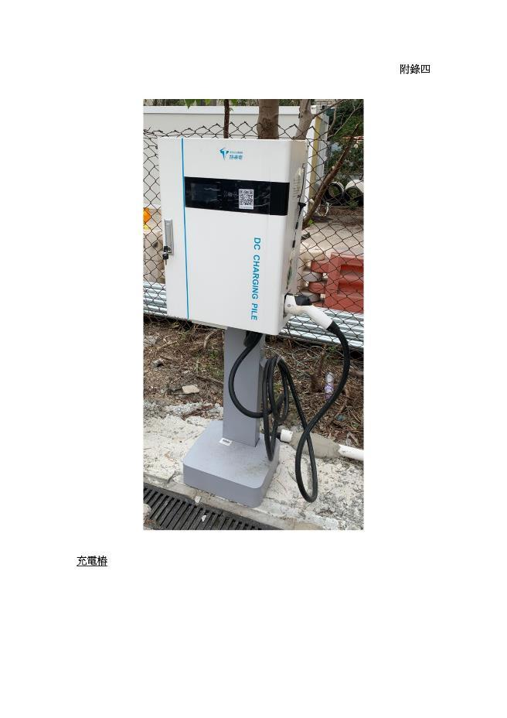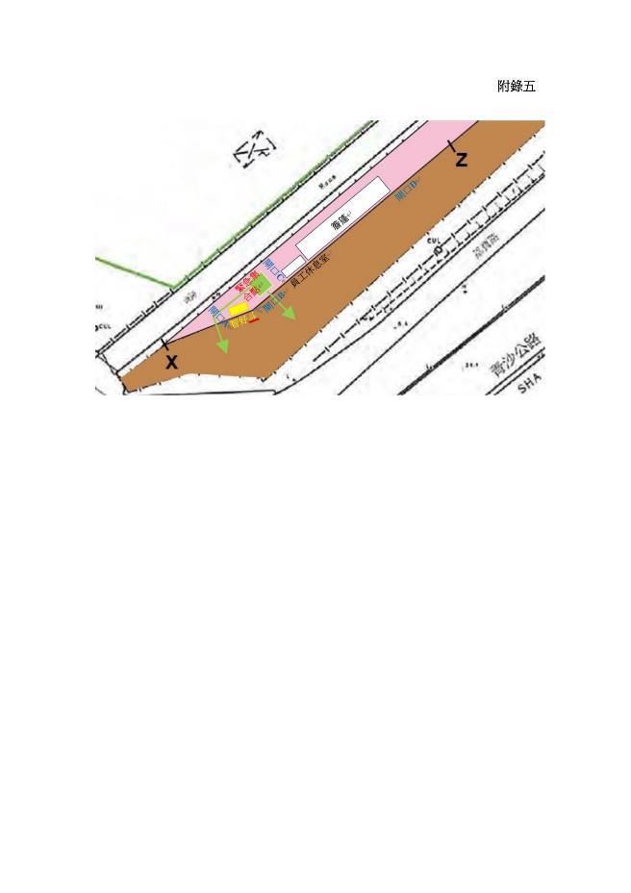
附錄二
附錄三
附錄四

政府用地
香港島南區 薄扶林 域多利道  時間：全天候24小時  https://maps.app.goo.gl/G82RNvpTYHEwL4WN9 | 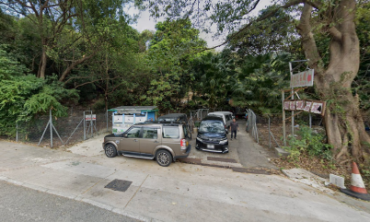

公眾垃圾收集站
香港島東區 筲箕灣 東喜道垃圾收集站  時間：垃圾站的開放時間內 (07:00-00:00) 的前後半小時內，可擺放過夜  https://maps.app.goo.gl/2chtHLc3Yh6iPVRH8 | 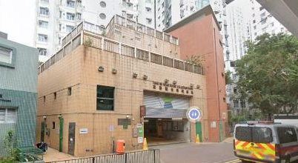
九龍九龍城區 九龍塘 浸會大學道垃圾收集站  時間：垃圾站的開放時間內 (06:30-17:30) 的前後半小時內，可擺放過夜  https://maps.app.goo.gl/xBH2eLeKDw6PUN5C8 | 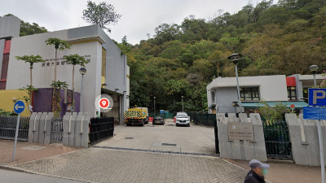

路旁位置
九龍油尖旺區 大角咀 海輝道  時間：全天候24小時  https://maps.app.goo.gl/TRMJfB23zwY3JNes6 | 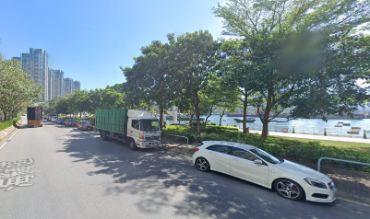
九龍油尖旺區 油麻地 文匯街  時間：全天候24小時  https://maps.app.goo.gl/6aAtvgCe5XfxPN9v6 | 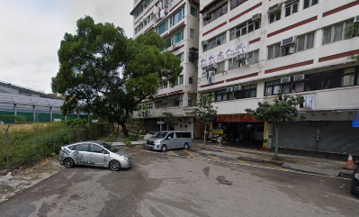
九龍九龍城區 紅磡 安靜道  時間：全天候24小時  https://maps.app.goo.gl/usoacvo4aidAXhf26 | 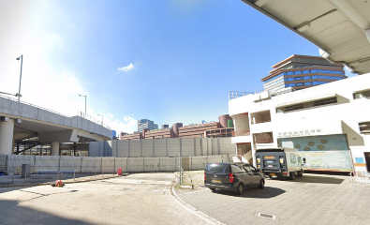
九龍黃大仙區 東頭村道  時間：全天候24小時  https://maps.app.goo.gl/VYpGspd68Ly1JZMk6 | 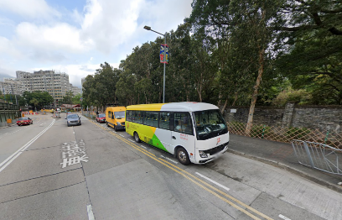

附件七 APPENDIX VII
「環保斗認證計劃」規格要求
(此為參考文件，並非指定生產力促進局為服務提供者)

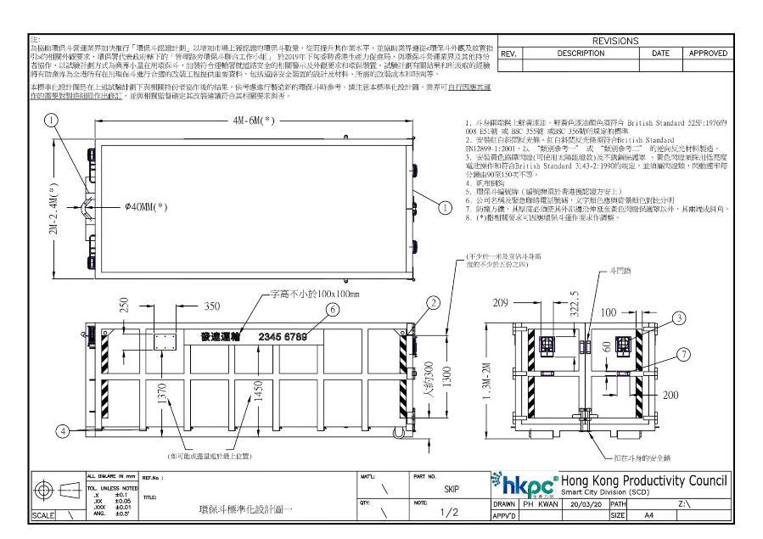

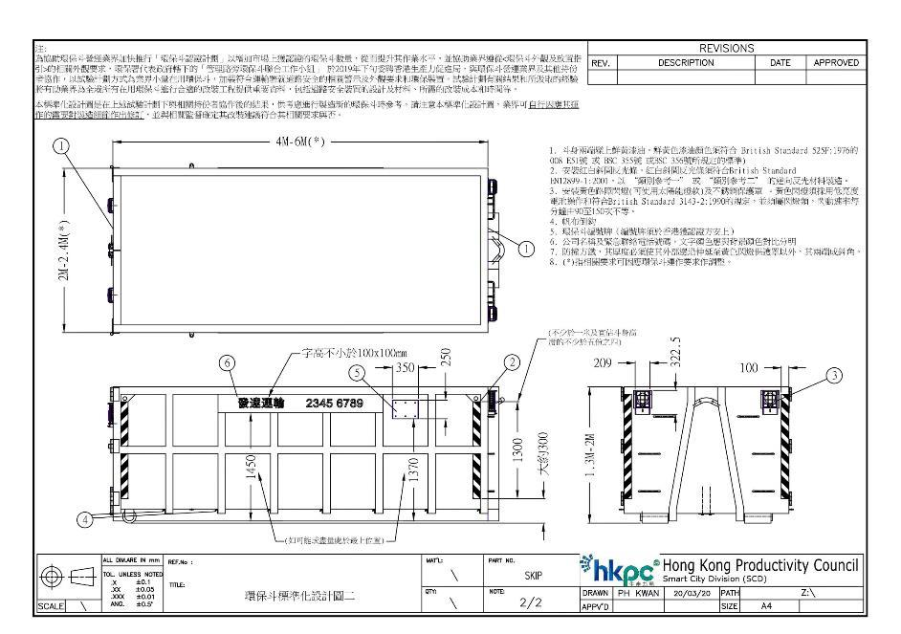

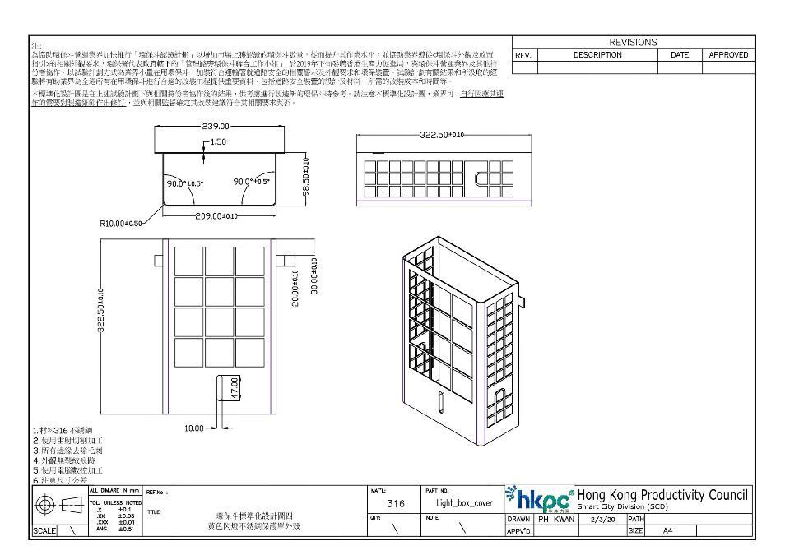

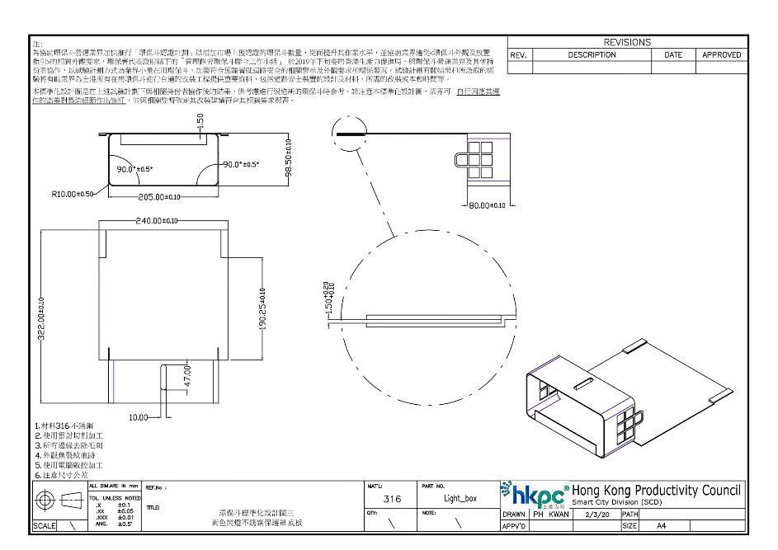

附件八 APPENDIX VIII
「智好斗」示意圖
(只屬示意之用，並不一定代表實物。如有需要可安排視察實物。)
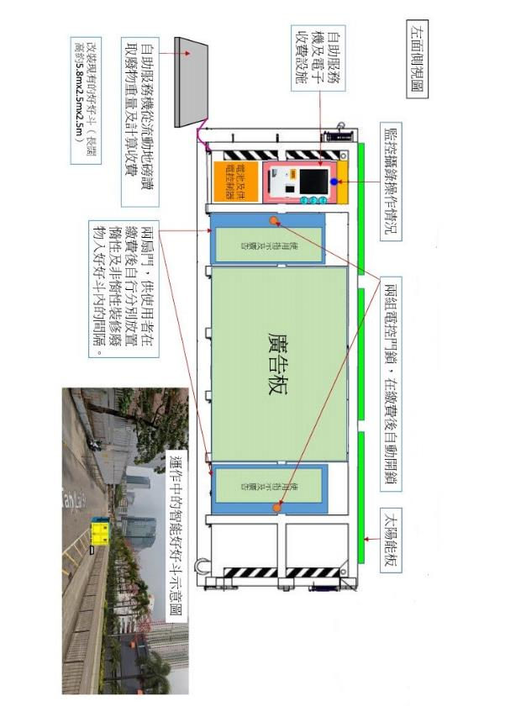

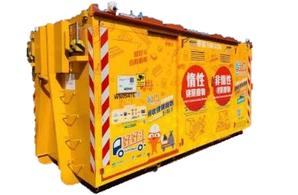

操作時

操作時


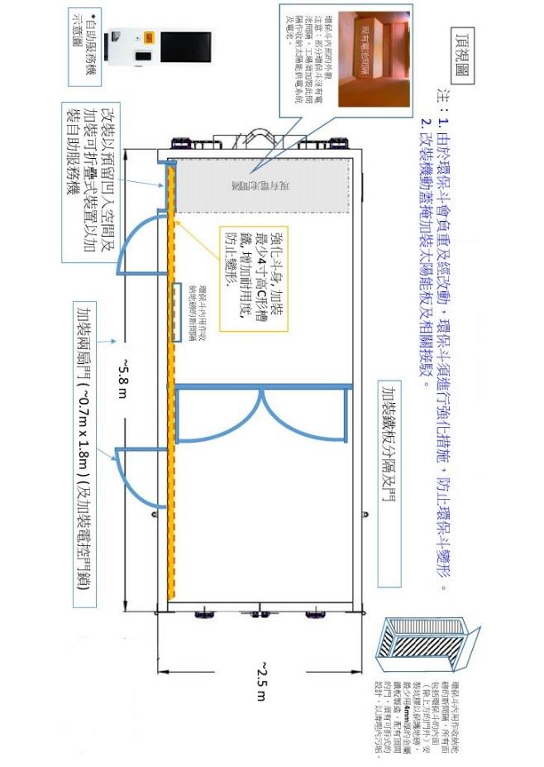

~4 m

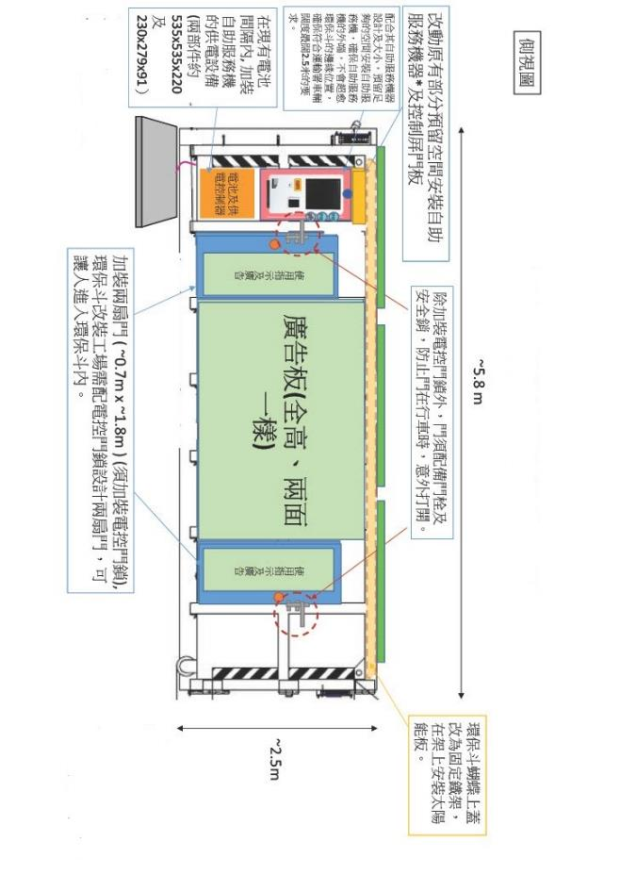

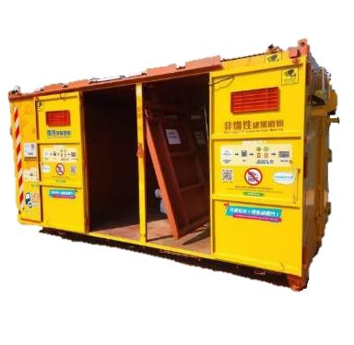

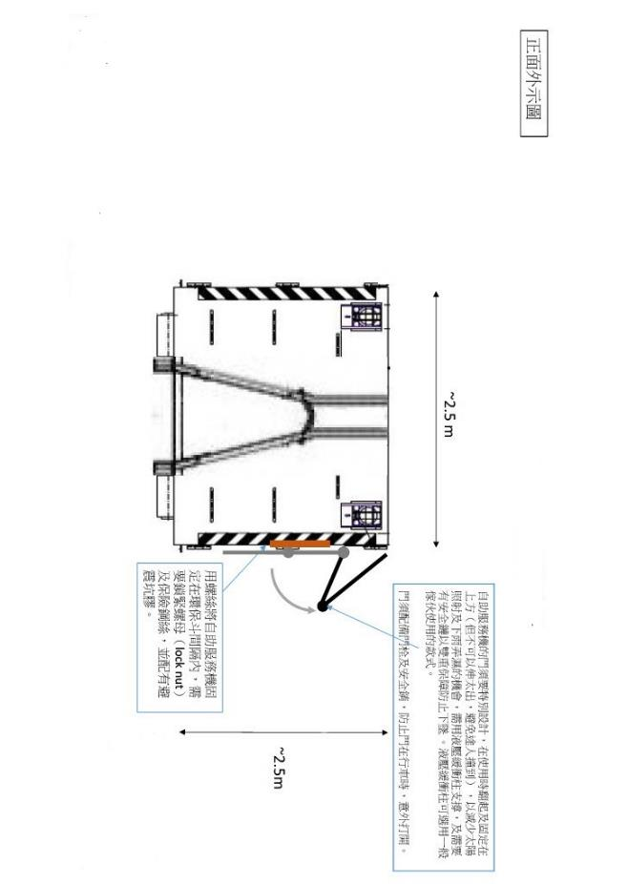

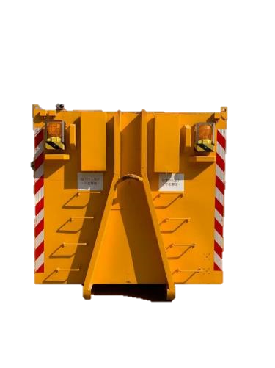

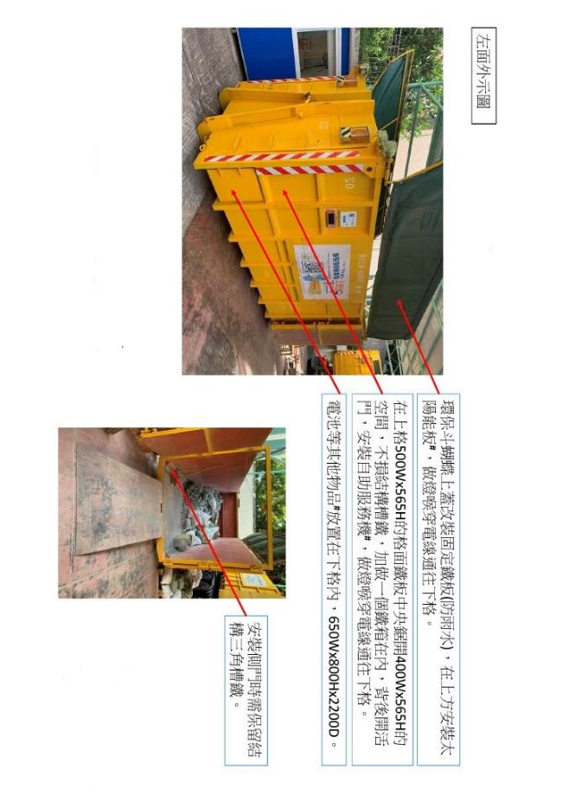



「智好斗2.0」示意圖
(只屬示意之用，並不一定代表實物。)
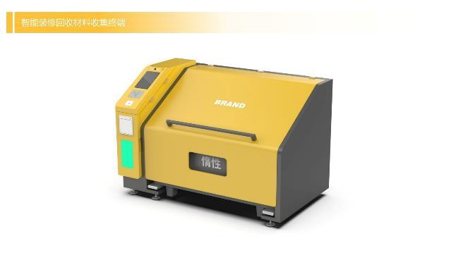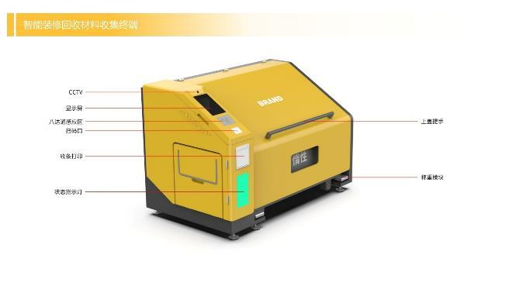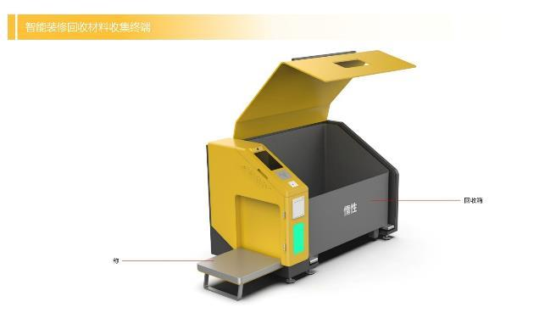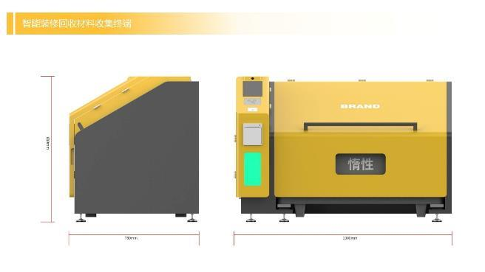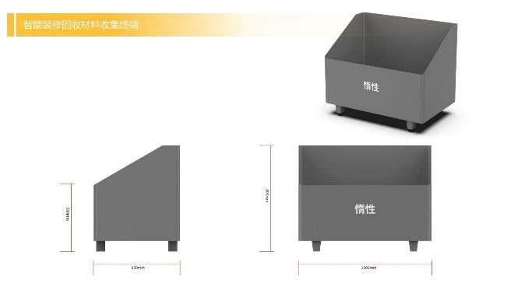
附件九 APPENDIX IX
致: 零碳行動協進會
UNIT J, 15/F
MAXGRAND PLAZA
3 TAI YU STREET
SAN PO KONG, HONG KONG

回收基金項目 ISP-2425-38-002 零碳行動的「好好斗」市區小型裝修工程
建築廢物源頭分類及回收試行項目

建築廢物收集及分類場地管理服務合約 Ref: ZCAA-A001/10/25

報價表格
Price Schedule

***投標者必須把「報價表格」及 「技術附表」分開兩個信封投遞，並確保「技術附表」內不包含任何合約價錢，如投標者違反上述條款，該標書將不獲考慮。***
致: 零碳行動協進會
UNIT J, 15/F
MAXGRAND PLAZA
3 TAI YU STREET
SAN PO KONG, HONG KONG

回收基金項目 ISP-2425-38-002 零碳行動的「好好斗」市區小型裝修工程
建築廢物源頭分類及回收試行項目

建築廢物收集及分類場地管理服務合約 Ref: ZCAA-A001/10/25

技術附表
Technical Information

***投標者必須把「報價表格」及 「技術附表」分開兩個信封投遞，並確保「技術附表」內不包含任何合約價錢，如投標者違反上述條款，該標書將不獲考慮。***

