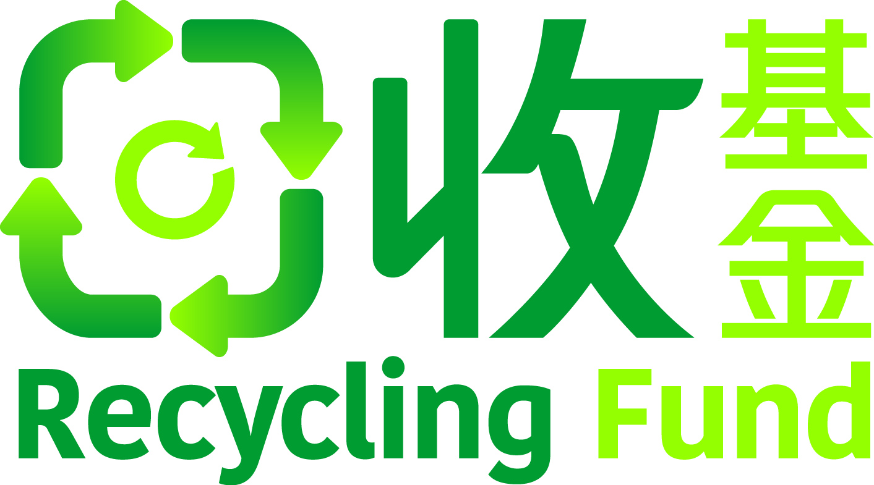


團體名稱 Group name:
姓名 Name:
姓名 Name:
姓名 Name:
姓名 Name:
姓名 Name:
請將填妥的表格，以電郵方式發送到 recyclingfund@hkpc.org，
截止日期為 2025年11月14日。
Kindly submit the completed Application Form by emailing to recyclingfund@hkpc.org
on or before the deadline of 14th November 2025

執行伙伴
Implementation Partner
作為一間新成立及初創企業，您正在申請「回收基金」中「新成立及初創企業開展項目」，以獲取資金支持，推動相關的回收業務發展。申請表將協助您詳細說明項目內容，並展示資助如何促進公司的增長和可持續發展。請提供關於項目及其預期影響的詳細資料。
As a new and start-up enterprise, you are preparing an application of the Solicitation Theme on Projects from New and Start-up Enterprises under the Recycling Fund to seek funding support for advancing your recycling business initiatives. This application form will guide you in outlining your project and demonstrating how the funding will enhance your business growth and sustainability. Please provide details about your company, the project, and its anticipated impact.
這份申請表僅供本比賽使用。This application form is intended for this competition only.
RECYCLING FUND's 10th ANNIVERSARY CASE COMPETITION:
Innovate to Sustain

回收基金十週年
案例比賽:
創新以永續
回收基金The Recycling Fund新成立及初創企業開展項目
Projects from New and Start-up Enterprises (SUP)
申請表格計劃書Application Form Proposal

甲部：申請者資料
Section A – Particulars of the Applicant
 | 項目名稱  Project Title: |  | (英文 English)
 | 項目名稱  Project Title: |  | (中文Chinese)
項目概覽
Project Overview:

3. 執行項目的成員 (成員資料亦將會被秘書處用作聯絡方式)：
Key Members of the Project Team (Members information will also be used by the Secretariat for contact purposes):
(i) 項目統籌人 Project Coordinator
姓名 (英文)  Name (English): | (Mr/Ms)#
姓名 (中文)  Name (Chinese): | (先生/女士)#
學校名稱 &
主修課程
University Name & Major Subject:
電話號碼 Tel No.:
電郵 Email Address:

(ii) 副項目統籌人 Deputy Project Coordinator
姓名 (英文)  Name (English): | (Mr/Ms)#
姓名 (中文)  Name (Chinese): | (先生/女士)#
學校名稱 &
主修課程
University Name & Major Subject:
電話號碼 Tel No.:
電郵 Email Address:

(iii) 其他成員 Other member
姓名 (英文)  Name (English): | (Mr/Ms)#
姓名 (中文)  Name (Chinese): | (先生/女士)#
學校名稱 &
主修課程
University Name & Major Subject:
電話號碼 Tel No.:
電郵 Email Address:

(iv) 其他成員 Other member
姓名 (英文)  Name (English): | (Mr/Ms)#
姓名 (中文)  Name (Chinese): | (先生/女士)#
學校名稱 &
主修課程
University Name & Major Subject:
電話號碼 Tel No.:
電郵 Email Address:

(v) 其他成員 Other member
姓名 (英文)  Name (English): | (Mr/Ms)#
姓名 (中文)  Name (Chinese): | (先生/女士)#
學校名稱 &
主修課程
University Name & Major Subject:
電話號碼 Tel No.:
電郵 Email Address:

#請刪去不適用者Please delete if not applicable

乙部：項目內容Section B – Project Details
- 項目所需時間(6 - 24個月) Project Duration
(6 to 24months):
- 項目總估計費用Total Estimated Project Cost : | (港幣HK$)
- 申請資助金額Amount of Funding Sought : | (港幣HK$)
- 申請者投資金額Amount of Cash Contribution from the Applicant : | (港幣HK$)
- 項目計劃Project Plan:
請根據提供下列詳細資料。Please provide the following information of the project in details.
- 項目目標 (可選擇多於一項) Objective(s) of the project (may choose more than 1 option):

☐ 在回收業務上實踐理念
To execute ideas in recycling businesses
☐ 採用創新技術、方法、設備等以改進或提升回收及相關作業的效率
To adopt innovative technologies, ideas, equipment, etc. to facilitate or enhance efficiency of recycling related operations

☐ 建立具商業規模的營運模式，把可循環物料回收或升級再造成為新商品或創新產品
To establish operations in upcycling or recycling of recyclables to new or innovative products in commercial scale

☐ 其他
Others

- 項目可行性及需要性Need and Viability of the Project
現時回收業的問題、情況及對未來市場的估計
The current problem, situation and projected market condition of the recycling industry
解釋此項目的需要及可行性，如何應用創新技術或方法以解決回收業的需要
Explain the need and viability of this project on addressing the need of the industry by applying innovative technology or methodology

- 技術可行性Technical Viability
(請從技術層面詳細說明項目的可行性，如有需要亦請同時提供支持文件。)
(Please provide details on the viability of the project from the technical perspectives, please also provide supporting documents if necessary.)

- 實施計劃Implementation Plan
(請提供詳盡資料說明實施計劃後如何達到目的，及請提供如何應用技術、方法、設備等以改進或提升回收及相關作業的效率或成本效益。)
(Please describe in details how the plan could achieve the objectives and provide the information of applying innovative technologies, ideas, equipment, etc..)

- 項目的商業及/或宣傳計劃，及項目完成後的可持續性Business and/or publicity plan, and sustainability of the project
(1. 商業計劃 — 請說明及証明企業的商業及宣傳計劃在商業上屬可行及合乎成本效益，如投資金額、項目於何時會獲得淨利潤等;
2. 項目可持續性— 請說明項目如何在沒有進一步的資助撥款下，仍然可持續發展。)
(1. Business plan: Please describe and demonstrate the cost effectiveness and financially viability of the business and publicity plan, such as investment amount, the timeline for the project with net profit etc.;
2. Sustainability: Please describe how the project should be financial sustainable without further funding after the project period.)

- 項目團隊經驗Experience of Project Team:
請提供項目團隊相關經驗，如有需要亦請同時提供支持文件。
Please provide the details of Relevant experience of Project Team, please also provide supporting documents if necessary.

- 有關涉及增加處理回收物數量的項目，申請者必須填寫以下列表 (如適用)：
For projects involving an increase of the quantity of recyclables treated, the applicant must fill in the following table (if applicable):
(i) 回收物收集/投入及 回收物/回收產品產出Collect/Input of Recyclables and Output Treated Recyclables/Recycled Products (if applicable)
回收物收集/投入 Collect/Input of Recyclables
 | (1) | (2) | (3)
處理回收物種類
Type of recyclables to be handled
收集及處理量 Collection and processing amount
收集渠道
Potential source
回收物/回收產品產出 Output Treated Recyclables/Recycled Products
 | (1) | (2) | (3)
回收物/回收產品產出Output treated recyclables / products
重量 / 數量
Weight / Amount
下游出路
Potential outlet

- 實施計劃摘要Summary of the Implementation Plan:
請清楚、具體和量化地說明項目的建議里程碑，以及實施項目所需的措施或活動及其時間表。
Please specify the proposed milestone(s) in clear, specific and measurable terms and the measures/activities required to implement the plan as well as the timetable involved.
開始日期 至 完結日期  (月/年)  Commencement Date to Completion Date (month/year) | 措施或活動達致里程碑或成果  Measures/Activities to Achieve the Milestones/Deliverables
1)
2)
3)
4)
5)

- 預算計劃 Budget Plan
請清楚地列出所有的支出項目，並必須發生在項目的開始和完成期間。
Please list out all expenditure items in breakdown and the items must be incurred between the commencement and completion dates of the project.
支出項支  Expenditure Item | 單價  (港幣)  Unit Cost (HK$) | 數量  Quantity | 項目預算開支(港幣)  Estimated Cost for the Item (HK$)
總數 Total ($):

回收基金The Recycling Fund
申請者須知Notes for Applicant
- 在填寫申請計劃書之前，請詳細閱讀申請指引。 Please study the Guide to Application carefully before completing the Application Form Proposal.
- 嚴格禁止抄襲。每位申請者的作品不得侵犯或違反任何第三方的權利，包括但不限於知識產權，並且不得構成誹謗或侵犯任何隱私、公開、挪用、保密或合同權利。任何形式的不當行為或違反法律或損害公共利益的行為將導致取消資格。 Plagiarism is strictly prohibited. Each entry of applicant must not infringe or violate any rights of third parties, including, but not limited to, Intellectual Property Rights, and must not constitute defamation or violate any privacy, publicity, misappropriation, confidentiality, or contractual rights. Any form of inappropriate behavior, or actions that violate laws or harm public interests will result in disqualification.
- 回收基金秘書處 / 執行機構保留發布所有參賽作品及使用您的照片的權利用於宣傳用途。在任何情況下，參賽作品都不會在申請者與回收基金秘書處 / 執行機構之間或申請者與任何其他方之間產生保密關係或保密義務。回收基金秘書處 / 執行機構一概無須負上任何法律責任，因任何方違反其義務而引致的任何損失或損害。 The Recycling Fund Secretariat / Implementing Agencies reserves the right to publish all entries and use your photos for promotional purposes. Under no circumstances will any entry create a confidential relationship or obligation of secrecy between any applicant and the Recycling Fund Secretariat / Implementing Agencies or between the applicant and any other party. The Recycling Fund Secretariat / Implementing Agencies shall not be held liable for any loss or damage suffered from any party's breach of obligations.
- 本次比賽中由申請者提交的想法和內容僅代表申請者的觀點和意見，並不代表回收基金秘書處 / 執行機構的觀點或意見。 The ideas and content submitted by applicants for this competition solely represent the views and opinions of the applicants and do not reflect the views or opinions of the Recycling Fund Secretariat / Implementing Agencies.
- 回收基金秘書處、執行機構、評審、合作夥伴以及代表回收基金秘書處及／或執行機構的任何人將不向任何申請者承擔與比賽有關的責任或義務（包括但不限於對任何間接或相應而生損失或損害的責任，例如損失利潤、任何財產損失、損害、人身傷害或死亡的責任，以及基於宣傳權、誹謗及／或侵犯私隱權的索賠）。 Recycling Fund Secretariat, the Implementing Agencies, Judges, Partners and anyone acting on behalf of the Recycling Fund Secretariat and/or the Implementing Agencies will have no responsibility or liability whatsoever to any applicant (including, but not limited to, liability for any indirect or consequential loss or damage such as loss of profit, liability for any property loss, damage, personal injury or death, as well as claims based on publicity rights, defamation, and/or invasion of privacy) in connection with the Case competition.
- 回收基金秘書處 / 執行機構保留權利以申請者曾經參與、正在參與或有理由相信申請者曾經或正在參與可能導致或構成發生危害國家安全罪行的行為或活動為由，取消申請者的是次申請。The Recycling Fund Secretariat / Implementing Agencies reserves the right to disqualify the application on the grounds that applicant has engaged, is engaging, or is reasonably believed to have engaged or be engaging in acts or activities that are likely to cause or constitute the occurrence of offences endangering national security.
- 一旦提交案例比賽的申請計劃書，您同意所有條款和條件。 By submitting the application form proposal for case competition, you consent to all the terms and conditions.
- 申請詳情可參閱「申請指引」，有關指引及申請表格可在「回收基金」的網頁下載。查詢可致電或電郵秘書處。 For details about application, please refer to the Guide to Application. The Guide to Application and Application Form Proposal can be downloaded from the website of the Recycling Fund. Enquiries can be directed to the Secretariat by phone or by email.
電話Telephone： | (852) 2788-5658
電郵E-mail： | recyclingfund@hkpc.org
網頁 Website： | www.recyclingfund.hk

每個團隊由1至5名成員組成（團隊可以由不同學院機構的成員組成）。Each team consists of 1-5 member(s) (the team can be formed from different institutions.
推行項目的所需時間須與乙部第8項內實施計劃提供的項目推行時間表吻合。Project duration needs to align with the project implementation plan in item 8 of Section B.
每個項目最多獲資助總核准開支的 50%，總資助上限為港幣 200 萬。Grants for each project will cover as much as 50% of supported expenditure with a cap of HK$2,000,000.

